Maze Workbook (Sample Answers)

Introduction – Questions
What questions do you need to answer before the activity? (at least 2)
Answers will vary. Example answers:
1. What is coding?
2. How are we going to code?
3. How big is the maze?
4. What kind of healthy choices?

Pre-Assessment
Answers will vary. Example answers:

What is a healthy choice?
A healthy choice is something good for you.

What is an unhealthy choice?
An unhealthy choice is something that hurts you.

What are the long-term consequences of making healthy and unhealthy choices?
Long-term consequences of healthy choices are that you won't get sick, and for unhealthy choices, you will get sick.

What does it take to code a robot?
Run, eat vegetables, exercise, sleep well

Healthy Choices
Answers will vary. Example answers:
- Running; exercising; playing tag, football, or soccer; swimming; dancing
- Eating vegetables; eating fruits; making food at home; eating well-balanced meals
- Sleeping well; getting 8-10 hours of sleep a night
- Playing outside; getting outside
- Moving for at least 10 min every hour

Unhealthy Choices
Answers will vary. Example answers:
- Eating a lot of candy, drinking sodas
- Playing video games all day
- Eating fast food all the time
- Binge watching TV
- Spending hours on social media
- Staying up late
- Eating Takis for breakfast, eating only candy for snack time

- Checklist/Expectations
Prototype Maze
- Needs to have a START and an END.
- For every healthy choice, there needs to be an unhealthy choice.
- Minimum 3 healthy choices and 3 unhealthy choices.
- Maximum 5 healthy choices and 5 unhealthy choices.
- The choices do not need to be drawn on the prototype but would be required on the final. This is a good time to decide what they would look like; tracing from a computer will not be an option.
- Must be approved by the teacher before moving to the final copy.

Final Maze
- Only one paper will be provided – all mistakes must be incorporated into the design – problem solve.
- Recreate the APPROVED maze.
- Illustrations with labels must be drawn.

Code
- The robot needs to begin at the start mark to go through the healthy choices of the maze
and finish at the end mark.

IF there is time, the robot may:
- Make noises when going through options.
- Change colors when going through options.
- Change speeds.
- Do small “dances.”

Troubleshooting Notes
Answers will vary. Example answers:

Hints: How far did the robot travel based on the code you wrote?
Our robot did not turn as we wanted. It went somewhere else.

Do you want the robot to go farther or shorter?
We need to fix the angle turn and then measure the path to make sure the robot completes it.

Do you need to change the duration (time) or speed?
Yes, it goes too fast.

What does turning left mean in this code?
It moves to the robot's left, not our left. We also need to see the angle.

What does turning right mean in this code?
It moves to the robot's right, not our right. We also need to see the angle.

Post Assessment
Answer the following questions. Use complete sentences.
Answers will vary. Example answers:

What was your robot's goal in the maze?
My robot's goal was to go through the healthy choices and make it to the end. I also wanted to touch on the exercise and sleep choices.

What coding blocks did you use to reach the end?
I used move forward, turn left, and turn right blocks. I also used a loop so my robot could do
the same moves more than once.

Did anything go wrong? If so, how did you fix it?
Yes! My robot went the wrong way and hit a wall. I fixed it by changing the turn block and
making it turn the other way.

If you had to add one obstacle, how would you change your code?
I would add a spinning donut that moves. I would put a wait block so my robot stops and then goes when it’s safe.
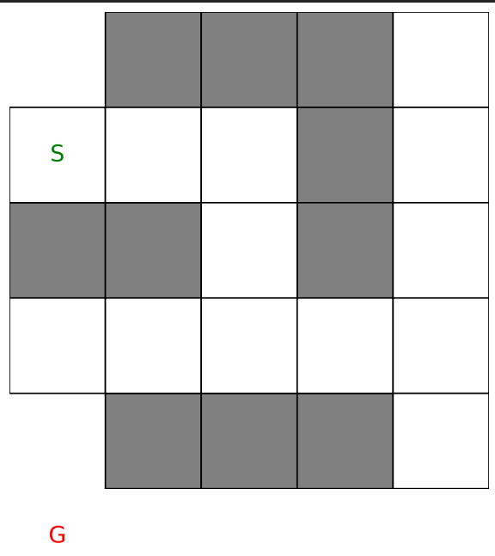
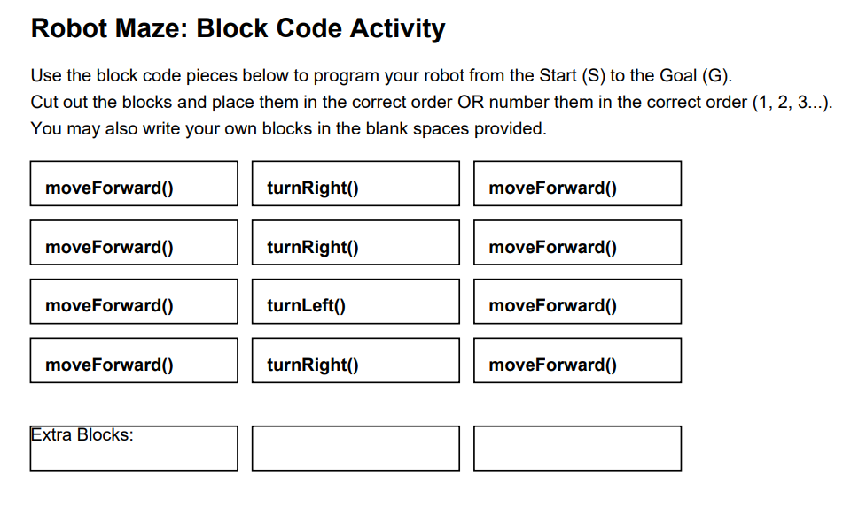

Potential student answer:


