Clean the Dirty Water Student Worksheet
Phase 1: Introduction and Ask
Introduction Activity

You and your partner are walking down the street and come across a pond of dirty water sitting on the sidewalk after a day of rainstorms in your city.

- What type of items/things would you see in the water to make it look dirty?

- How would you remove each item or thing in the water?

The Engineering Design Challenge
You are a team of chemical and environmental engineers. Your mission is to design a filtration system to clean dirty water from a local water source in your city using inexpensive materials. The goal is to obtain approximately 10 mL of clean water.

Engineers use science to solve real-world problems like clean water access. Let’s see how well your design works to clean the dirty water.

Qualitative and Quantitative Observations
Describe the sample using your qualitative observational skills. No tasting the sample!

Sight

Sound

Smell

Touch

Using a piece of pH paper, test the dirty water sample.

Color of pH paper

pH value

Phase 2: Imagine and Plan Your Filtration System
Before putting a filtration system together, you must look at the available materials and imagine what you would use to create it. Below are the available materials to build your filtration system. Your group must use THREE LAYERS, with each layer a different material from the list of available materials. Remember, you will place your filtration system into a large plastic funnel to operate it. The goal is to obtain 10 mL of filtered water.

☐ | Coffee filter | ☐ | Gauze
☐ | Cotton fabric | ☐ | Baking soda
☐ | Cotton balls | ☐ | Untreated sawdust
☐ | Paper towels | ☐ | Grass clippings
☐ | Felt

- Thinking about the design of your filtration system, draw the system to show how you and your partner will layer the materials. In the drawing, identify each layer from the bottom to the top.

- What layers will you use in your filtration system starting from the bottom to the top?
Material Layer 3 (Top)
Material Layer 2 (Middle)
Material Layer 1 (Bottom)

- Why did you choose these layers for your filtration system?

Phase 3: Create Your Filtration System
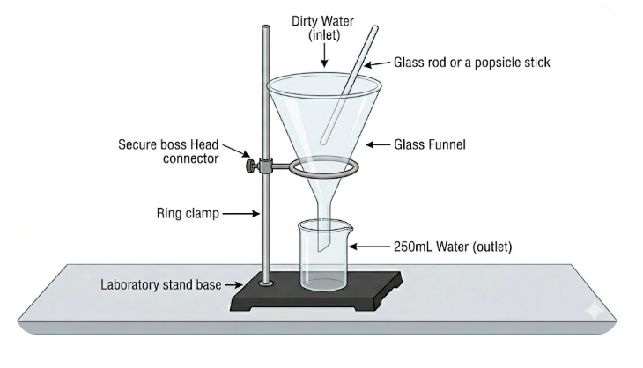
It is time to create your filtration system. You will need the following materials and equipment to set up your filtration system.

Materials
- 1 large plastic funnel
- 1 large 250 mL beaker
- 1 lab stand
- 1 ring support for the large plastic funnel
- chosen filtration materials

Instructions to set up filter and testing apparatus.
- Assemble your selected filtration materials in the large plastic funnel, following the layer order you planned in Phase 2.
- Attach the ring support to the lab stand.
- Place the funnel containing your filtration system securely in the ring support.
- Place the 250 mL beaker beneath the funnel to collect the filtered water. Adjust the height of the ring support, if necessary, so the funnel is positioned securely over the beaker.
Phase 4: Test Your Filtration System
It is time to put your filtration system to the test! You will need the following materials and equipment to test your filtration system.

Materials
- 1 sample of dirty water
- 1 piece of pH paper
- 1 large popsicle stick
- 1 50 mL graduated cylinder

Instructions to test your filter.
- Review the pH of the dirty water that you recorded in Phase 1. Record this value in the data table below as your pH before filtration.
- Before pouring, observe your dirty water sample. Remember that vegetable oil is less dense than water and may float on the surface. Gently stir the sample with the craft stick so the contents are distributed throughout the sample.
- Slowly pour the dirty water into your filtration system.
- Use the craft stick, if necessary, to transfer any soil, sand, or other material remaining in the sample container into the filter.
- Observe your filtration system for approximately 10 minutes as the water passes through it. Pay attention to:
  - How quickly the water moves through the filter.
  - Where particles or oil appear to be trapped.
  - Any changes you notice in the filtration materials.
  - Any problems with the filtration system, such as clogging, leaking, or overflowing.
- After filtration is complete, carefully remove the 250 mL collection beaker from beneath the funnel.
- Observe the filtered water. Record its color, clarity, visible particles, visible oil droplets or film, and any other relevant observations in the data table.
- Test the pH of the filtered water using pH paper. Record the pH in the data table.
- Pour the filtered water into the 50 mL graduated cylinder. Measure and record the volume of filtered water collected.

Qualitative and Quantitative Data
pH before filtering the dirty water
pH after filtering the dirty water
Amount of “clean” water obtained from the filtration system

Describe the “clean water” after filtration using your qualitative data collection methods. No tasting the water!
Sight
Sound
Smell
Touch

Phase 5: Improve and Reflect Like an Engineer
Now that you have tested your filtration system, analyze your results and think like an engineer. What worked well? What could be improved? Use evidence from your observations and data to evaluate your design.

Evaluate Your Design
- What role did each material play in your filtration system? What evidence from your test supports your answer?

- Why did you and your partner choose these materials and arrange them in this order?

- How much filtered water did your filtration system produce? Did you meet the goal of approximately 10 mL?

- Compare your filtered water with the original dirty water. How effectively did your filtration system improve the water?

Compare Designs
- Compare your filtration system and results with those of another group.
  - What did the other group(s) do differently than your group?

  - How did the other group's results compare with your results?

  - What can you learn from the other group's design and results?

Improve Your Design

Connect to Real-World Engineering

- Why is it important to create a water filtration system to clean the water you drink from your faucet at home?

- Why do you think chemical and environmental engineers are important in real life?

Extension
Using your student-issued laptop or personal device, research the following questions to make connections to the creation of your water filtration system.

- How does this activity relate to real water treatment plants?

- What are other examples where chemical and environment engineers solving global problems?

