Sample Graph

1. Complete the following table with the data gathered from the test strips.
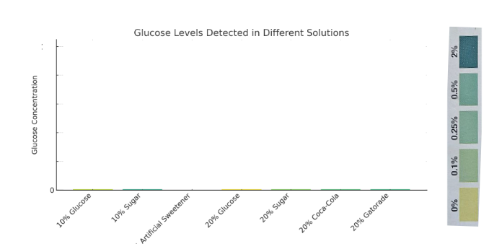

2. What patterns do you see in the graph? What conclusions can you draw?

