Get in Gear Post-Activity Quiz
- Define the following words.
Speed:
Torque:
Gear train:
- Compute the gear ratios illustrated below:
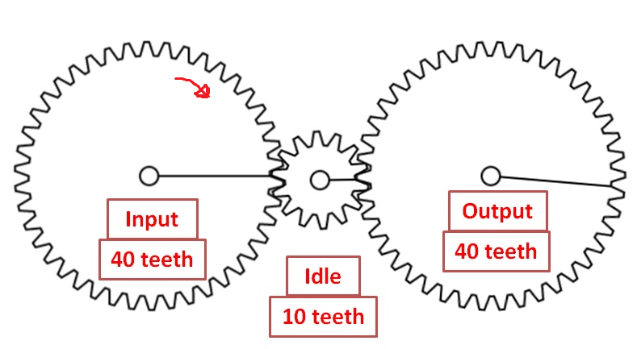 | Gear ratio:  Circle the correct direction of rotation for:  Idle gear:  Output gear:
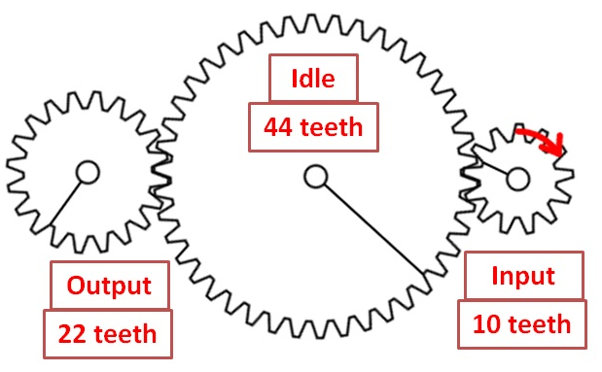 | Gear ratio:  Circle the correct direction of rotation for:  Idle gear:  Output gear:
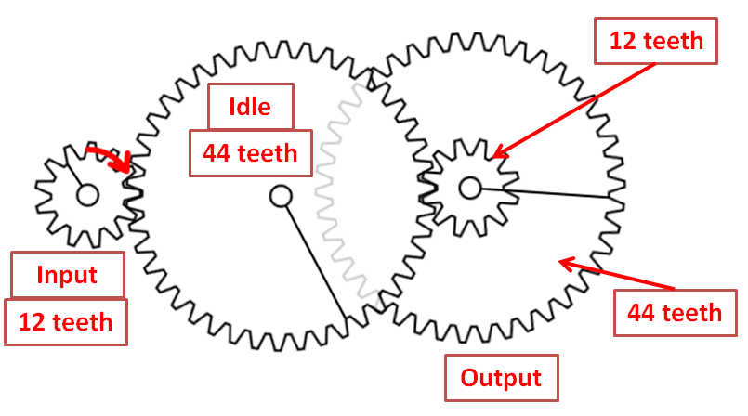 | Gear ratio:  Circle the correct direction of rotation for:  Idle gear:  Output gear:
- In the gear assembly diagrams below, which one produces torque? _____
Which one produces speed? _____ Which one is neutral? _____ (write the correct letter)
A | B | C
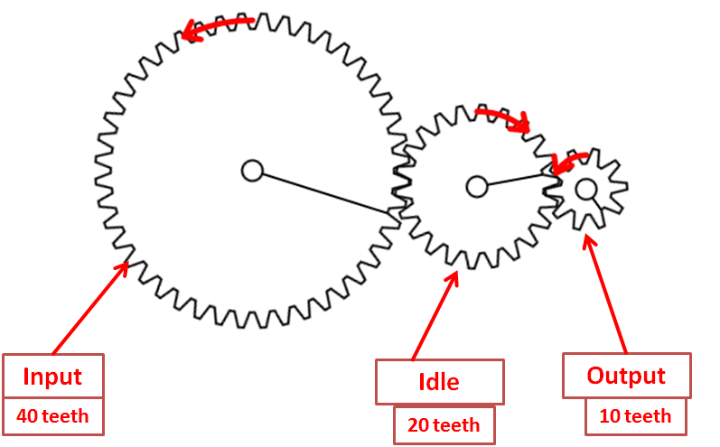 | 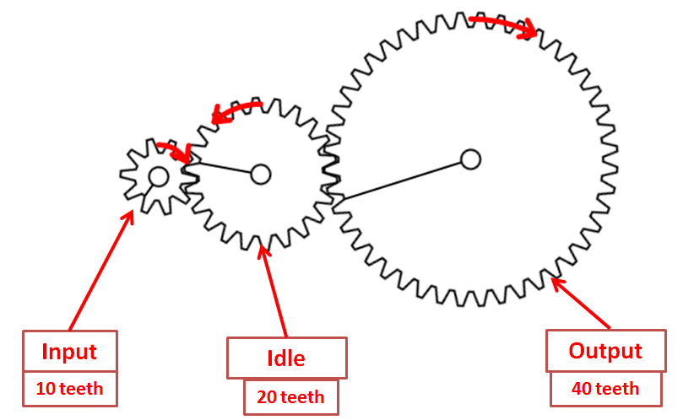 | 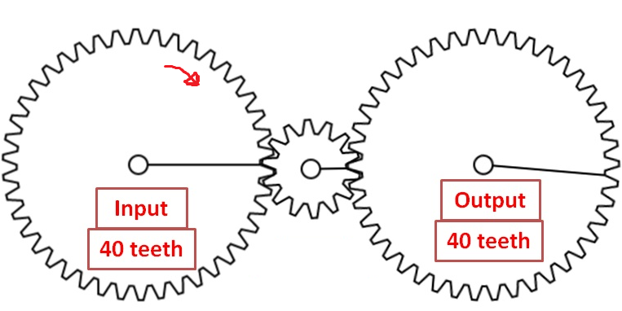
- As an engineer, you want to design a racing car, but you only have gears with 8, 24 and 72 teeth. The maximum power speed the LEGO EV3 motor can delivered is 100 and you want your robot to move at a power speed of 300.
- What gear ratio do you need for the robot transmission?

- Which gears can you choose for the transmission?

- How do you arrange the gears in the gear train? Draw a picture to illustrate.
- As an engineer, you want to build a powerful bulldozer robot. Using the standard EV3 motor, you can only push a half-pound object. Available are gears with 8, 24 and 72 teeth. You want to build a transmission with a high torque that can push a 4.5-lb object.
- What gears ratio do you need for the robot transmission?

- Which gears do you choose for the transmission?

- How do you arrange the gears in the gear train? Draw a picture to illustrate.

