Elevator Building Guide
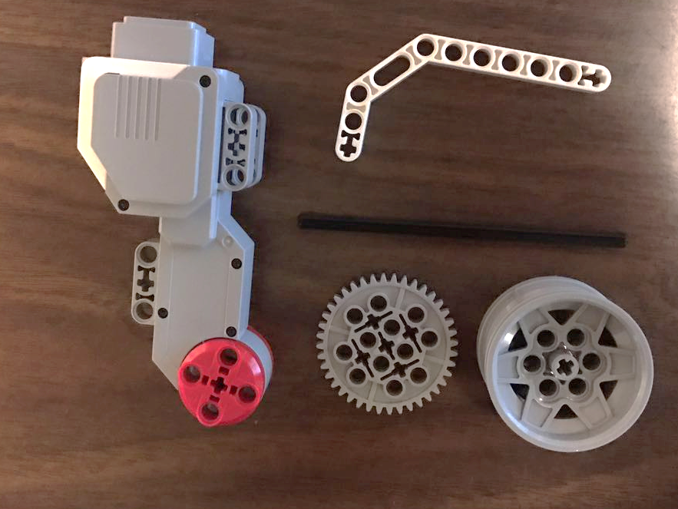
- To construct the elevator motor, obtain the following LEGO pieces.

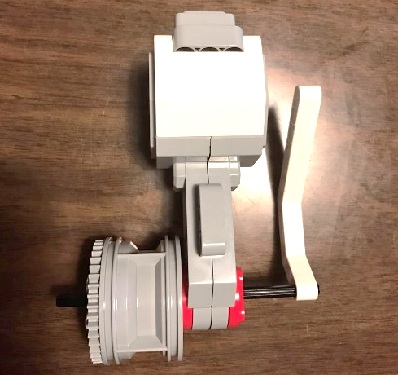
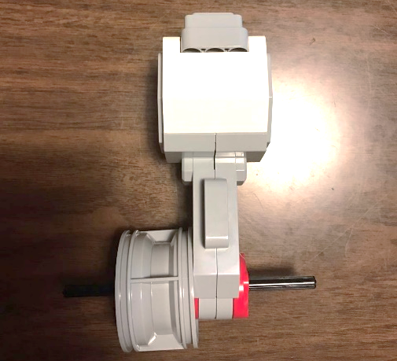
- Build using the LEGO pieces.

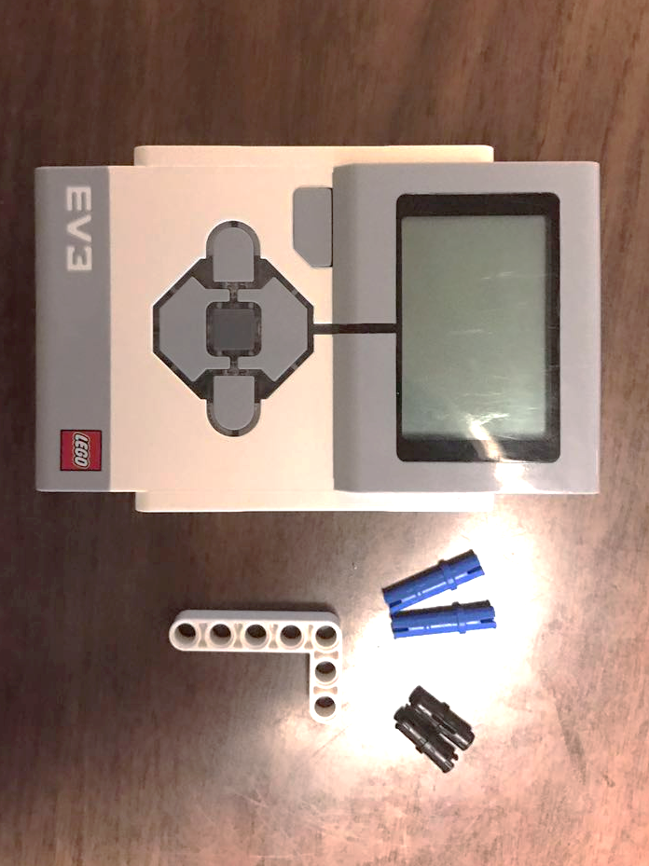
- To create a mount for the elevator motor, obtain the following pieces.

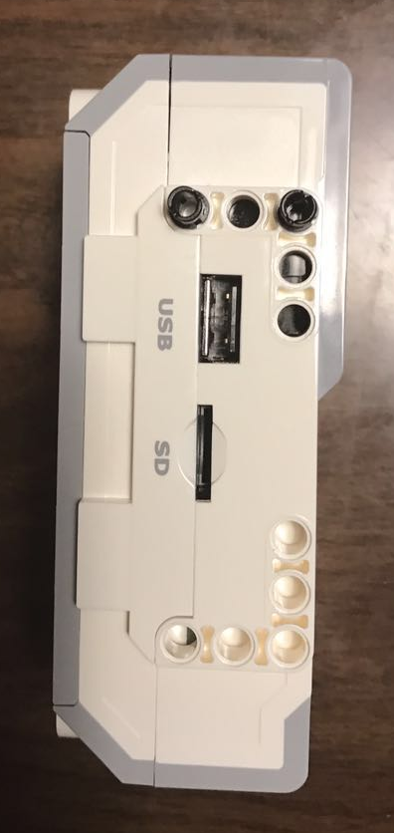
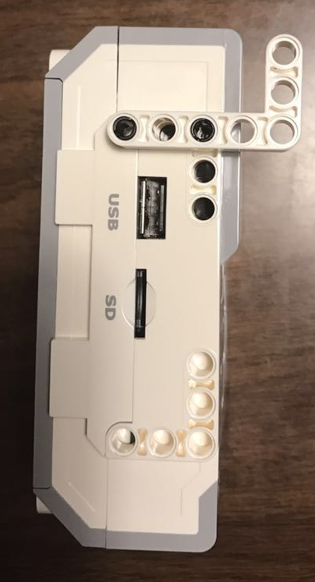
- Build using the LEGO pieces.

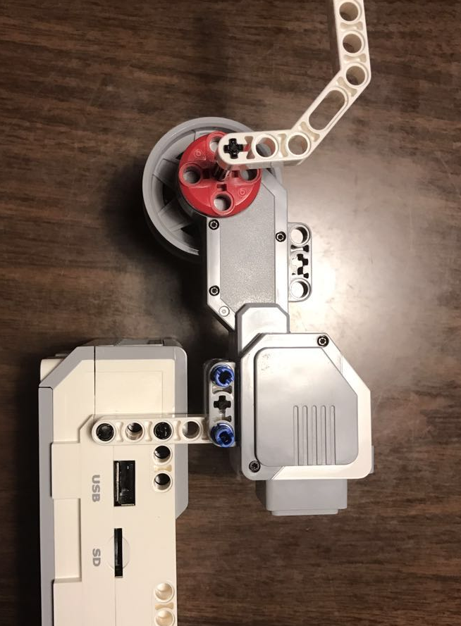
- Attach your motor, as shown, using the LEGO pieces.

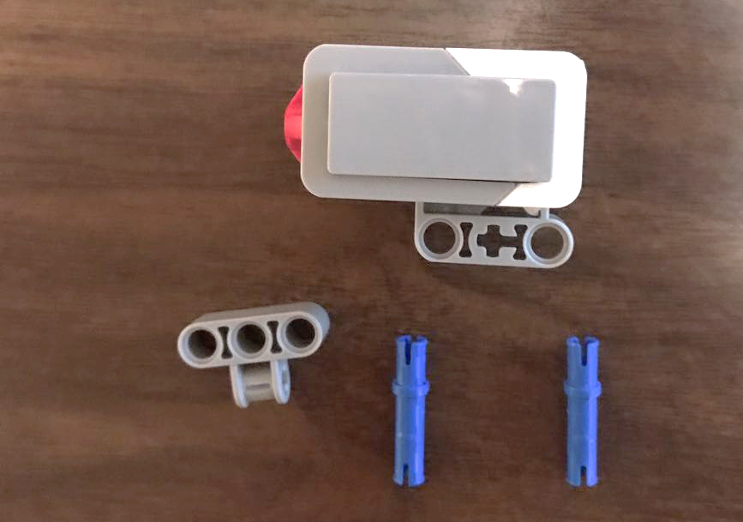
- To construct the elevator button from a touch sensor, obtain the following LEGO pieces.

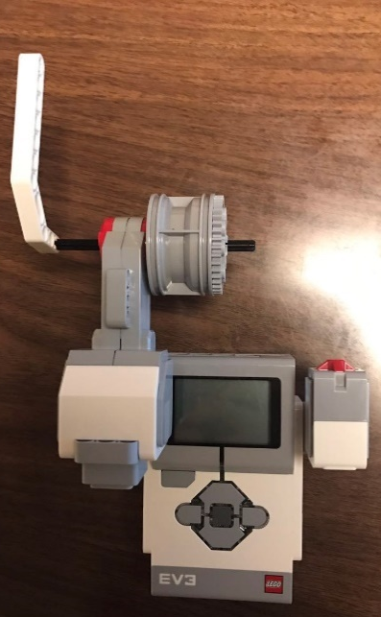
- Build using the LEGO pieces.
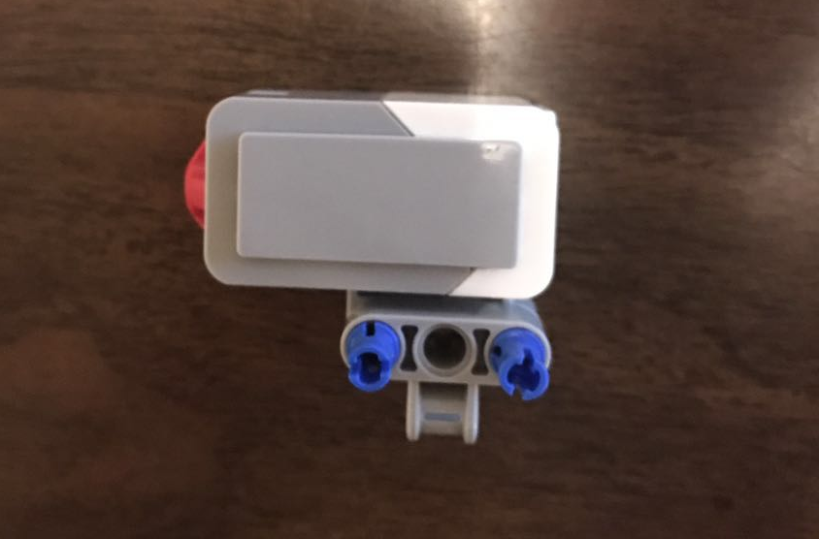

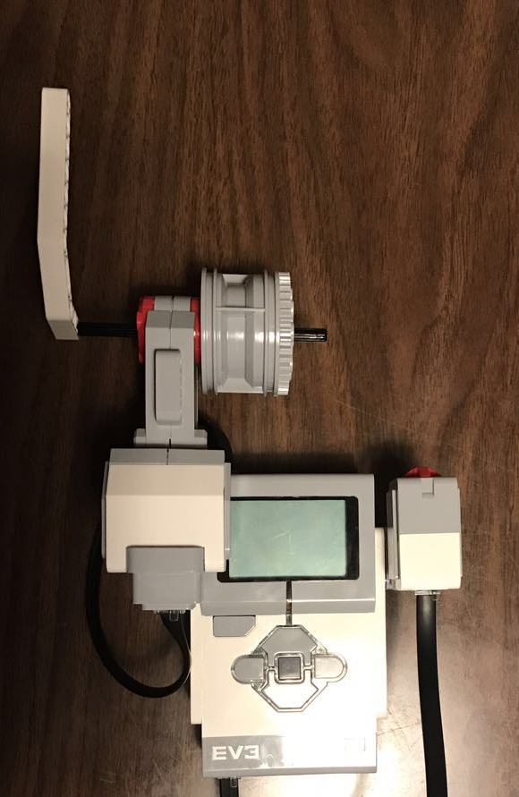
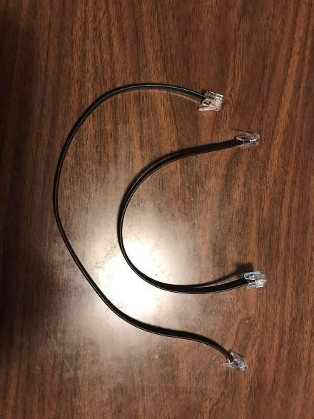
- Attach the cables to the sensor (use port 1) and motor (use port A).

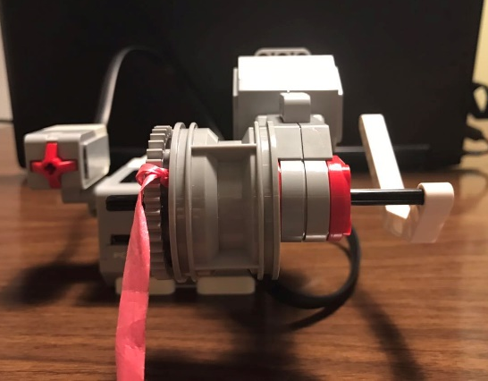

- Attach your designed elevator box and cable to the gear, as shown below.

- Use the handle on the motor to move the elevator up and down.
