The Car with a Lot of Potential Activity –
Vehicle Building Instructions
The following step-by-step instructions guide you through the process of building LEGO® vehicles so that, using them, students learn about potential energy.
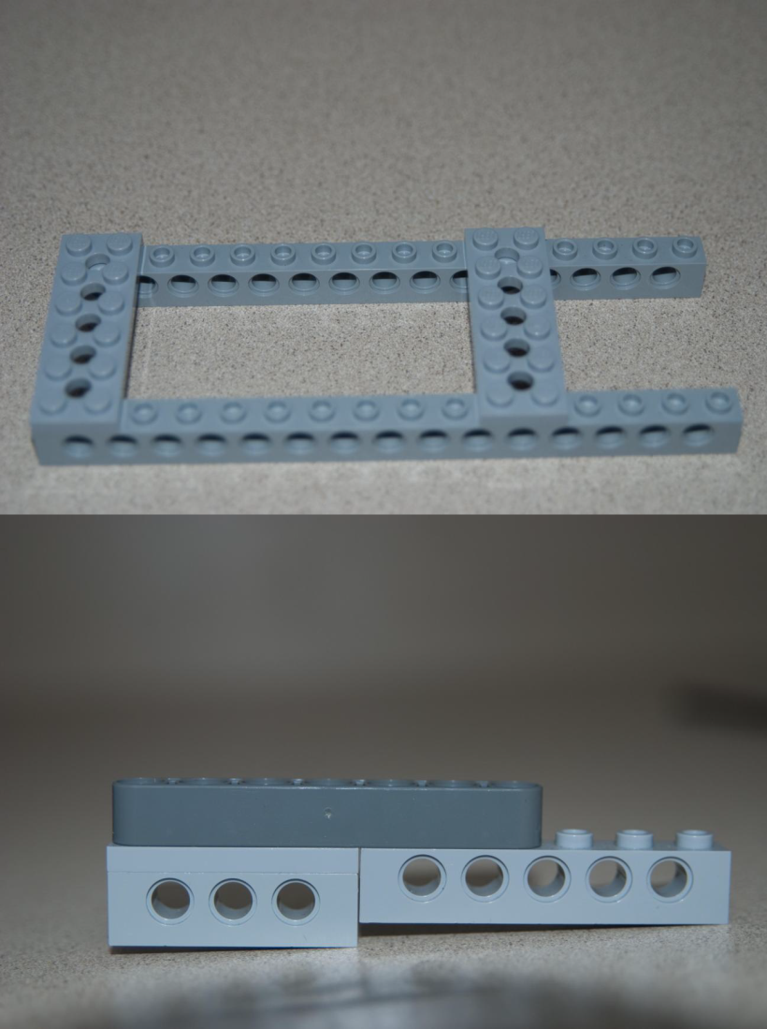 | - Build the base of the car, as shown at left.
 | - Build one side of the car.
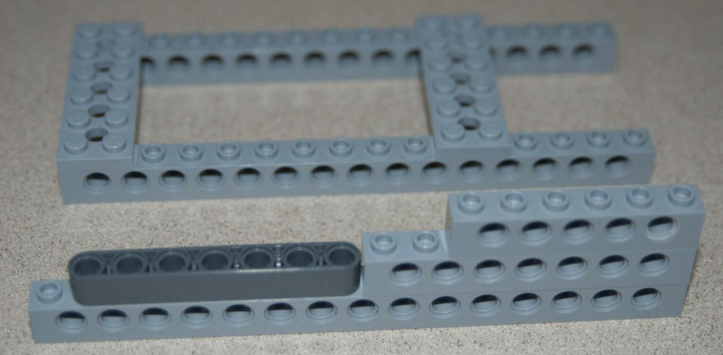 | - Build the second side of the car.
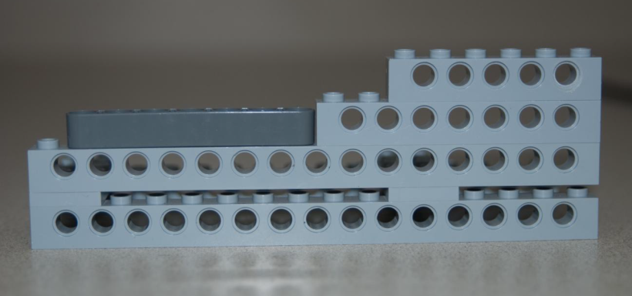 | - Attach that side to the base from Step 1.
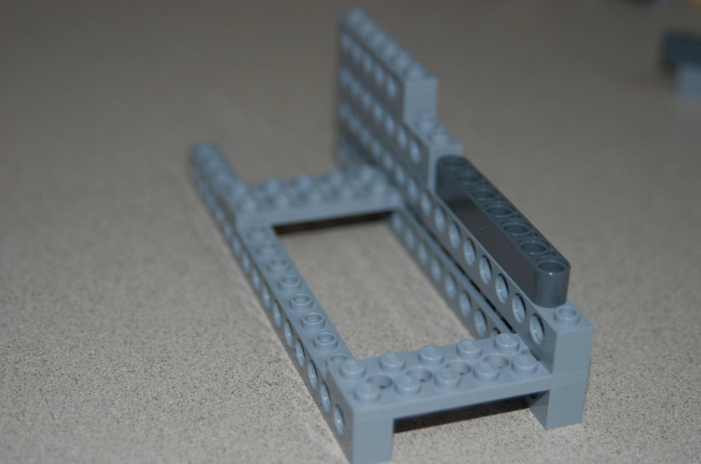 | - The base should now look like the image at left.
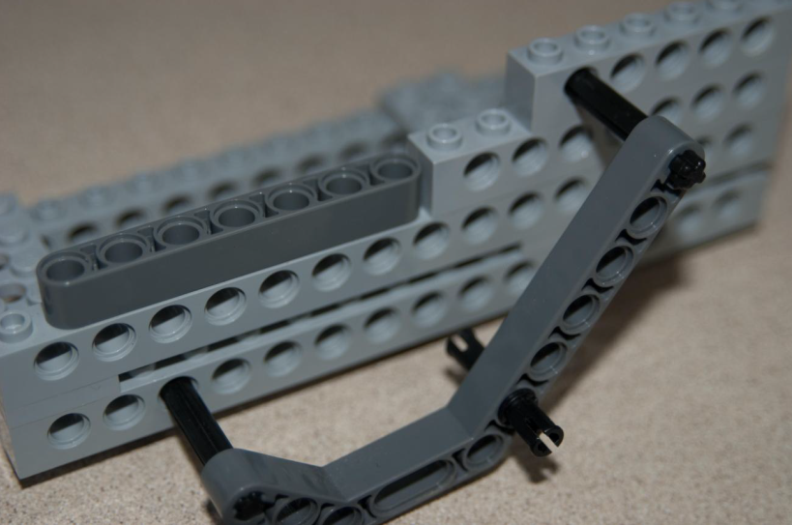 | - Attaching a support, as shown.
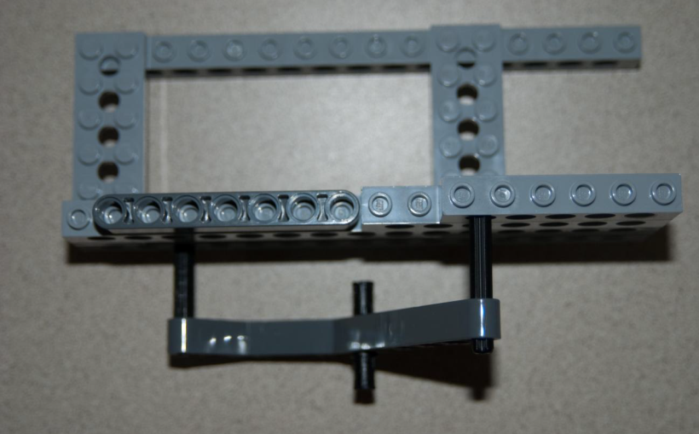 | - Shown is the base from the top, with support attached.
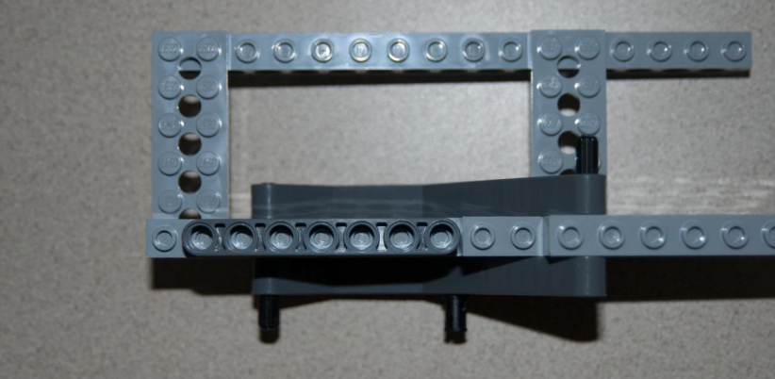 | - Attach another supporting beam on the inside (see image at left).
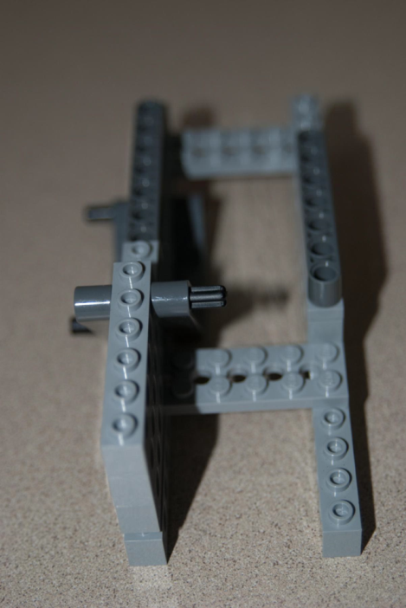  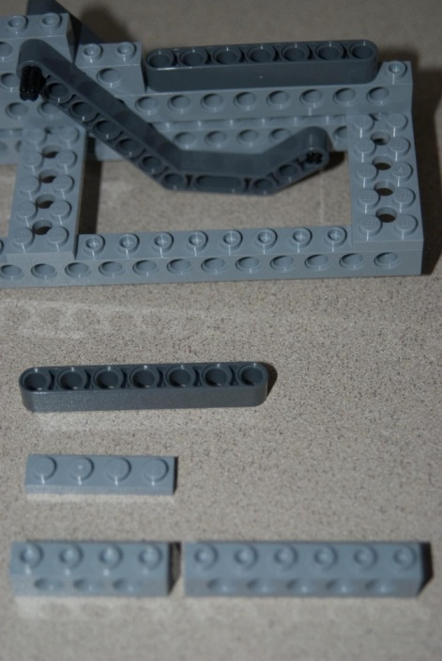 | - Construct the supports for the second side, as shown.
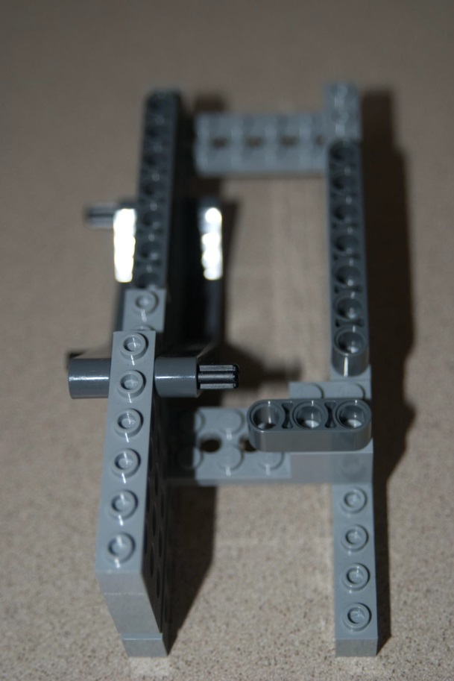 | - Create the piece shown (inset) and attach it to the base of the car, as shown.
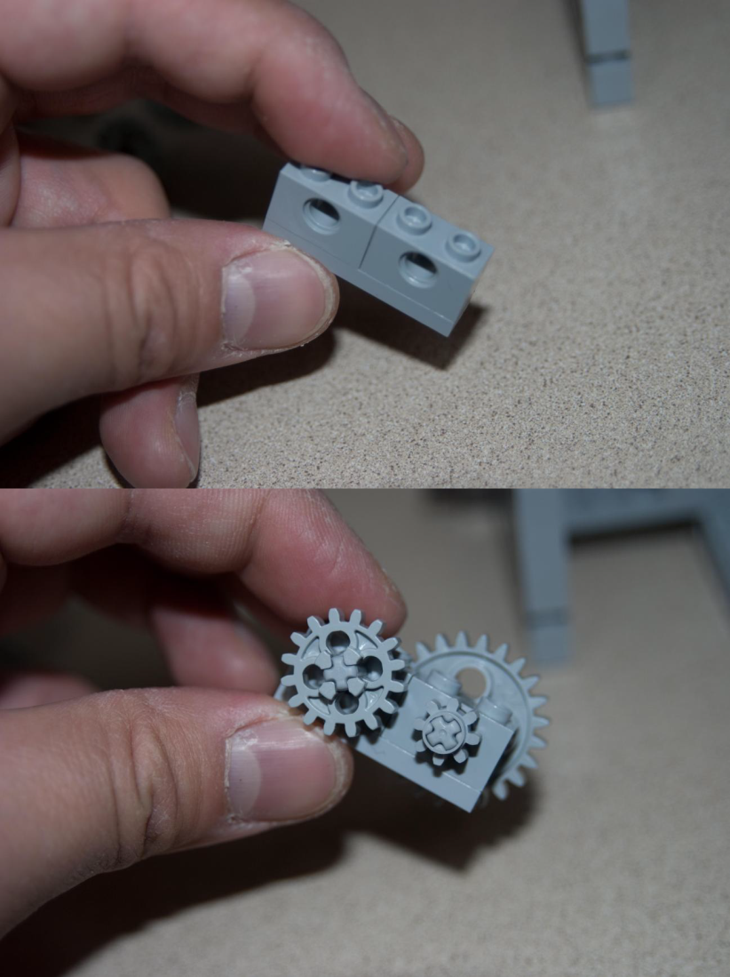 | - Create the gear box by starting with the pieces shown at left.
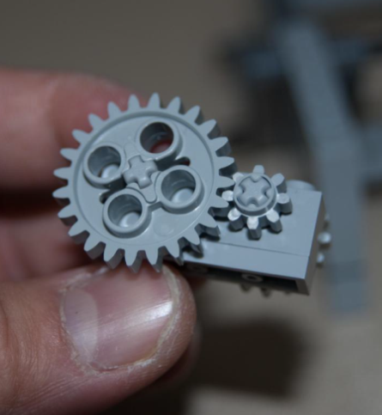 | - Add gears to the first side and then the other side.
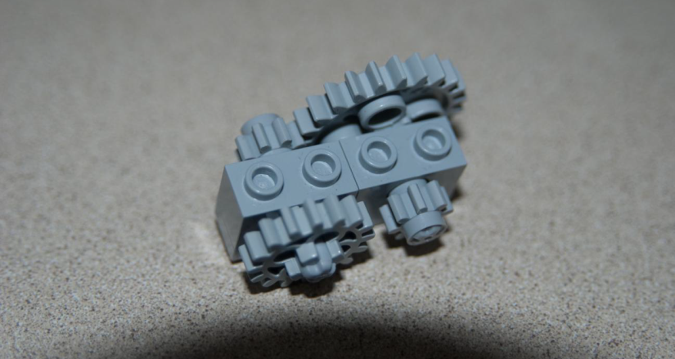 | - From the top, the gear box should appear as shown at left.
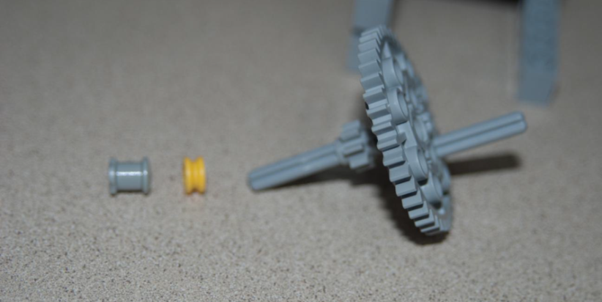 | - Construct an additional gear on an axle, using the pieces shown at let.
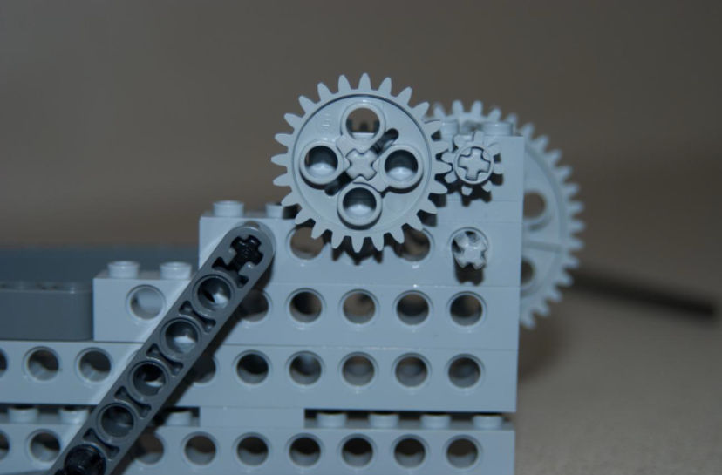 | - Attach the additional gear to the gear box. Attach the fully assembled gear box to the car.
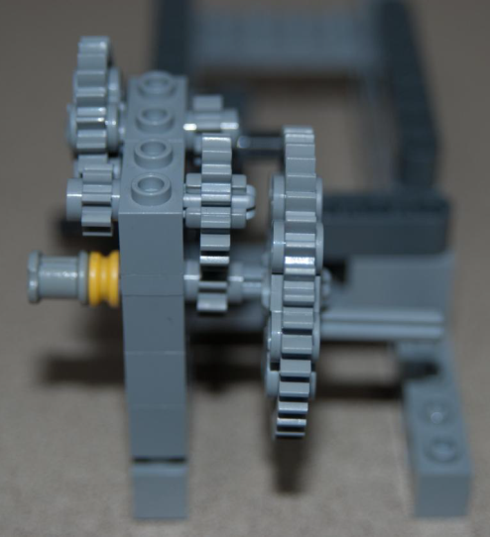  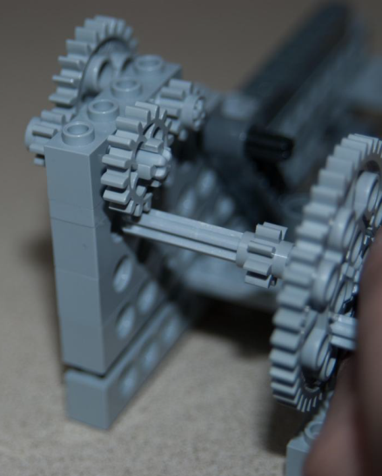 | - Refer to the two images at left for proper constructing and attaching of the gear box to the car.
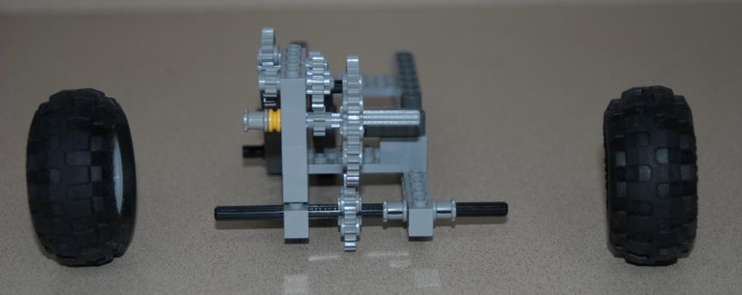  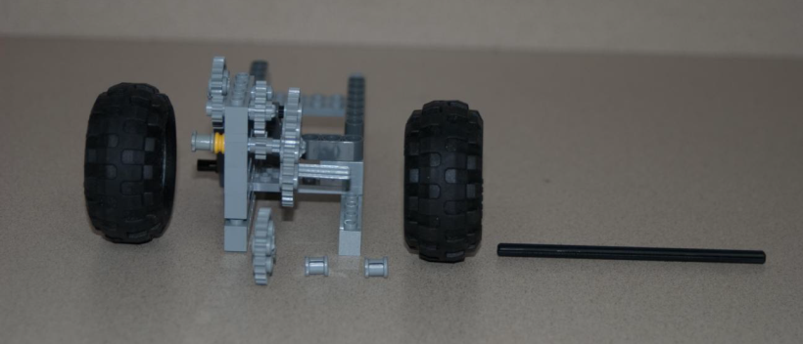 | - Add wheels to the gear box using the pieces shown at left.
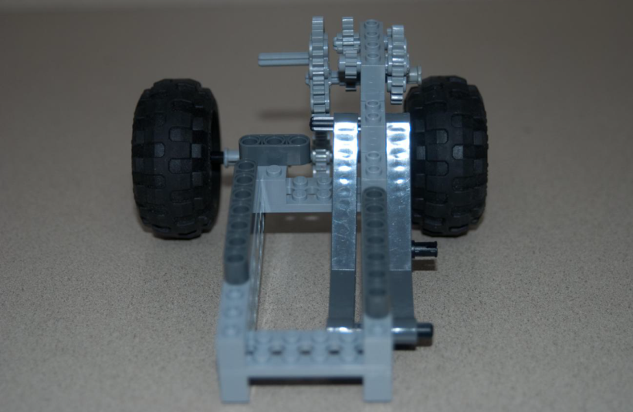 | - The car base should look like the image at left.
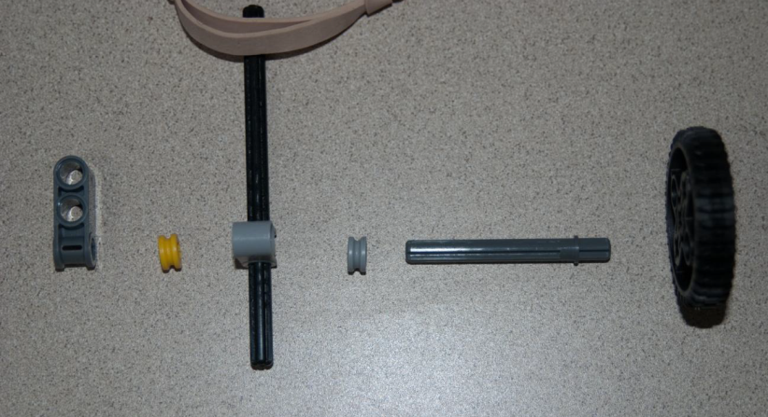 | - Using the pieces shown at left, construct the engine.
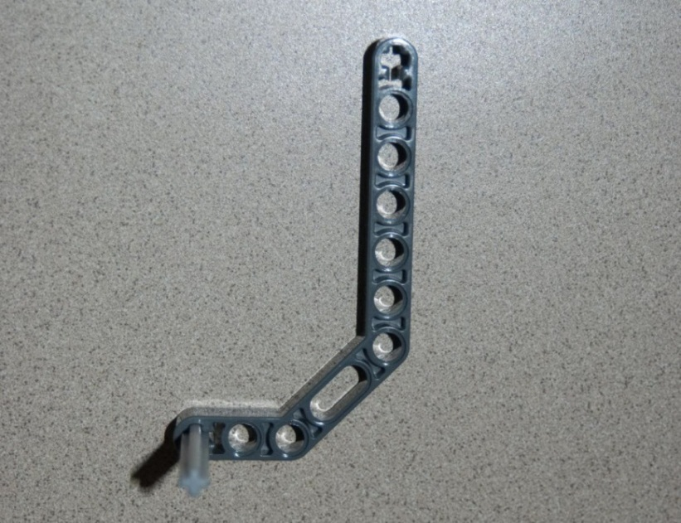 | - Use a beam piece to add an axle piece to your vehicle.
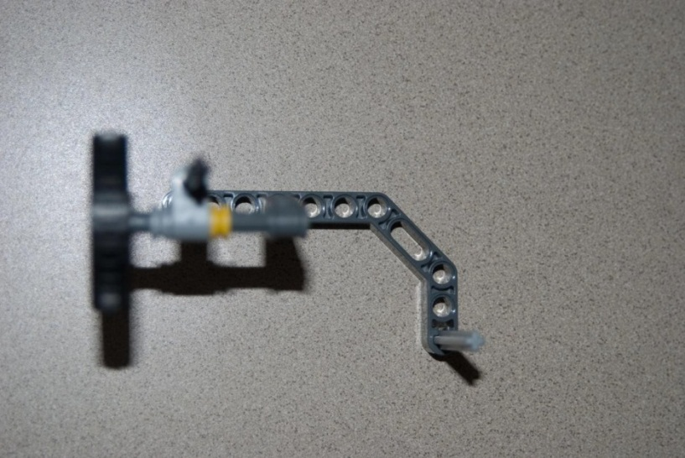 | - Add the engine parts (from Step 19) to the axel.
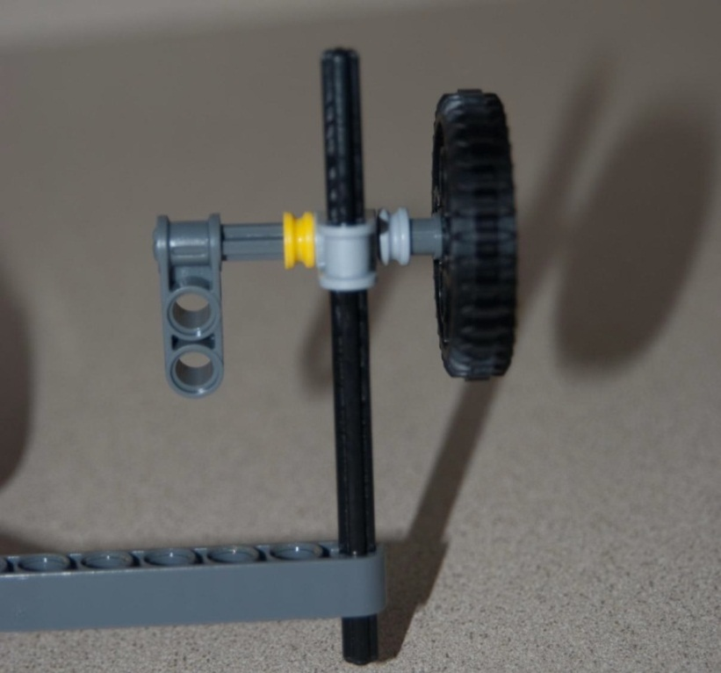 | - Shown at left is a view of the car from the side.
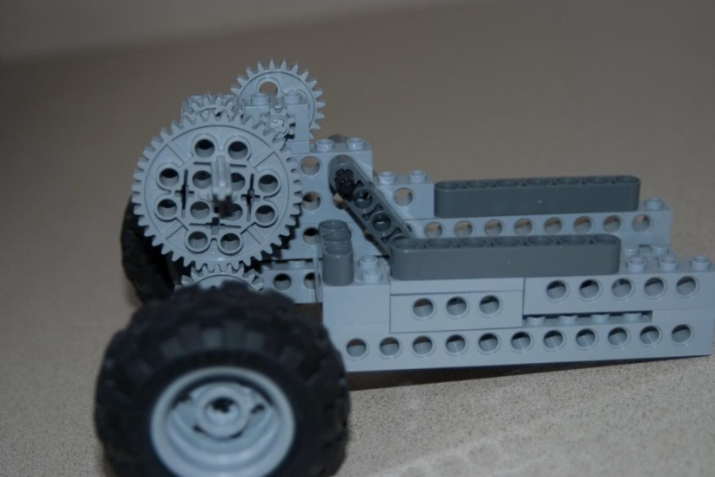 | - Arrange the car on a desk as shown in the image at left.
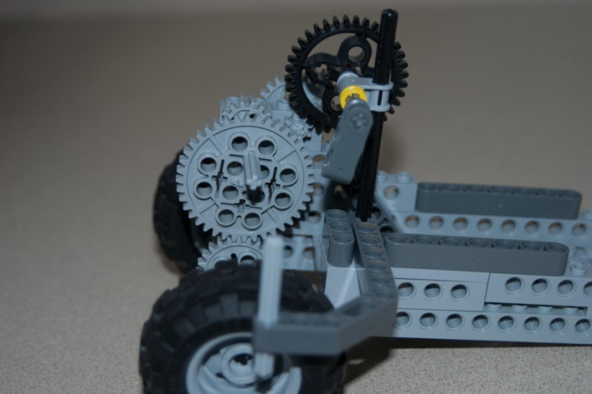 | - Add on the parts for the engine (from Step 22).
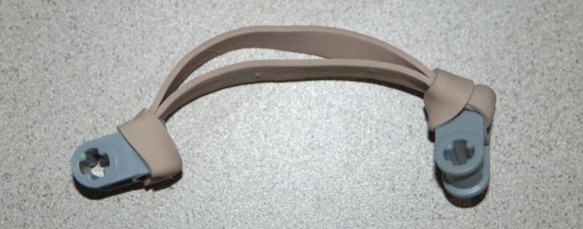  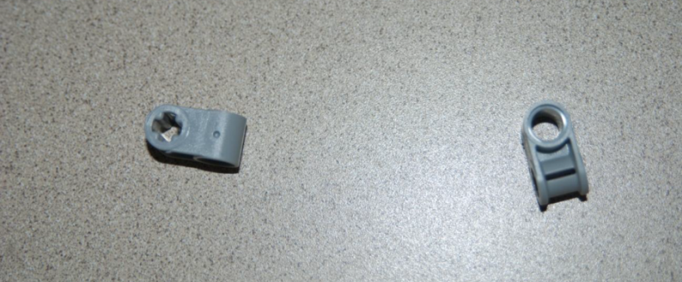 | - Using the following pieces, add a rubber band, as shown at left.
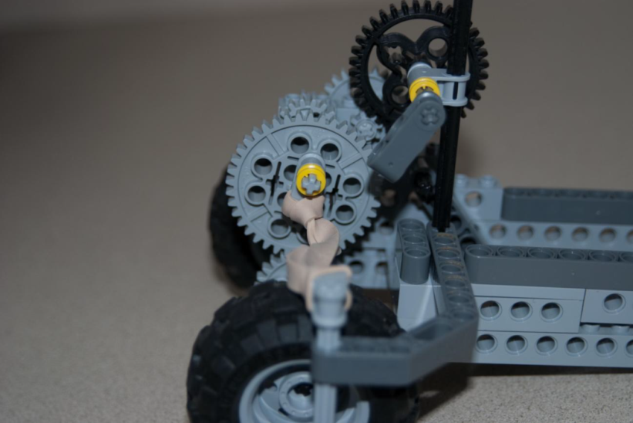 | - Add the rubber band component to the engine, as shown at left.
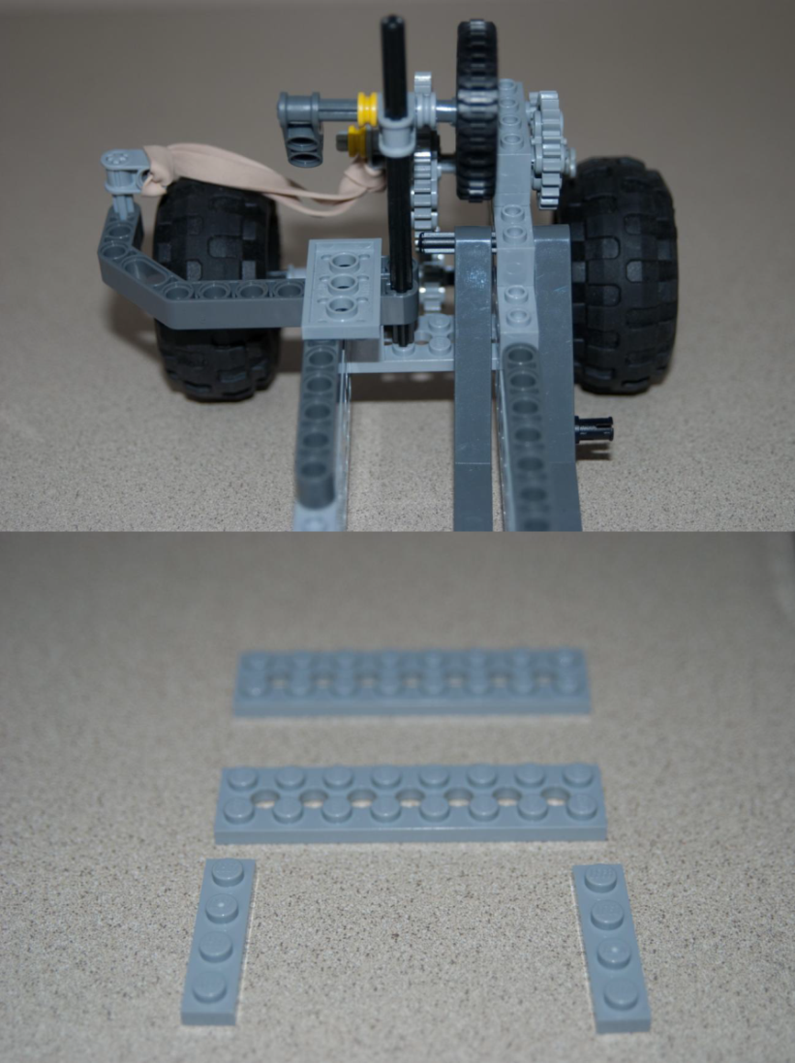 | - Shown is the assembled rubber band/axle view from the front of the car.
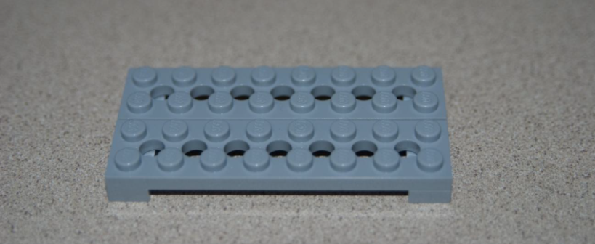 | - Using the following pieces, assemble them as shown at left, bottom.
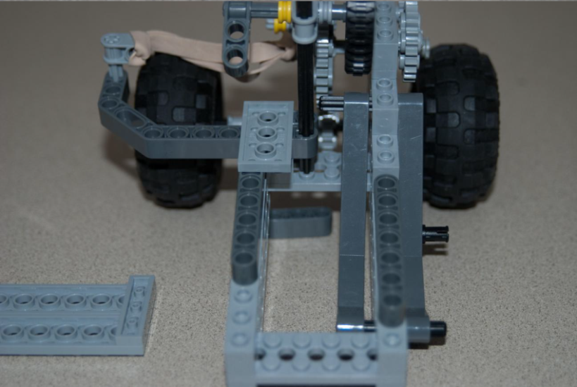 | - Arrange the car on a desk as shown in the image at left.
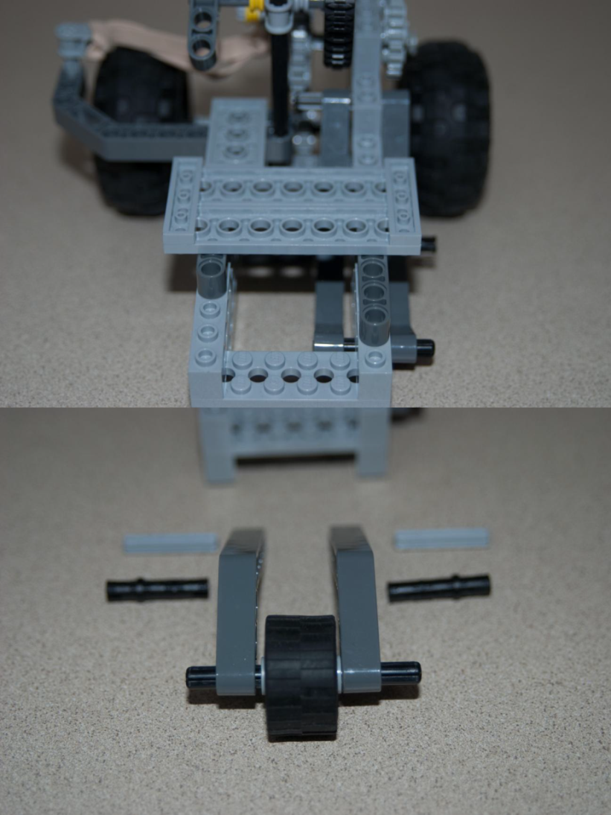 | - Add the parts to the car as shown at left.
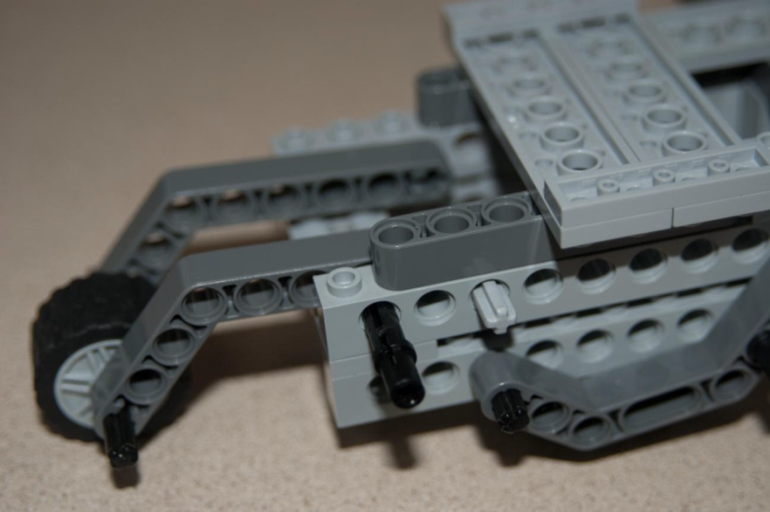 | - Using the parts shown at left (top), assemble the front wheel. Find the following parts and assemble it on the car, as shown at left (bottom).  Note: This is the caster wheel; it is used for the car’s stability.
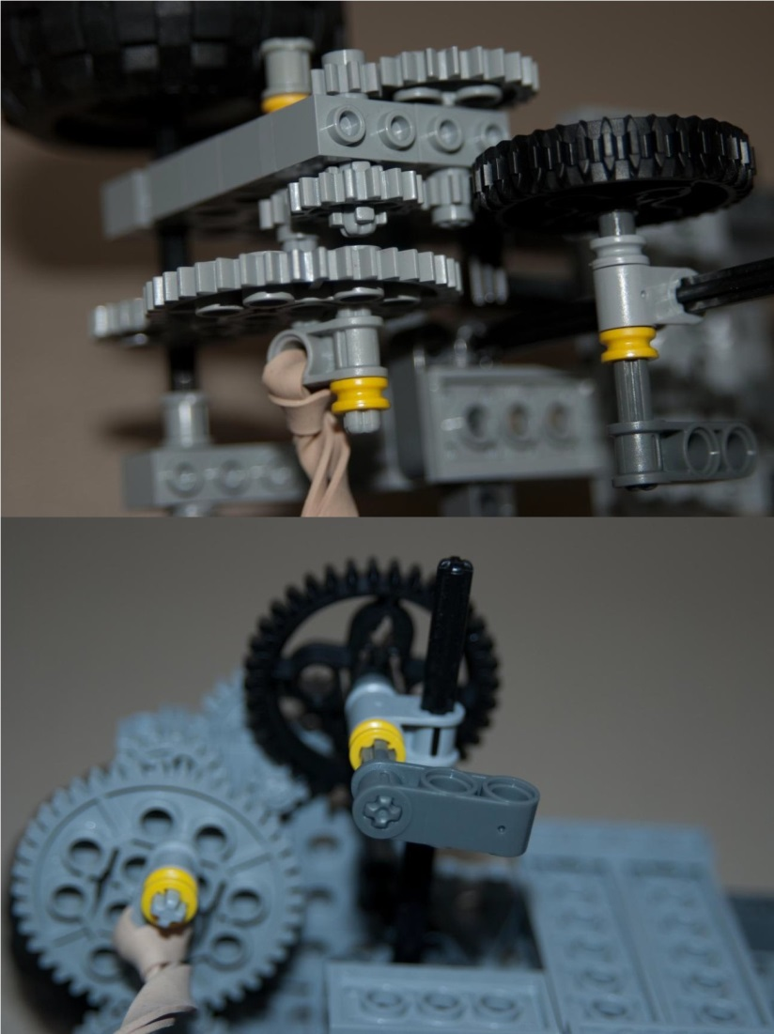 | - Check the gear train is properly connected before testing/operating the vehicle.
 | - Turn the handle to add elastic potential energy into the car.

