Stream Table River Modeling Activity

Introduction: Running water flows downhill due to the pull of gravity. The rate of channel abrasion varies from stream to stream, depending on factors such as discharge, channel characteristics, and supply of rock fragments.

The velocity of a stream depends on its discharge and its change in elevation. Higher discharge levels are associated with higher erosion and deposition, which can change the course of the river over time. According to NASA, “The trough carrying the north-flowing Red River decreases in elevation only 40 meters (130 feet) from Fargo to the Canadian border over a straight-line distance of 235 kilometers (145 miles).” Calculating the approximate angle formed by the change in elevation gives an angle of 0.0097 degrees. Rivers that have a smaller change in elevation tend to meander. One feature of a meandering river is when it changes course and cuts off a section of the river, forming a body of water called an Oxbow Lake.

The Red River Flood Plain (nasa.gov)
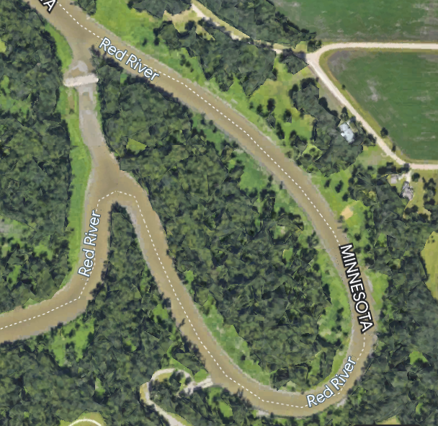

Pre-Lab Directions:
Navigate to Google Earth. Locate the Fargo-Moorhead area and zoom in until you are able to find the location of an oxbow lake. Once you locate an oxbow lake, take a screenshot of the location and insert the screenshot below. Draw an arrow to indicate the original course of the river before the oxbow lake was formed.

Using Google Earth, identify a section of the Red River within the Fargo-Moorhead area that appears to be in the early stages of developing an oxbow lake. Take a screenshot of this location and insert it below. You will use this screenshot as a guide to help you develop your model on the stream table.

Objective: Model the section of the Red River that you identified in your Pre-Lab procedure. Using evidence and reasoning, defend the claim that seasonal floods can increase the abundance of mosquito breeding habitat.

Materials:
- aquarium sand
- stream table
- water
- stopwatch
- camera
- ruler
- pencil
- funnel
- extra tubing
- duct tape or zip tie
- 2 500 mL beakers
- laptop, iPad with Internet access
- (optional) pitch locator

Procedure 1: Setup and normal river discharge
- Find the stream table at your lab station. Using your ruler, spot check throughout the stream table to ensure that your sand is level and has a uniform depth.
- Using the screenshot that you captured using Google Earth (or the image above), model that section of the Red River in your stream table as accurately as possible. Ensure a uniform width to your riverbed by using two fingers to create your riverbed.
- After creating your riverbed, activate the pump and allow water to flow through the system for a period of 10 minutes. During this period, you will gather qualitative data by capturing an image of the riverbed conditions every 2 minutes.
- After your 10-minute period has elapsed, capture a final image of your riverbed. You will now turn the pump off to stop the flow of water.
- Review the images that you captured. Identify the image that best demonstrates the process of erosion and deposition and attach the image below. Draw an arrow with labels to indicate at least one area of your riverbed that demonstrates the process of erosion and another area that demonstrates deposition.
Procedure 2: Modeling a flood - increase discharge levels

- Find your funnel and ensure the length of tubing is secured tightly using either tape or a zip tie.
- Ensure that you have two 500 mL beakers at your lab station and fill both with water.
- Assign roles for this phase of testing to each group member. One person will be responsible for holding the funnel and tubing in place next to the original discharge from the stream table; one person will be responsible for slowly adding water to the funnel; and one person will be responsible for filling the beakers as they are emptied.
- Your group will then turn the pump back on and begin adding water to the funnel. This will increase the discharge level of the system, modeling the conditions present in a seasonal flood.
- You will maintain these flood conditions for a period of 2 minutes; once the time has elapsed, you will capture a final image of your riverbed system that you can compare to the final photo from the normal discharge conditions.
- Attach the final image from each phase of testing side by side below. In the post-flood image, indicate any areas that have experienced increased erosion by circling them. Indicate areas that experienced increased deposition by drawing an arrow pointing to them.
- Finally, draw a rectangle around any areas that have developed as favorable breeding habitat for mosquitos. When you identify these areas, explain the features of that location that make them suitable as breeding habitat for mosquitoes.
- As a group, ensure that your stream table is returned to the condition in which you found it. Use your ruler to level the sand within the table. Ensure the sand is a uniform depth of between 1 and 1.5 cm. Make sure the sand is as level as possible.

Discussion Questions

- What is the relationship between discharge and rates of erosion?

- The Red River experiences an increase in discharge most years at some point between March and May. Speculate what causes this increase in discharge.

- Using the pitch locator or the formula rise/run = slope, calculate the approximate angle of the stream table’s slope.

