River Maps Worksheet

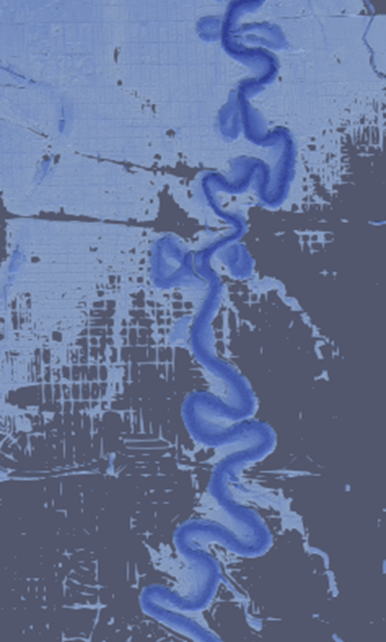
Instructions: Below are two rivers: the Red River (United States) and the Ucayali River (Peru). Examine the two images and answer the questions that follow.
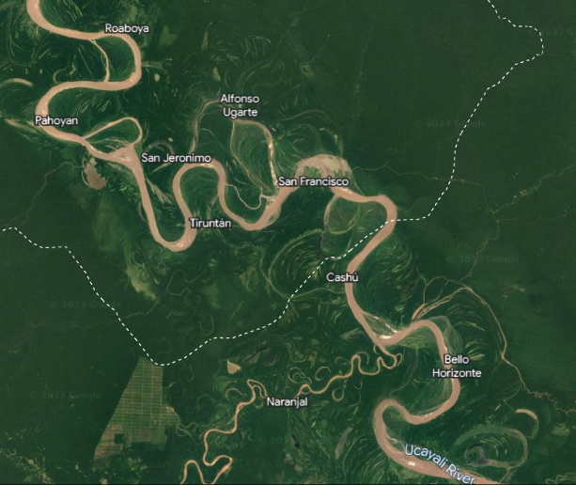
Image Source: earth.google.com

Image Source: ParaView
1. In a few sentences, describe how these two rivers are similar.

2. In a few sentences, describe how these two rivers are different.

