Student Instructions
Digital Circuit
- Go onto the Tinkercad website (www.tinkercad.com) and log in. Then, go under Tinkering to open up the Circuits and click on Create.
- Select Arduino under the Components tab on the right-hand side of the screen.
- Scroll down and select the LCD and drag it onto the platform.
- Add LED lights, resistor, and a breadboard to your circuit. All of these need to be plugged in on the same terminal strip and not go over the center divider. The LED lights should be in the same rows; they are labeled with numbers. You may need to bend the anode wire of the LED lights so that the two ends are the same length.
- Connect the LED lights and resistor to the breadboard and the breadboard to the Arduino.
- The resistor needs to line up with the anode side (longer wire) of the LED lights in another row. Bend the resistor wires to “plug” into the breadboard.
- The other side of the resistor needs to be in the same column (letter), so your resistor is perpendicular to the LED lights.
- Connect a wire to the breadboard in the same row as the resistor (number should be the same, but different letter) and drag that wire to one of the pin numbers on the Arduino (e.g., 12).
- You will need another wire that is in the same row as the cathode of the LEDs and drag it to the negative power rail.
- The breadboard needs to get connected to the Arduino for power. Drag a wire from the negative power rail of the breadboard to the ground on the Arduino. Drag a wire from the positive power rail of the breadboard to the 5V.
- Now you are ready to code. Click on Code in the top-right corner.
- Select Blocks + Code if you don’t have text coding experience. This will open up both forms of coding.
- Using the blocks, code the LCD screen to flash a countdown from 30 to 0. Please note, some of the code will already be there. (The text code will update as you use the blocks portion to code.)
- On start, change the message on the print to “Don’t be tardy” (or whatever message you will be displaying).
- Add an output of turning on the backlight of the LCD screen.
- Add a variable—seconds to 30.
- Add a control of wait for 1 second.
- Under the Forever code, add a control to repeat while the seconds are greater than or equal to 0.
- Change the output code that is already there for the LCD from “turn on the backlight” to “turn on the display”.
- Change the control from 500 milliseconds to 1 second.
- Add another output of set position of LCD screen to column 0 row 0.
- Add output on LCD 1 to turn off the display.
- Then add output on LCD 1 clear the screen.
- Add output print to LCD 1 “Don’t be tardy.”
- Add control of wait 1 second.
- Change variable by -2 seconds.
- Code for the LED lights to flash synchronously with the 30-second countdown.
- Under the “Forever” code section, add an output set pin 12 HIGH (or whatever power pin is connected to the LED lights) right below the print to LCD output.
- Under the second portion of outputs in the forever code, add output of set pin 12 LOW under the output LCD clear the screen.
- Test your design on Tinkercad and make changes as needed. If everything is correct, you will see the simulator work; the LCD screen will flash a countdown of “Don’t be tardy,” with the time counting down by 2s from 30 to 0. The LED lights will blink on and off with the countdown. See Figure 1.
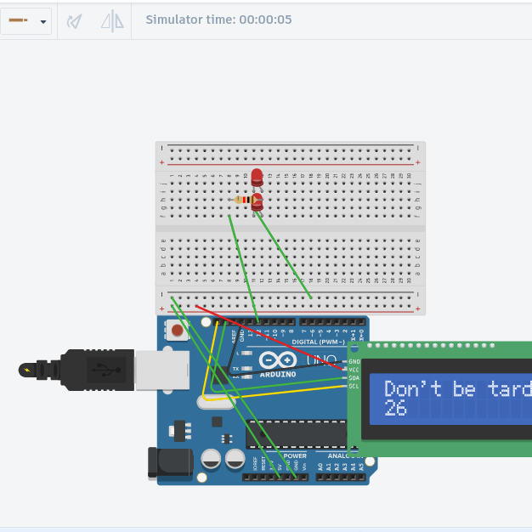
Figure 1. Working simulation.

Physical Model
- After your setup works on the simulation, make a physical model of the Arduino circuit using the simulator to help you see how it should be put together. See video tutorial for help.
- Make sure you have installed the driver per instructions on the create.arduino.cc "downloads" website. Do not proceed until this step is completed. On Chromebooks, go to the Chrome Webstore and search for Arduino Create for Education. Install and then open the app and create an account.
- On the Arduino site, click on New Sketch.
- Go back to Tinkercad. GO IN THE BLOCKS AND CHANGE THE SERIAL COMMUNICATION NUMBER from I2C (MCP23008) to I2C (PCF8574) and copy the Text code. (IF YOU DON’T DO THIS, YOUR CODE WILL NOT BE RECOGNIZED BY THE LCD SCREEN.)
- Paste it in the Sketch box on the Arduino site.
- Find the Text code that lists the LiquidCrystal variable settings. Change the first number in the parentheses from 32 to 0x27. THIS IS NECESSARY; OTHERWISE, THE LCD SCREEN WILL NOT DISPLAY YOUR MESSAGE! See Figure 2.
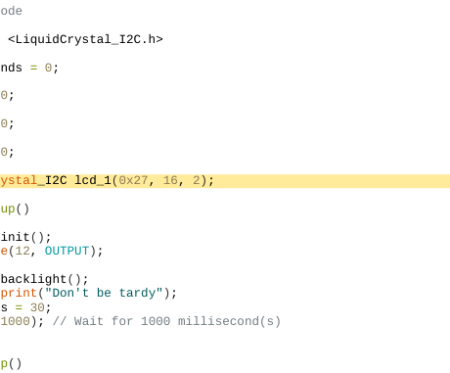
Figure 2. Where to change the variable settings on the Arduino site.
- Connect the physical circuit to the computer with a cord to the USB outlet.
- Click on the dropdown menu to select Arduino Uno (if it doesn’t do it automatically).
- Click on the arrow to the left of the dropdown menu to upload the code to your physical model.
- Your circuit should duplicate what the simulation showed. If not, check to make sure all of the wires are connected securely and in the correct areas. See Figure 3.
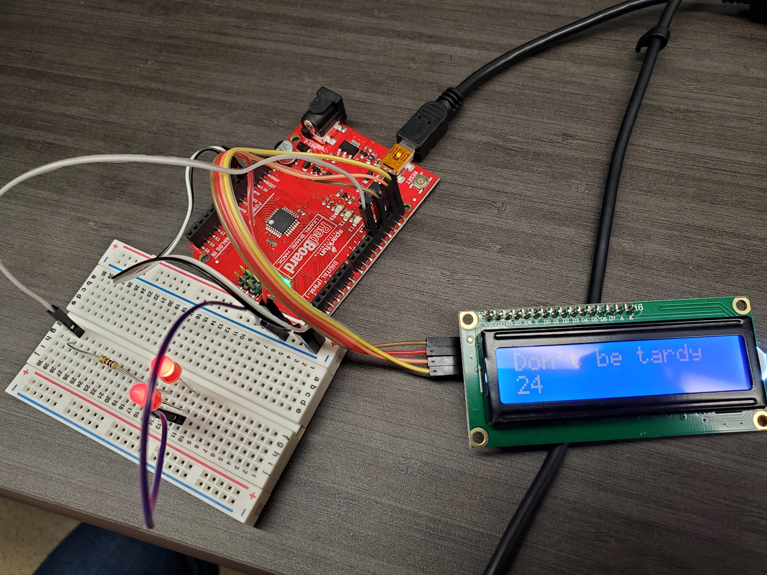
Figure 3. Physical model of the working Tardy warning system.

