Intro Activities Worksheet
Understanding the Science and Mathematics

Note: You may use the definitions to help you complete the activities below.
Activity 1: Discovering Nondestructive Testing (NDT)
You are not permitted to look under the cover. Each solid is labeled with a number, 1-10.
Learn everything that you can about the hidden solids by rolling marbles around them. Fill out the graph below using only what you see on the board and what you discover by rolling the marbles.
Solid # | Description | Grid Location
1
2
3
4
5
6
7
8
9
10

Question: What conclusion(s) can you make about inspecting specimens using only your eyesight?

Activity 2: Discovering the Magnetic Field
Determine and draw (with arrows) the magnetic field pattern when you place a magnetic on the clear frame of the magnetic field demonstrator. In part 2, use what you learned about the field lines from one magnet to draw the field lines of three.
- One magnet with north and south side:

N
S

- Three magnets:

S
N
S

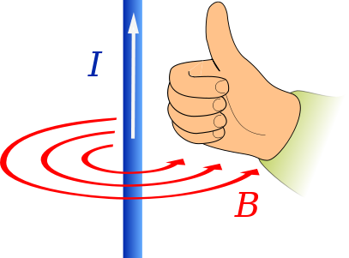

Activity 3: Discovering Current Flow
Draw a picture that illustrates your finding for the current flow. When turning the crank clockwise, current flows from the positive + (red) wire to the negative + (black) wire. Use the right-hand rule to show the resulting magnetic field flow for each direction of current flow. Point your compass toward north.
Turning the crank clockwise | Turning the crank counterclockwise
black  red | black  red
Q: How did changing the current flow affect the compass? | Q: How did changing the current flow affect the magnetic field?

Activity 4: Using Systems of Equations and Ohm’s Law to Solve a Circuit Problem
In this activity, find three currents by solving a system of three equations.
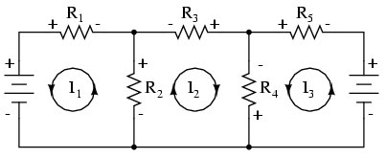
$${-E}_{1}$$
$${-E}_{2}$$

Either by hand or using a Ti-Nspire calculator, solve the following three equations with three unknown variables. The three unknowns are the currents represented by $I_{1}$, $I_{2}$, and $I_{3}$, as illustrated above.
The equations needed for the analysis of the above circuit are:
Values of the known quantities base on the experimental circuit:
$E_{1}=3.3$ volts
$E_{2}=5.1$ volts
$$R_{1}= 52.3 k ohms$$
$$R_{2}= 28 k ohms$$
$$R_{3}= 10.5 k ohms$$
$$R_{4}= 12.1 k ohms$$
$$R_{5}= 14.7 k ohms$$
$$\left(1\right) -E_{1}+R_{2}\left(I_{1}+I_{2}\right)-I_{1}R_{1}=0$$
$$\left(2\right) -R_{2}\left(I_{2}+I_{1}\right)-R_{4}\left(I_{2}+I_{3}\right)-I_{2}R_{3}=0$$
$$\left(3\right) R_{4}\left(I_{3}+I_{2}\right)+E_{2}+I_{3}R_{5}=0$$

Below, write the equations with the correct unknowns, replacing the variable with the quantities given above.
(1)
(2)
(3)

Use the Ti-Nspire to solve the equations by replacing the I unknowns with xyz; write your answers below. Remember: final units are amperes.
$$I_{1}=$$
$$I_{2}=$$
$$I_{3}=$$

Now that you know the current values, verify them by testing the teacher’s pre-built circuit.
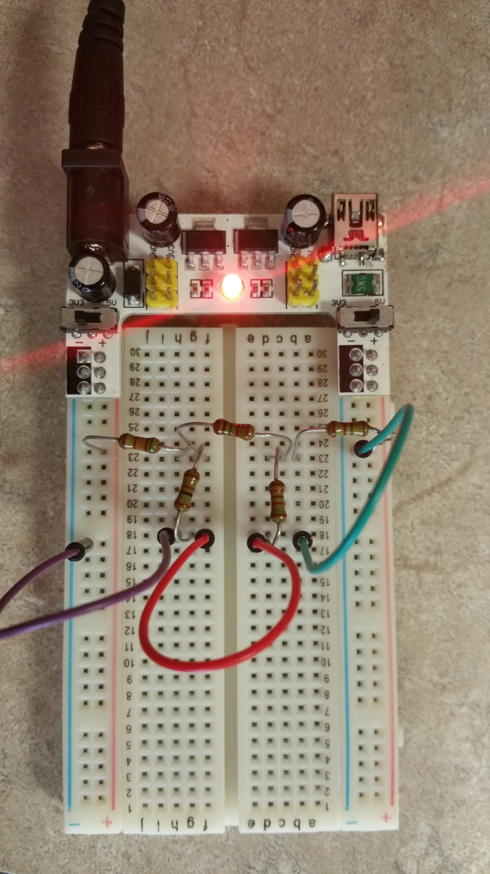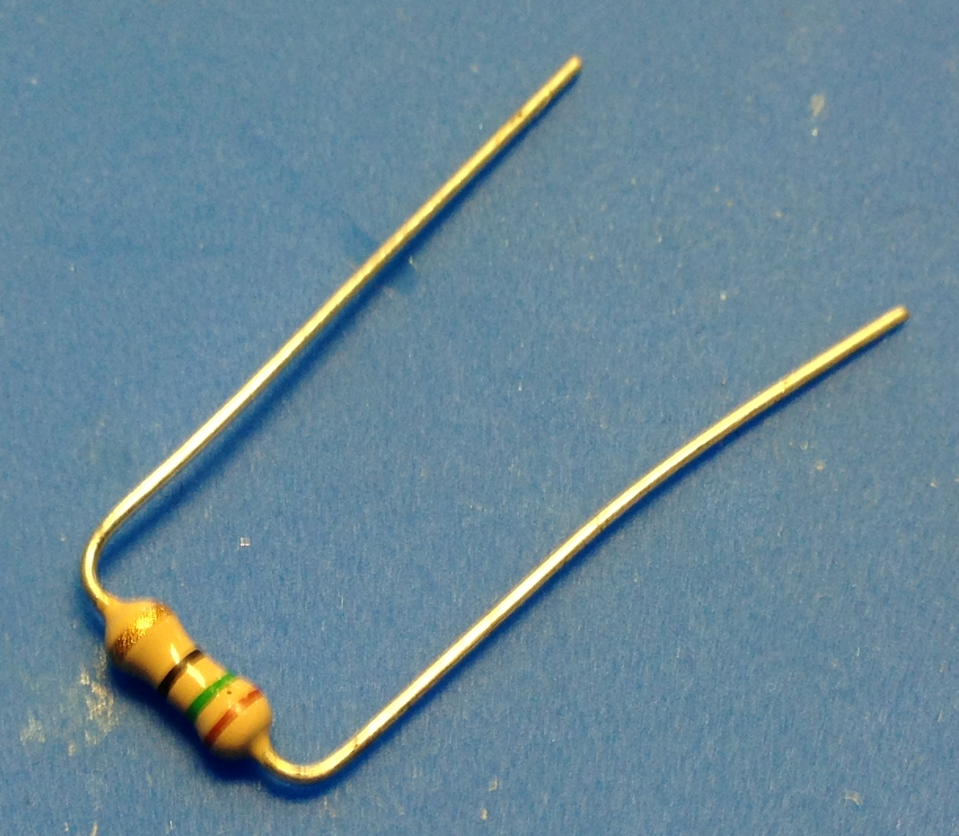
red probe
black probe
Photo 1 Photo 2
Photo 1 shows an experimental circuit that is the real electrical circuit for the previous schematic diagram. The resistors are lined up in the same way. If you are not sure, please ask for help.
Measure the voltage across each resistor and use it to calculate the current. It is important to use the voltage meter the same way every time. So, orient the resistor so that it faces you, as in Photo 2.
With the power on, place the red probe on the left side and the black probe on the right—and then take the reading. Do this the same way for $R_{1}$, $R_{2}$, and $R_{3}.$ Record your values below:
$$V_{1}=$$
$$V_{2}=$$
$$V_{3}=$$

Now use Ohm’s equation $V=R∙I$ to calculate the current. You need the know the values for $R_{1}$, $R_{2}$, and $R_{3}.$ Solve for I. Clearly label your currents $I_{1}$, $I_{2}$, and $I_{3}$.
$$I=\frac{V}{R}$$

How close were your current values using both methods?

Activity 5: Finite Element Method (FEM) Simulation
In this activity, you will simulate a finite element method model. You will select input values that result in the approximate solution graph. Your goal is to select a value that forces the approximate solution to match the true solution graph. In other words, so they line up perfectly.
- Key in a number between 10 and 400. Choose numbers with intention. Note that numbers smaller than 10 or greater than 400 will not work, and the number 0 exits the program.
- Begin keying in numbers. Does the approximate solution match the true solution well? If it does, you are done; if not, pick a different number. Your goal is to keep trying values until your graph is a perfect fit with the true solution. Find the minimum value that makes the graphs perfect matches.
Expect to see this message:
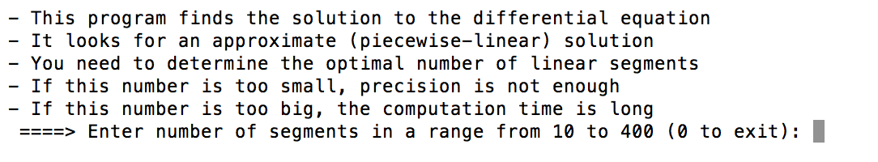

The optimal number of linear segments is ___________.

Concluding Assignment: As a group, create a poster that presents your findings and answers the essential question. The poster must include the following components:
- Poster title
- All group members’ names, class name and school period
- Brief explanation and diagrams that explain one of the following:
- Nondestructive evaluation (NDE)
- Physics, including eddy current and magnetic field
- Finite element method (the math)
- Answer to the essential question: How can we investigate and measure the inside of an object or its structure if we cannot take it apart?

