Applying Systems of Equations Pre/Post-Quiz Answer Key
- Solve the following system of equations using a method of your choice to find $i_{1}, i_{2}, and i_{3}$.
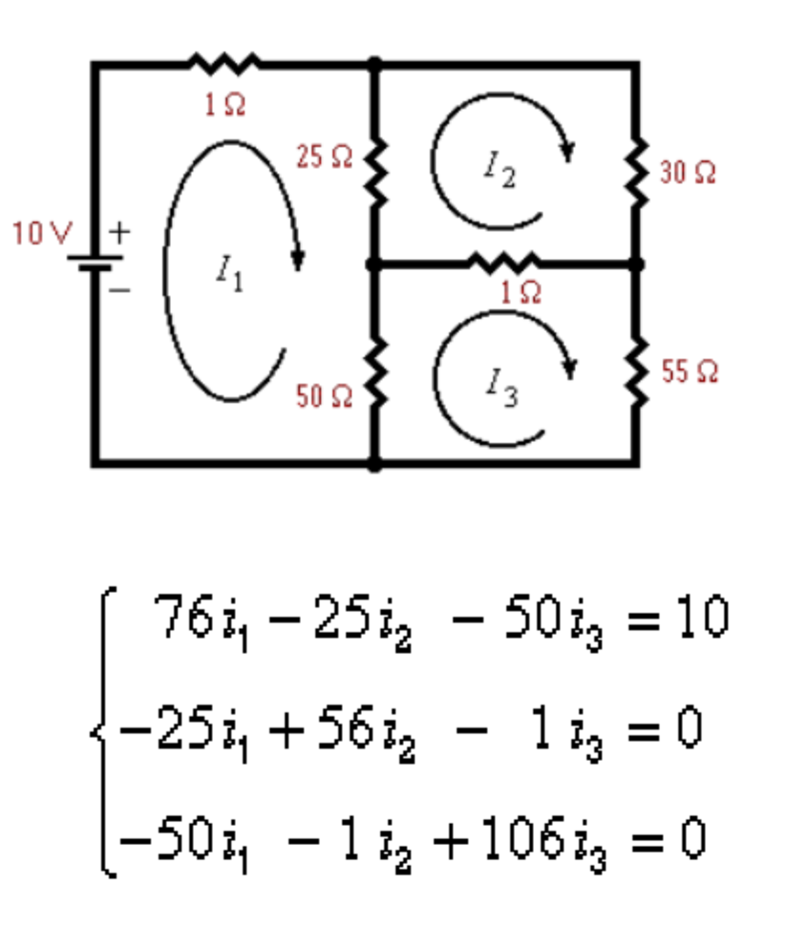
$i_{1}=\frac{5935}{24231}$=.24 amps

$i_{2}=\frac{900}{8077}=.11$ amps

$i_{3}=\frac{2825}{24231}=.12$ amps

- Why can systems of equations be used to model an electronic circuit? How did you solve them? Refer to the above diagram to help with your explanation. Explain in two or three sentences. You do not need to set up any equations.
Systems of equations can be used to find currents that flow through electrical circuits. Since these current flows are linear (Ohm’s law), they can be modeled by a system of equations. I used… Students may indicate the method they used, such as Cramer’s rule, matrices or a calculator.

