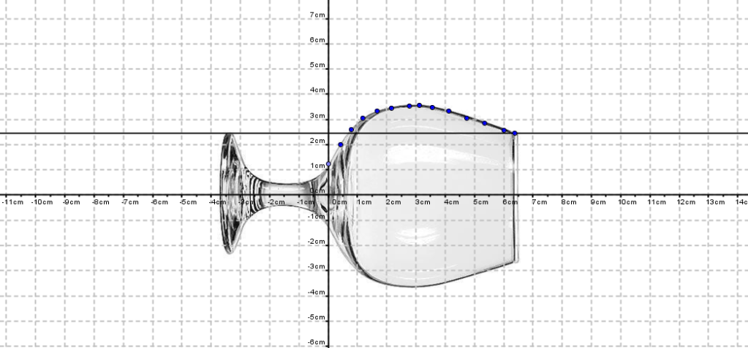
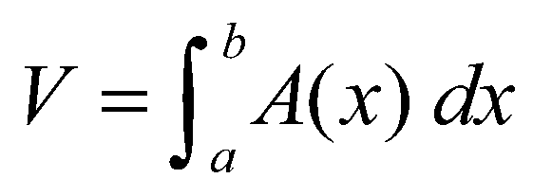
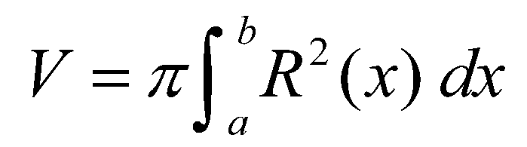
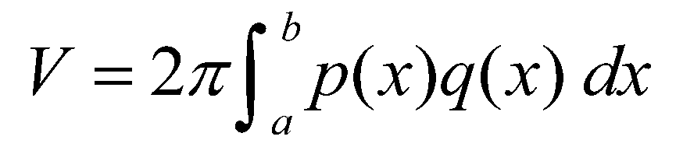
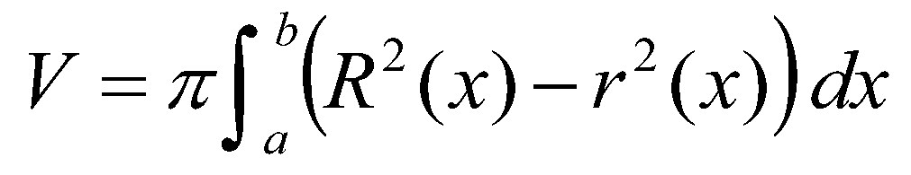
Volumes of Complex Solids

Overview: The purpose of this project is to apply integral calculus formulas and numerical integration methods to compute volumes of different complex solids, provided these objects can be considered solids of revolution, or solids with known cross sections. The complex solids considered in this project have no algebraic expression for their revolving lines. However, it is possible to find a set of points on this revolving line and their distances to the axis of revolution. To determine these points and distances requires the application of computer measurement techniques, scale factors and technology aids such as computers, digital cameras, Microsoft Excel and PowerPoint, and GeoGebra.
Project Overview
- Students work in groups of three.
- The first part of this project is to calibrate the method by approximating the volume of a solid of revolution with known dimensions and volume. A comparison of the obtained volume to the real volume gives the method’s error. Use a spherical object as a practice object, such as a large marble, baseball or tennis ball.
- Take photographs of the side view of the practice object. Be aware of the lighting; select the image that casts the least shade. Include in the photograph a ruler or other object of known dimensions as a reference, in case you cannot measure the object’s diameter and to help you determine the scale factor.
- Transfer the best photograph(s) to a computer and load it in the GeoGebra Graphics window. Using this software application’s tools, perform the measurement of the partition points and corresponding radius.
- Copy your data to an-Excel worksheet and create a table for the real-scale solid dimensions measurement points. Using the scale factor, multiply the on-screen pixels measurements to real-scale dimensions.
- With the points obtained in step 5, generate in Excel a graph of the revolving line of the solid of revolution. Using the points on this line, and the trapezoidal rule, calculate the corresponding integral in the volume formula. Decide on your approach: To best approximate the solid’s volume, it may help to use different partitions on different portions of the solid’s revolving line. Compare your approximated volume with the real volume, and calculate the approximation’s error.
- Repeat steps 4 to 6 to approximate the volume of your assigned real-world cooling tower.
- Create a standalone slideshow (or video) to summarize and explain your team’s work and results.
- Present your results to the rest of the class.

Project Checklist
Results and Calculations | Points |  | Evaluation
- Slide with project title and student names. | 2
- Slide with project description and purpose. Description of your team’s approach method and calculations to approximate the volume. | 5
- Slide(s) with photograph and description of the practice object used to calibrate the method; inclusion of the solid’s real volume and dimensions. | 8
- Slide(s) with the steps taken to approximate the practice object’s volume. | 5
- Slide(s) with table(s) containing the on-screen measurements, scale factor used, and final actual practice object dimensions obtained. | 10
- Slide with the graph of the solid’s revolving line. Graph must be labeled and x-y-axis units specified. | 5
- Slide(s) with all the formulas used, calculations performed and approximated practice object volume obtained, including units. The estimation error is stated. | 10
- Slides including a photograph of the assigned cooling tower. Slides containing all the steps 5 - 7 performed to approximate the cooling tower volume. | 50
- Slide with final conclusions about the method and results. And a slide with bibliography/references used. | 5
Total Points:

Results Presentation Checklist | Points |  | Evaluation
- PowerPoint standalone slideshow or video (mp3, wma, mpeg) containing information and results listed in points 1 – 9, with recorded explanations; non-standalone slideshow and class presentation may earn 30 points maximum. | 60  -or-  30
- In-class results presentation with proficient presentation and answers. | 30
- Students look professional (as if for a professional job interview). | 10
Total Points:
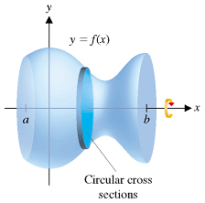
Notes: | - This project and final presentation average to a major test grade for the current grading period.  - No project presentation will be accepted after the due date.  - In-class project presentation is mandatory.  - During tutorial time, help will be available for numerical calculations, Excel calculations and graphs, GeoGebra use for measurements, and presentation preparation.  - Due date: [_______date here_______]

Possible Cooling Towers Projects
- Doel Power Station, Belgium (ht: 176 m)  - Westfalen Power Plant, Germany (ht: 122 m)  - West Burton Power Stations, UK (ht: 107 m)  - Kharkov Power Plant, Ukraine (ht: 90 m)  - Drax Power Station, UK (ht: 114 m)  - Ratcliffe-on-Soar Power Station, UK (ht: 118 m)  - Fiddlers Ferry Power Station, UK (ht: 114 m) | - Homer City Generating Station, US (ht: 110 m)  - Willington Power Station, UK (ht: 91 m)  - Blackburn Meadows Power Station, UK (ht: 76 m)  - ABLE Thorpe Marsh Power Station, UK (ht: 100 m)  - Chapelcross Power Station, UK (ht: 91.5 m)  - Dukovany Power Station, Czech Republic (ht: 125 m)
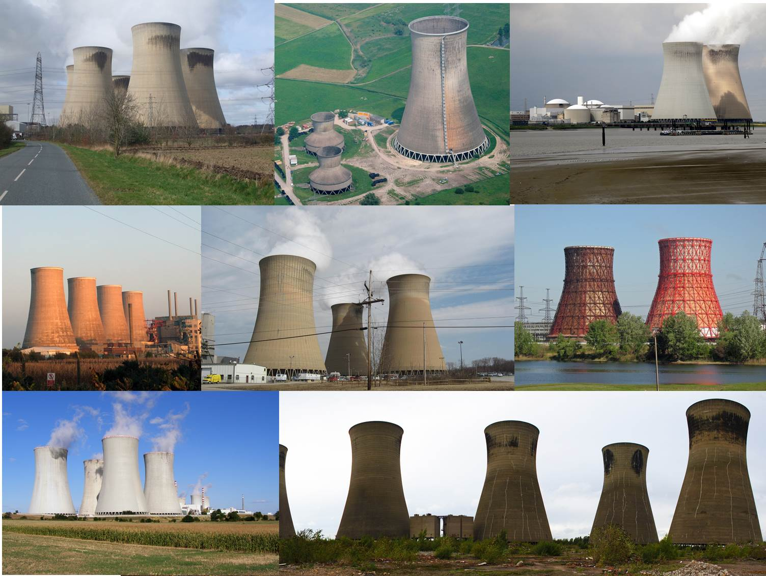

Additional Resources and Support
Calculus
- Briggs, W. L., Cochran, L. & Gillett, B. Calculus AP Edition. Upper Saddle River, NJ: Pearson Education, 2014.
- Larson, R. Edwards, B. & Hostetler, R. P. Calculus of a Single Variable, 8th Ed. Boston, MA: Houghton-Mifflin, 2006.
GeoGebra
- GeoGebra Tutorials, GeoGebra Manual. https://www.geogebra.org/manual/en/Tutorials
- GeoGebra Video Tutorials by Andrew Martin. https://www.youtube.com/channel/UCaMn-9tZF4sDHEOqWubgU0g/feed
Microsoft Excel
- Get Started with Formulas and Functions. (Downloadable course/tutorial) Microsoft Office Training, Microsoft Support Office, Microsoft Corporation. https://support.office.com/en-us/article/Get-Started-with-Formulas-and-Functions-e0b10c56-700c-4961-a7b2-a0fc5866735e
Microsoft PowerPoint
- Microsoft PowerPoint Tutorials. 2009 Electric Teacher. http://www.electricteacher.com/tutorial3.htm
- MS PowerPoint—How to Create a Standalone Presentation [.ppt to .exe] HD. Posted September 19, 2015. Office Tutorials, Microsoft Corporation. http://www.officetutes.com/ms-powerpoint-how-to-create-a-standalone-presentation-ppt-to-exe-hd/

- Tips for Making Effective PowerPoint Presentations. Plus, “The Seven Deadly Sins of PowerPoint Presentations” by Joseph Sommerville. (plus a downloadable 53-slide PowerPoint file) National Conference of State Legislatures. http://www.ncsl.org/legislators-staff/legislative-staff/legislative-staff-coordinating-committee/tips-for-making-effective-powerpoint-presentations.aspx
Nuclear Power Plants
- How Nuclear Power Plants Work / Nuclear Energy by Thomas Schwenke (animation; 4:47-minutes): https://www.youtube.com/watch?v=_UwexvaCMWA
- Cooling Tower / Stack Effect / Natural Convection by Thomas Schwenke (animation; 2:16-minutes): https://www.youtube.com/watch?v=xKzenFW0ZIg
- How Does a Thermal Power Plant Work? by Learn Engineering (animation; 7:02-minutes): https://www.youtube.com/watch?v=IdPTuwKEfmA
- Cooling Tower. Wikipedia, The Free Encyclopedia. https://en.wikipedia.org/wiki/Cooling_tower
Cooling Tower Information and Photos
- Doel Power Station, Belgium: https://en.wikipedia.org/wiki/Doel_Nuclear_Power_Station
Photo: https://commons.wikimedia.org/wiki/File:Doel_Kerncentrale_2.JPG
- Westfalen Power Plant, Germany: http://www.rwe.com/web/cms/en/1770974/rwe-generation-se/locations/germany/westfalen-power-plant/
Photo: https://commons.wikimedia.org/wiki/File:Power_station_Westfalen._Cooling_towers.jpg
- West Burton Power Stations, UK: https://en.wikipedia.org/wiki/West_Burton_power_stations
Photo: https://commons.wikimedia.org/wiki/File:View_from_Upper_Ings_Lane_-_geograph.org.uk_-_285251.jpg
- Kharkov Power Plant, Ukraine: https://en.wikipedia.org/wiki/Cooling_tower; Photo:
https://en.wikipedia.org/wiki/File:%D0%9F%D0%B5%D1%81%D0%BE%D1%87%D0%B8%D0%BD_%D0%A2%D0%AD%D0%A65_%D0%93%D1%80%D0%B0%D0%B4%D0%B8%D1%80%D0%BD%D0%B8_VizuIMG_2181.JPG
- Drax Power Station, UK: https://en.wikipedia.org/wiki/Drax_power_station
Photo: https://commons.wikimedia.org/wiki/File:Drax_Power_Station_Northern_Cooling_Towers_-_geograph.org.uk_-_1219824.jpg
- Ratcliffe-on-Soar Power Station, UK: https://en.wikipedia.org/wiki/Ratcliffe-on-Soar_power_station
Photo: http://s0.geograph.org.uk/photos/39/64/396420_9c4ca98a.jpg
- Fiddlers Ferry Power Station, UK: https://en.wikipedia.org/wiki/Fiddlers_Ferry_power_station
Photo: http://www.geograph.org.uk/photo/3427771
- Homer City Generating Station, US: https://en.wikipedia.org/wiki/Homer_City_Generating_Station
Photo: https://en.wikipedia.org/wiki/File:HCGeneratingCoolingTowers.JPG
- Willington Power Station, UK: http://www.crepello.net/Willington/PowerStation.htm
Photo: http://s0.geograph.org.uk/geophotos/03/58/00/3580038_752b59e7.jpg
- Blackburn Meadows Power Station, UK: https://en.wikipedia.org/wiki/Blackburn_Meadows_Power_Station
Photo: http://s0.geograph.org.uk/photos/03/78/037873_b8fdc0fa.jpg
- ABLE Thorpe Marsh Power Station, UK: http://www.ableuk.com/sites/land-sites/thorpe-marsh/
Photos: https://commons.wikimedia.org/wiki/File:Thorpe_marsh_cooling_tower_panorama2.jpg
https://morfis.files.wordpress.com/2011/01/thorpe-marsh-power-station.jpg
- Chapelcross Power Station, Scotland, UK: https://en.wikipedia.org/wiki/Chapelcross_nuclear_power_station
Photos: https://commons.wikimedia.org/wiki/File:Chapelcross_Nuclear_Power_Station_1.jpg
https://commons.wikimedia.org/wiki/File:Chapelcross_Nuclear_Power_Station_2.jpg
- Dukovany Power Station, Czech Republic: https://en.wikipedia.org/wiki/Dukovany_Nuclear_Power_Station
Photo: https://commons.wikimedia.org/wiki/File:Dukovany_Nuclear_Power_Station_2.jpg
Other Topics
- Greatest Engineering Achievements of the 20th Century: http://www.greatachievements.org/

 |  | Below Standard | Met Standard | Above Standard
A | Project Title, Student Names | - Incomplete or missing student names, project name or date | - Student names, project name and date displayed | - Student names, project name, date displayed  - Attention-catching animation  - Background music
B | Project Description | - Missing or incomplete outline of the project objective  - Missing or incomplete outline of procedures and resources used  - Missing or incomplete outline of results obtained | - Correct description of the project objective  - Correct outline of the procedures and resources used  - Correct summary of obtained results | - Correct description of the project objective  - Correct outline of the procedures and resources used  - Correct summary of obtained results  - Eye-catching slide format & animations  - Figures/photos to help understanding
C | Practice Object Data | - Incomplete or missing on-screen measured values  - Missing solids image and/or description  - Data incorrectly formatted, labeled or separated  - Displayed data difficult to read (font size < 24 pt and/or font color does not contrast with slide background)  - Scale factor missing or incorrect  - Missing real solid dimensions or units | - Complete on-screen measured values  - Data formatted, clearly labeled and separated  - Displayed data easy to read (font size > 24 pt and color contrasts with background color)  - Solid’s image included with description  - Correct scale factor displayed  - Real solid dimensions and units displayed | - Complete on-screen measured values  - Data formatted, clearly labeled and separated  - Displayed data easy to read (font size > 24 pt and color contrasts with background color)  - Solid’s image included with description  - Correct scale factor displayed  - Real solid dimensions & units displayed  - Eye-catching slide format & animations
D | Practice Object Revolving Line Graph | - Missing graph  - Unlabeled axis; no units specified  - Graph title missing and/or difficult to read  - Graph colors difficult to see | - Graph with all measured points  - Axis correctly formatted and labeled  - Graph title included and easy to read  - Graph colors with good contrast | - Graph with all measured points  - Axis correctly formatted and labeled  - Graph title included and easy to read  - Graph colors with good contrast  - Eye-catching slide format & animations
E | Practice Object Volume Calculations and Results | - Calculations to obtain volume missing or incomplete  - Used formulas missing  - Estimated volume and/or units missing  - Estimation error missing or incorrect  - Font difficult to read | - Calculations displayed  - Used formulas displayed  - Estimated volume and units displayed  - Correct estimation error displayed  - Easy to read font used | - Calculations displayed  - Used formulas displayed  - Estimated volume and units displayed  - Correct estimation error displayed  - Easy to read font used  - Eye-catching slide format & animations

 |  |  |  | Below Standard | Met Standard | Above Standard
F |  | Cooling Tower Data |  | - Incomplete or missing on-screen measured values  - Missing cooling tower image, description and location  - Data incorrectly formatted, labeled or separated  - Data displayed difficult to read (font size < 24; no color contrast w slide background)  - Scale factor missing or incorrect  - Missing real cooling tower dimensions and/or units | - Complete on-screen measured values  - Cooling tower image and description included  - Data formatted, clearly labeled and separated  - Data displayed easy to read (font size > 24 and color contrasts w background color)  - Correct scale factor displayed  - Real cooling tower dimensions and units displayed | - Complete on-screen measured values  - Cooling tower image and description included  - Data formatted, clearly labeled and separated  - Data displayed easy to read (font size > 24 and color contrasts w background color)  - Correct scale factor displayed  - Real cooling tower dimensions and units displayed  - Eye-catching slide format & animations
G |  | Cooling Tower Revolving Line Graph |  | - Missing graph  - Axis not labeled; no units specified  - Graph title missing and/or difficult to read  - Graph colors difficult to see | - Graph with all measured points  - Axis correctly formatted and labeled  - Graph title included and easy to read  - Graph colors with good contrast | - Graph with all measured points  - Axis correctly formatted and labeled  - Graph title included and easy to read  - Graph colors with good contrast  - Eye-catching slide format & animations
H |  | Cooling Tower Volume Calculations and Results |  | - Calculations to obtain volume missing or incomplete  - Formulas used missing  - Estimated volume and/or units missing  - Estimation error missing or incorrect  - Font difficult read | - Calculations displayed  - Formulas used displayed  - Estimated volume and units displayed  - Correct estimation error displayed  - Easy-to-read font used | - Calculations displayed  - Formulas used displayed  - Estimated volume and units displayed  - Correct estimation error displayed  - Easy-to-read font used  - Eye-catching slide format & animations
 | I |  | Project Conclusions | - Missing, incomplete or incorrect project conclusions  - Conclusions missing or poorly done in problem context | - Correct conclusions, procedures and results  - Conclusions completely in problem context | - Correct conclusions, procedures and results  - Conclusions fully in problem context  - Eye-catching slide format & animations  - Illustrations, graphs or figures to help understanding
 | J |  | Overall Report | - Slides not formatted  - Difficult-to-read fonts used  - Not a standalone presentation | - Slides professionally formatted  - Most of the presentation text readable (font size > 24 pt and in appropriate color)  - Standalone presentation | - Slides formatted using topic-related photos as backgrounds, and students’ own design  - All text in readable font (font size > 24 pt and in appropriate color)  - Eye-catching slide transitions

Project Results Report Presentation
 | Non-Professional | Quite professional | Professional
Body Language | - Reading notes or slides  - Sight not on audience  - Lacks confidence during the entire presentation  - No natural movements or gestures (fidgeting or nervous) | - Sometimes reads notes or slides  - Some audience eye contact  - Some movement and gestures  - Some confidence and poise (but still somewhat nervous) | - Audience eye contact  - Little or any reading of slides or notes  - Natural movements and gestures  - Looks confident during the entire presentation
Voice | - Speaks too softly to be understood  - Speaks too quickly or slowly  - Frequently uses words or sounds like: Okay, so…, you know…, uh, umm, I mean…  - Does not use the correct technical language or formal English | - Speaks clearly most of the time  - Sometimes speaks too quickly or slowly  - Speaks loudly enough for most of the audience  - Occasionally uses words or sounds like: Okay, so…, you know…, uh, umm, I mean…  - Uses correct technical language or formal English during most of the presentation | - Speaks clearly during the entire presentation  - Speaks at uniform volume, and at a normal pace, not too quickly or slowly  - Speaks loudly enough for everyone to hear  - Rarely or never uses words or sounds like: Okay, so…, you know…, uh, umm, I mean…  - Uses correct technical language or formal English during the entire presentation
Overall Presentation | - No main idea presented, incorrect or incomplete  - Ideas presented in the incorrect sequence  - Missing important steps in the development  - Missing, incorrect or incomplete introduction and/or conclusion  - Poor presentation time management  - Did not correctly answer the asked questions | - Main idea presented, but not proficiently explained  - Ideas presented in the correct order, but not proficiently connected or missing important points  - Introduction and conclusion present, but not effective  - Presentation completed in the allotted time, but time not proficiently distributed on topics or ideas  - Answers most questions correctly and in context | - Main idea presented in a clear and effective way  - Ideas presented in the correct order, emphasizing main points, and in context  - Effective introduction and conclusion  - Presentation completed in the allotted time, and time proficiently distributed on topics or ideas  - Answers questions correctly and in context, enriching answers with relevant information or examples
Student Look | - Wearing inappropriate clothes for the occasion | - Wearing semi-formal clothes | - Wearing appropriate clothes for the occasion (as if for a professional job interview)

