Self-Guided Learning Module Handout Answer Key
Day 1 Bell Ringer Quiz
Answers: hetero, hetero, homo, homo, homo, homo, homo
Task 1: Circle map answers and material types for urine, blood and milk
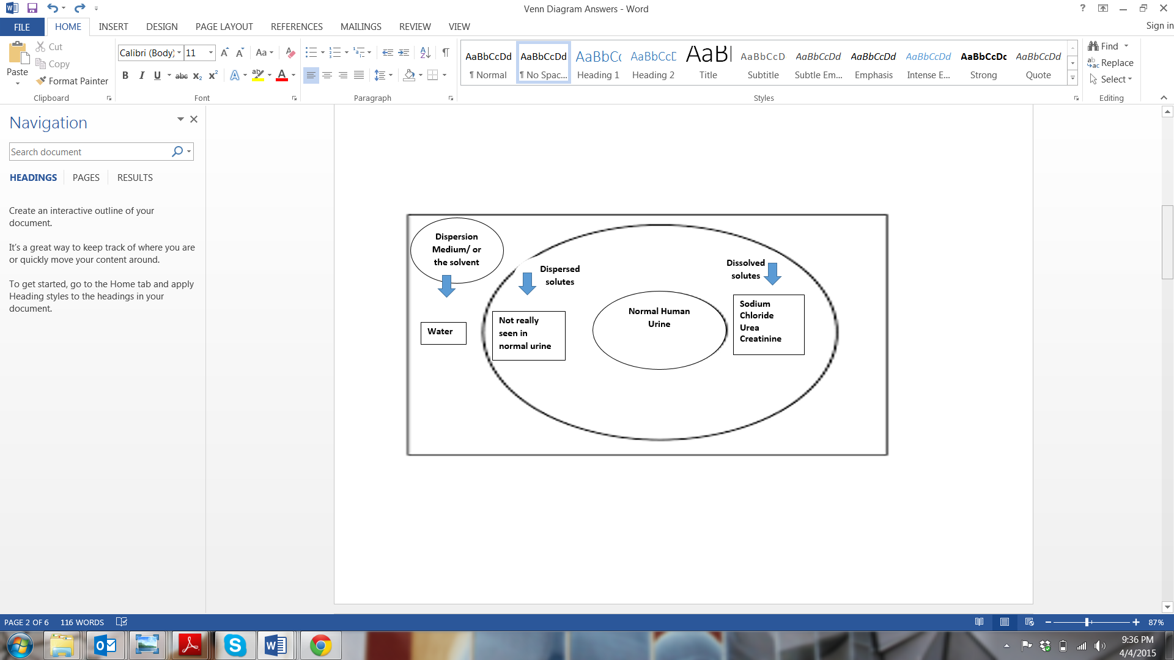
urine
mixture
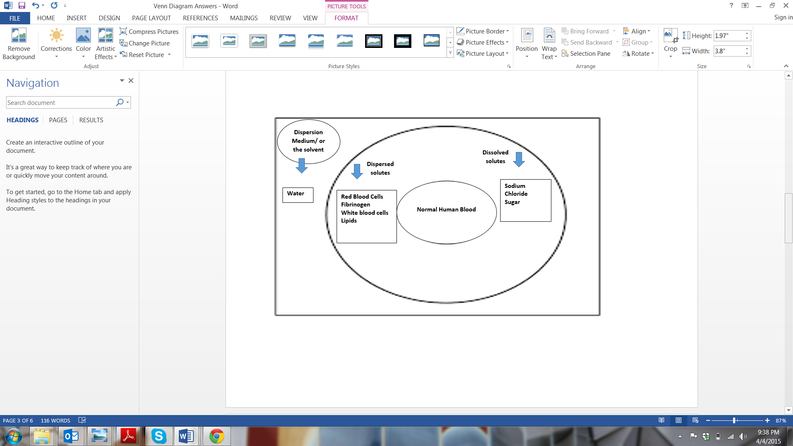
blood
mixture
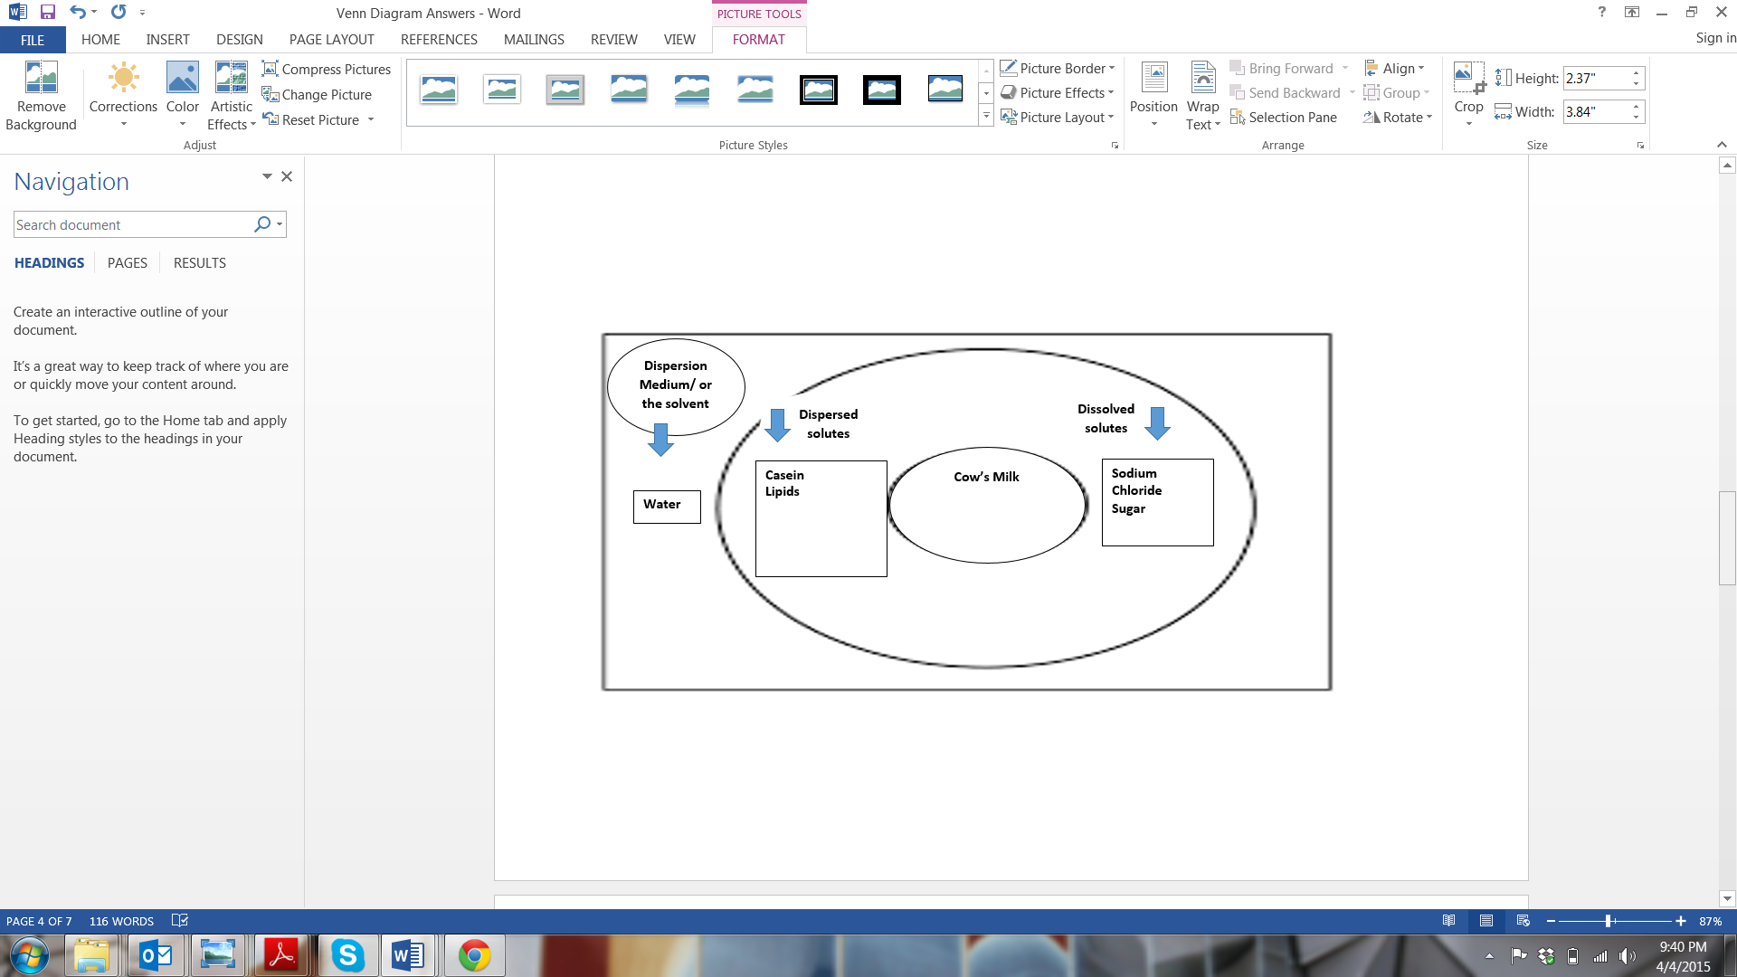
milk
mixture

Task 2: Warm-Up Summarization
Answers: See the Venn diagram below
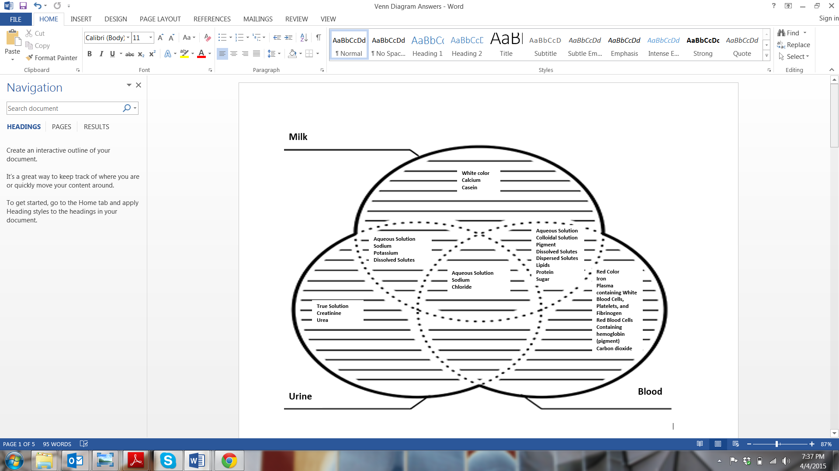
Question 1
Yes
Question 2
Blood and milk are similar in solution characteristics because both of them are multicomponent aqueous colloidal solutions containing both dissolved and dispersed solutes, and both contain lipids, sugar and protein.

Task 3.3 Milk and Blood Comparison
Comparison Factor | Milk | Blood
Dissolved solute concentration: somewhat equal OR more or less | Somewhat equal | Somewhat equal
Dispersed solute concentration:  equal OR more OR less | Less | More
Composition:  more complex OR less complex | Less complex than blood | More complex than milk
Function:  more intricate OR less intricate | Less intricate than blood | More intricate than milk
Dynamic flow as an integral part of the natural function: indispensable OR somewhat indispensable OR not truly indispensable | Somewhat indispensable for the function | Indispensable for the function
Solution integrity: Settling down on standing: occurs OR does not occur | Does not occur | Occurs
Anti-coagulant to prevent instant coagulation: needed OR not needed | Not needed | Needed
Question 3: Formulate a Hypothesis
Example hypotheses: Blood is a homogeneous mixture. OR Blood is a heterogeneous mixture.
Question 4: Evaluation of Milk as a Model
Expect answers to vary, depending on the imagination/creativity applied. Consider students’ explanations to assess their depth of understanding. Some students may consider milk to be a good model for blood based on some similarities in their compositions. However, some students may not consider milk to be a good model for blood because the standing behavior of blood is drastically different from the milk.
Question 5
Look at students’ work to see if they used the equation for weighted average and computed the weighted average specific gravity of blood:
(1.027 x 55/100) + (1.080 x 1/100) + (1.095 x 44/100) = 1.05745
Rounding 1.05745 results in a value of 1.060
Thus, the average specific gravity of normal human blood is 1.060.
Question 6
Yes
Question 7
Homogeneous. The various fractions of blood have been obtained from whole blood and when the specific gravities of the individual fractions are computed as per their percent composition, they give the specific gravity of whole blood. This is an indication of blood’s behavior as an integrated homogeneous mixture.
Question 8
Answers will vary since students write in their own words, however, see if they have captured the following ideas as provided in this example answer: The centrifugal force is used to separate particles from a solution according to their sizes, shapes, densities, viscosities of the medium and centrifuge rotor speed. Centrifugation is accelerated sedimentation in which dispersed systems are subjected to artificially-induced gravitational fields.
Question 9
Heterogeneous. Sedimentation is a well-known separation technique for heterogeneous mixtures; a mixture that can be separated by sedimentation is a heterogeneous mixture.
Question 10
Among the blood constituents, erythrocytes have the highest density.
Interim Summarization Answers
- sedimentation heterogeneous
- centrifugation homogeneous
- more
- mass size surface gravity
- viscosity
- coagulant colloidal
- multiphasic fluid
- red blood cells, white blood cells platelets
- higher
- hemoglobin
- iron
- platelets, arresting blood leakage
- white blood cells fighting infection
- 92% dispersed dissolved
- red blood cell
- plasma
- coagulation
- hemostasis
- thrombosis
- answers will vary
Question 11
By mixing the olive oil – petroleum jelly solution with the V8 beverage. Use the wooden stick to stir the solution.
Question 12
By letting the V8 beverage/petroleum jelly/olive oil mixture to stand undisturbed.
Question 13
By centrifugation.
Task 9: Experimental Investigation observations and inferences
Experiment | Experimental Observation | Inference
Remove the screw cap and place equal volumes of the V8 beverage and olive oil in which 1% petroleum jelly has already been dissolved. Stir it with the wooden stirrer stick. Close the test tube with the screw cap and let the test tube stand in a test tube stand. Observe the sediment falling level every five minutes. Collect three to four values at five-minute intervals. | If the ESR value for normal human blood is about 15 mm per hour, how much of a fall in erythrocytes did you observe in your blood model? | Values would slightly differ, depending on the exact amount of the components added; 13 mm to 23 mm is a reasonable value.
Carefully transfer the contents of the test tube from Experiment 1 into a centrifuge tube. Use the wooden stick to stir well without splashing. Centrifuge it at a speed of 500–600 rpm. | The model blood separates into two fractions | Petroleum jelly remains invisible. The aqueous and the oil fractions have separated out neatly.
Use the same centrifuge tube, place it back in the centrifuge and spin it at a speed of 2500–3000 rpm. | The model blood separates into three fractions. | Petroleum jelly is visible as a third layer between the aqueous and oil fractions.
Question 14
Petroleum jelly separates only at the higher speed of rotation.
Task 10
Answers will vary; below is a model/example answer for Task 10:
My proposed theory of the mixture nature of blood is based on the laboratory investigations I made using a model blood prepared by mixing nearly equal volumes of V8 drink and olive oil that contained about 1% (mass by volume) of petroleum jelly. The postulates of my theory are as follows:
- Blood behaves like a heterogeneous mixture as it undergoes sedimentation when the erythrocytes settle out of plasma fall under the influence of gravity.
- Blood behaves like a homogeneous mixture as it cleaves into three layers upon centrifugation to sort into the erythrocytes, buffy coat and plasma.
- Blood behaves both as a homogeneous and a heterogeneous mixture.
During the theory development portion of the activity, permit the title of the theory to be worded differently; examples: Mixture Dualism Theory of Blood; Mixture Duality Theory of Blood, Theory of Dual Mixture Nature of Blood or Theory of Mixture Dualism in Blood.
For the improvement of the theory, talk about the possibility of blood as a mixture system. Example Improvement/Alternate Theory Explanation: Blood is a homogeneously heterogeneous mixture.

Task 11
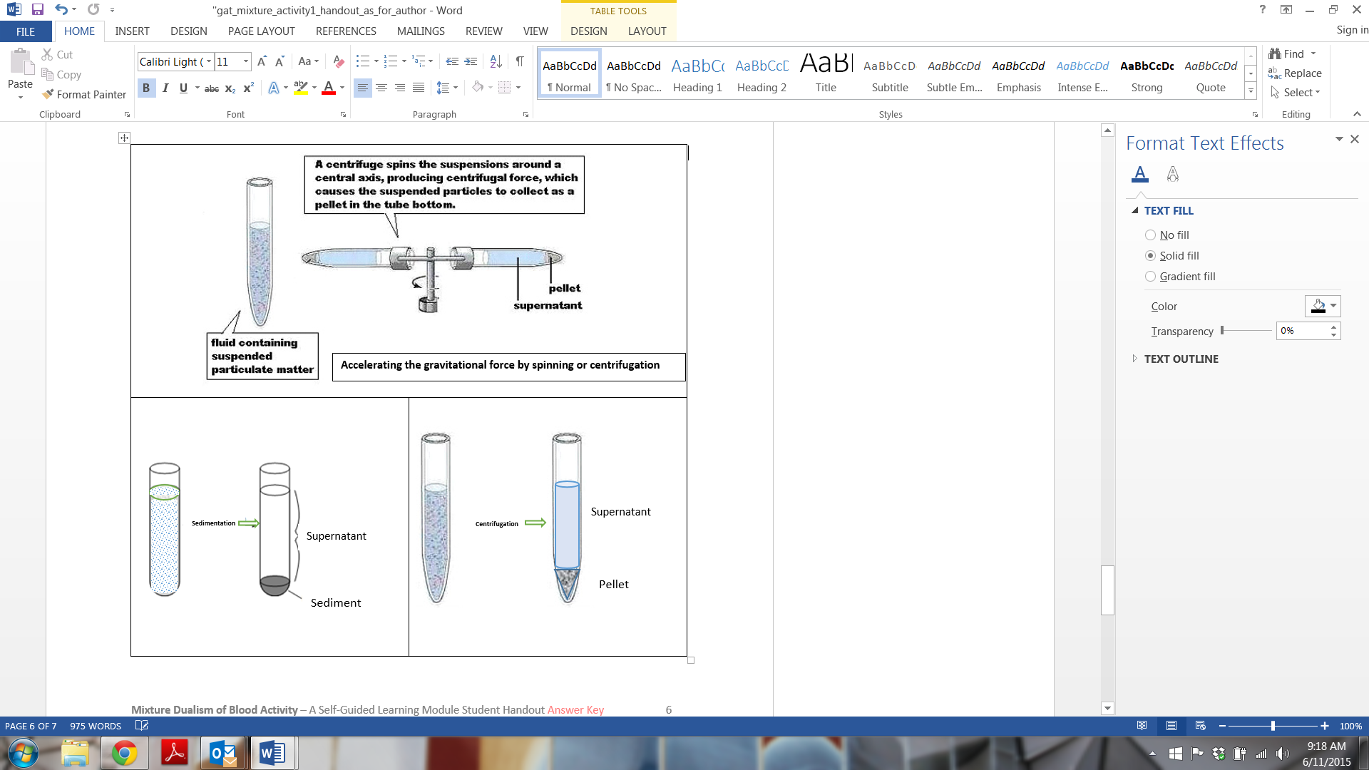
Centrifugation and sedimentation techniques are related in the sense that both are sedimentation techniques. In normal sedimentation, particles settle out under the influence of gravity. In centrifugation, particles settle out under the influence of accelerated gravity. So centrifugation is accelerated sedimentation. The relationship between the two techniques is illustrated in the set of three diagrams in Figure A.

Centrifugation

Sedimentation
Centrifugation

Figure A. A comparison of sedimentation and centrifugation. Source: Top diagram courtesy of Osmania University at http://14.139.82.43/cfrd/ctfg.html (for noncommercial educational usage). Bottom right: Adapted and redrawn from the top diagram.
Centrifugation
Sedimentation

We can make one more correlation between the two techniques. Longer standing results in better sedimentation efficiency; higher speed results in better centrifugation efficiency. By adjusting the spinning speed, we can separate particles of different dimensions or density. Such a separation process is referred to as differential centrifugation. This similarity is illustrated in Figure B.
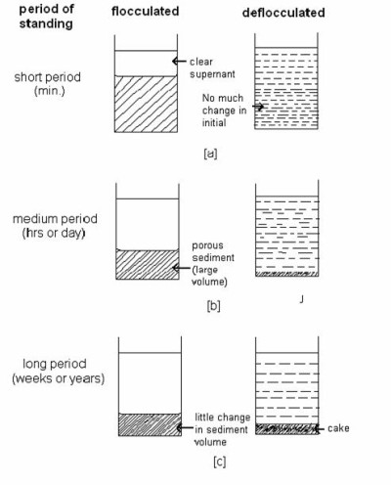

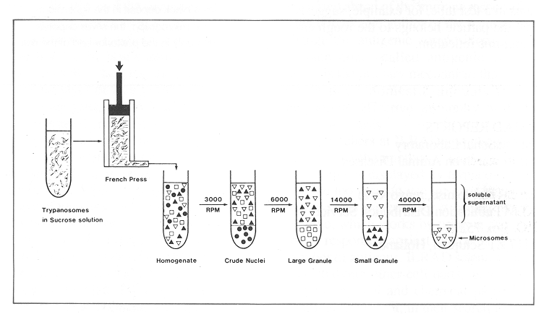

Figure B. Top: The effect of standing time on the efficiency of the sedimentation process. Bottom: The effect of spinning speed on the efficiency of centrifugation. Sources: Top diagram courtesy of L.M. College of Pharmacy at https://sites.google.com/site/lmcpabd/suspensions (for noncommercial educational usage). Bottom diagram: Adapted from Medical Biochemistry Blog at http://reenambc.blogspot.com/2013/01/biochemistry-inroduction-cell.html (for noncommercial educational usage).

Homework
Task 12: Explain centrifugation techniques, principles and applications
Three types of centrifugation fall under two major categories, as shown in the following flow chart:
Centrifugation
differential centrifugation
density gradient centrifugation
rate-zonal centrifugation
isopycnic centrifugation

Differential Centrifugation
The differential centrifugation technique is based on the fact that when we centrifuge a colloidal suspension containing particles of different densities or sizes, the various particles sediment at different rates, with the larger and denser particles sedimenting faster. So, in pellets obtained this way, there will be a series of pellets containing particles of decreasing sedimentation rate from bottom to top. With differential centrifugation it is difficult to achieve clear-cut segregation of the sediment into layers of different particle size, so some contamination of the adjacent layers is seen in every layer.
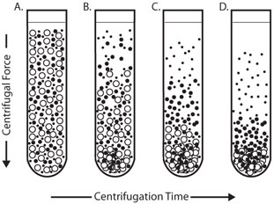
The rate of sedimentation decreases from bottom to top.

Figure C. Differential Centrifugation. Particles of different densities or sizes sediment at different rates with the largest and most dense particles sedimenting the fastest, followed by less dense and smaller particles. Source: Sigma-Aldrich BioFiles, Vol. 6, No. 5 - Centrifugation, page 6, Figure 1, at: http://www.sigmaaldrich.com/content/dam/sigma-aldrich/docs/Sigma-Aldrich/Brochure/1/biofiles_v6_n5.pdf. Reproduced with permission.

Rate-Zonal Centrifugation
Rate-zonal centrifugation eliminates the problem of cross-contamination of particles of different sedimentation rates. This is achieved by layering the sample as a narrow zone on top of a density gradient (see Figure D). The gradient stabilizes the bands and provides a medium of increasing density and viscosity. Consequently, the faster sedimenting particles are not contaminated by the slower particles and the layers are well defined. However, since the sample loading zone is narrow, we can only load very small volume of the sample (typically 10%).
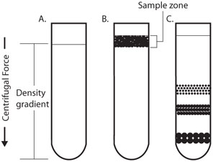

Figure D. Rate-Zonal Centrifugation. Sample is layered as a narrow zone on the top of a density gradient (2). Under centrifugal force, particles move at different rates depending on their mass (C). In rate zonal centrifugation, because of the density gradient setup, the speed at which particles sediment depends primarily on their size and mass instead of density. Thus, particles uniformly sediment within a density zone. Source: Sigma-Aldrich BioFiles, Vol. 6, No. 5 — Centrifugation, page 6, Figure 2, at: http://www.sigmaaldrich.com/content/dam/sigma-aldrich/docs/Sigma-Aldrich/Brochure/1/biofiles_v6_n5.pdf. Reproduced with permission.

Isopycnic Centrifugation
Iso means same and pycno means “thick” or “dense.” In isopycnic separation, particles are separated solely on the basis of their buoyancy or immersion ability in a medium, which is literally the density of the particle. Thus, the technique is also called buoyant or equilibrium separation. By this method, the particles never sediment to the bottom of the tube, no matter how long the centrifugation time (see Figure E).
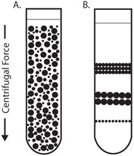
Figure E. Isopycnic Centrifugation. Starting with a uniform mixture of sample and density gradient (A) under centrifugal force, particles move until their density is the same as the surrounding medium (B).
Source: Sigma-Aldrich BioFiles, Vol. 6, No. 5 — Centrifugation, page 6, Figure 3, at: http://www.sigmaaldrich.com/content/dam/sigma-aldrich/docs/Sigma-Aldrich/Brochure/1/biofiles_v6_n5.pdf. Reproduced with permission.

Task 13
The market for blood products continues to expand. It is estimated that the global blood industry will reach $28.8 billion by 2017 (Medical Travel Today, July 2013). Thus, career options are plentiful in the blood processing industry. The jobs include both technical and non-technical, and range from call center associate to doctors; see the table below for a non-exhaustive list.
# | Job | Duties and Responsibilities | Educational Qualifications | Approx. $ Annual Pay
1 | call center associate | Calls donors based on inventory needs.  Understands minimum requirements for donor recruitment and donor deferral guidelines.  Uses assertive communication to secure appointments.  Determines suitable donation process each call.  Schedules, cancels and reschedules appointments.  Maintains accurate donor files and fills out appropriate forms. | High school diploma or equivalent req’d.  - Working knowledge of computers.  - Minimum 1 year experience in telemarketing and/or customer service.  - Call center experience preferred.  - Ability to accept and perform under a specific and ambitious goal structure. | $20,000
2 | driver | Prepares, transports, unloads, loads and returns vehicles before and after assigned blood drives.  Performs vehicle inspection and road tests.  Prepares for blood drives and site setups.  Completes DOT Drivers Logs.  Ensures exceptional customer service for donors and sponsors and correct processing of blood units as directed by the charge nurse.  Attends monthly donor services meeting. | High school diploma or equivalent req’d.  - Minimum 3 years of experience in driving trucks, buses or coaches.  - Class A or Class B CDL with air brake endorsement required.  - Current health card.  - Excellent driving record and CDL defensive driving.  - Customer Service skills and experience. | $26,000
3 | medical technician | Analyzes tissue samples.  Collects and analyzes blood for transfusions.  Performs analysis using lab equipment.  Keeps records of lab activities and records test results in patient records.  Conferences with doctors. | Associate degree with biology, chemistry, and healthcare with med tech certification | $40,200
4 | medical technologist | Performs more complicated tests than medical technicians.  May supervise medical technicians in the lab. | BS with biology and chemistry, with some additional training in medical technology or bachelors of science in medical technology or clinical sciences | $59,500
5 | flow cytometry  technologist | A specialized medical technologist.  The ability to manage multiple activities simultaneously and work with limited supervision  Superior analytical, PC, oral/written communication, and problem-solving skills. | Bachelors degree in medical technology or other science related field plus a NYS DOH clinical laboratory technologist license (ASCP certification preferred), and 2-3 years clinical lab experience, preferably exposure to flow cytometry. | $62,300
6 | collections registered nurse | Maintains confidentiality of donor/patient and employee information.  Registers and screens donors.  Determines donor acceptability for donations and uses appropriate procedures for donor deferral notification.  Transcribes doctor’s orders for autologous and directed donors.  Ensures donor and product safety.  Consistently follows manufacturer's instruction and SOPs ensure blood product compliance.  Ensures mobile screening and collections meet all requirements:  - Loads, unloads and sets up blood drive equipment at collection sites.  - Ensures confidentiality of donor screening at blood drive sites.  - Promotes donor safety and collection efficiency.  - Correctly packs blood transport boxes for shipments to lab following SOPs and guidelines.  Perform blood drive duties:  - Organizes blood drive collection supplies and equipment.  - Prepares and numbers blood bags and tubes prior to blood drive.  - Drives blood drive vehicle and/or passenger van.  - Reviews all supply check lists and loads all supplies for blood drives in the vehicles prior to departure. | Education: registered nurse (RN)  Experience: Broad knowledge of or ability to acquire knowledge of current blood banking principles and regulations.  Ability to acquire apheresis training/certification.  Certificate/license: Current state nursing licenses, valid state driver's license, and current CPR certification (or ability to obtain).  Other skills: excellent customer service skills; ability to organize and prioritize; ability to provide strong and consistent leadership; basic computer skills helpful; ability to interact proactively with internal and external customers; have a positive attitude; and help portray a positive image of the organization. | $66,200
7 | blood bank technologist | Specialists in blood bank technology demonstrate a superior level of technical proficiency and problem-solving ability in such areas as:  - Tests for blood group antigens, compatibility and antibody identification.  - Investigates abnormalities such as hemolytic diseases of the newborn, hemolytic anemias and adverse reactions to transfusion.  - Supports physicians in transfusion therapy for patients with coagulopathies (diseases affecting blood clotting), for example, or candidates for organ and cellular transplantation/therapy.  - Performs blood collection and processing, including selecting donors, collecting blood, typing blood and molecular testing.  -Performs viral marker testing for patient safety.  -Manages patient blood. | Bachelor’s degree with a major in biology, microbiology or another biological or physical science and certification as a medical technologist, plus an accredited, one-year specialized training program for certification o a master’s degree in blood bank technology, also known as immunohematology, for 24 months. | $70,000
8 | engineers: | Various engineering-oriented tasks | MS in chemical, biomedical, mechanical, and/or biotechnology fields | $70,000 (BS)  $95,000 (MS)
9 | scientists: biochemist, clinical chemist | Various research-oriented tasks | PhD in the respective field with experience. | $120,000
10 | IT specialists | Various software and programming-related tasks | BS or MS in computer science, computer engineering, and/or electrical and electronics engineering | $80,000 (BS)  $100,000 (MS)
11 | doctors |  | MD plus specialization courses or training | $180,000
From the jobs and their descriptions and salaries, it is evident that pursuing science and engineering majors helps you attain interesting, important and highly paid jobs. Most of these jobs are associated with multiple responsibilities. Having problem solving skills is a very important requirement. Ability to work in a team is absolutely essential. Personal hygiene, maintaining good health, abstaining from smoking, drugs and alcohol is a must. All these jobs require focus, concentration, deep learning plus excellent etiquette and open mindedness.
Resources

Medical Travel Today (July 3, 2013), Global Blood Industry to Reach $28.8 billion in 2017, at http://medicaltraveltoday.com/global-blood-industry-to-reach-28-8-billion-in-2017/
- Table content of career information reproduced with permission from:
- U.S. Bureau of Labor Statistics at www.bls.gov/
- NCH Northwest Community Healthcare Job Postings at http://nch.netreturns.biz/JobPosting/JobDetail.aspx?Id=c467a37e-4b07-4c04-a73c-be49f304be6b&utm_source=Indeed&utm_medium=cpc&utm_campaign=Indeed
- Indeed Jobs at http://www.indeed.com/q-Blood-Component-Processing-Tech-jobs.html
- Memorial Blood Center Job Postings at http://www.mbc.org/Careers/

