Suit Up! Worksheet Example Answers

Engineering Problem: Design an air-conditioned Ebola biohazard glove to help save the lives of doctors, nurses, medical assistants and family who treat and care for Ebola patients!
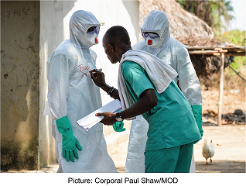

Background: Biomedical engineers apply engineering principles and design concepts to develop solutions to healthcare problems. They may design prosthetics, surgical equipment and even personal protective equipment. Engineers team up with healthcare professionals to design biohazard suits to protect people who work with dangerous chemicals and infectious diseases.
Ebola is an infectious disease that has affected thousands of people in West Africa in the current outbreak that started in December 2013. It is important for healthcare workers to wear protective equipment so that they do not get sick when treating patients. This protection usually involves a biohazard suit that completely covers the person (see the photograph above). Imagine firefighters with all of their gear on—suit, boots, gloves, mask and helmet. A biohazard suit is very similar and it gets really hot inside—up to 115 °F! Wow, that’s hot!
Your Engineering Challenge: To create a prototype of an Ebola biohazard glove that meets specific design requirements for one of your teammates to wear and test. In addition, use the air-conditioning unit to keep cool the hand and arm inside your biohazard glove.
Notes:

Step 1: Save the Ice! (10 minutes)
While you build your prototype glove, your air conditioning unit full of ice will sit at room temperature for up to 45 minutes. Your first task is to insulate your air conditioning unit, so the ice does not melt while you are building your Ebola biohazard glove.
Insulating Your Air-Conditioner
Engineering Challenge: Use any of the following materials to insulate your air-conditioning unit and keep the ice from melting. You do not need to use all of the materials.
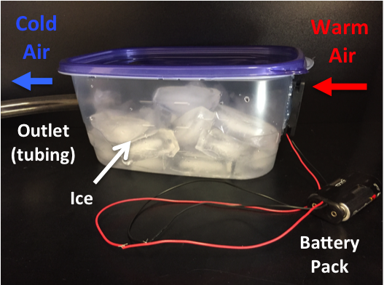
Materials:
- foam, 12 x 12-inch piece
- bubble wrap, 18 x 18-inch piece
- newspaper
- masking tape

Think about this:
70
The room temperature is about _____________ °F
32
The ice is about ______________ °F

ASK: Why does the ice melt? Where is the heat escaping from the air-conditioning unit? What surroundings are warmer than the ice?

Example answer: The ice melts because it is cooler than its surroundings. The air outside the container and the table that the container sits on are both warmer than the ice. The purpose of the insulation is to protect the ice from losing heat to these surroundings.

IMAGINE/PLAN: Which materials are you going to use? Where are you going to place them?
Before you start to build, draw a picture of your insulator below.

Expect students to have provided a labeled drawing too
Example answer: Use foam to insulate the bottom since it will lose the most heat to the table. Use bubble wrap and newspaper to insulate the sides. Use all of the materials to create the most insulation.

CREATE: Use the materials to insulate your air-conditioner.

Step 2: Building the Suit (30 minutes)
Engineering Challenge: Your next task is to design and build an Ebola biohazard glove! Choose one of your teammates to be the test subject. Once your glove is finished, you will connect it to your air conditioning unit to see how well it cools the glove. A thermometer placed on your teammate’s arm will gauge the temperature inside the glove. Then your teammate will complete a challenge course with the glove on his or her arm!
Tools
- scissors
- air-conditioning test unit
- thermometer
- stopwatch
Materials
- foam
- newspaper
- masking tape
- duct tape
- cardboard scraps
- trash bags (any kind)
- bubble wrap
- aluminum foil
- rubber bands
- clear scotch tape

Engineering Design Requirements
Your Ebola biohazard glove must:
- Extend just above the elbow, but no higher than the shoulder.
- The thermometer placed on the forearm must be visible through the suit.
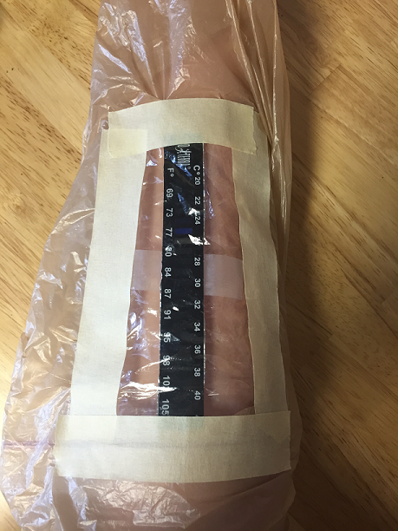
- Pass the challenge course: The glove wearer should be able to complete as many of the challenge course obstacles as possible with the gloved hand/arm!
Tip: This photograph is included to give teachers and idea of what it might look like to have the thermometer included in the suit. In this case, the thermometer is inside a Ziploc bag that is taped to an opening cut through a plastic shopping bag used for the glove. Consider giving students the thermometer already in a Ziploc bag or taped to a piece of clear plastic so that it is easier for them to incorporate it in their suits, and so you do not lose the thermometers!
Challenge Course: The glove-wearing teammate must try to complete the following challenges with the glove on, so design your glove with these requirements in mind:
1. Completely empty a syringe of water into a beaker.
2. Dispense three small candies from a container into a small cup.
3. Touch your index finger to your nose.
4. Submerge the gloved arm in a bucket of water to test for leaks.

Ideas:

REMEMBER: What are the design requirements for your suit?

Answer: You must be able to see the thermometer through the suit. The glove must extend above the elbow, but not above the shoulder.

ASK: What is your task? How will you complete the challenge course in your suit?

Example answer: Create an Ebola glove that meets the design requirements and can successfully pass the challenge course. The glove must have full use of the fingers, bend at the elbow, and be waterproof.

IMAGINE: Which materials will work best? How will you make the thermometer visible? Will you be able to move your fingers in the suit?

Example answer: Plastic will work best because it is waterproof. We will tape the thermometer to a clear Ziploc bag and make an opening for it in the forearm of the glove. We will trace our teammate’s hand to make a glove that will closely fit to his or her fingers so the fingers can be used to pick up items.

PLAN: Make a list of the materials you need to build your suit. Choose a volunteer from your group to be the test subject. Take measurements of your test subject’s arm and hand and include those on a drawing of your plan below.

Example materials: Black trash bag, clear Ziploc bag, bubble wrap, duct tape, masking tape, scissors, measuring tape

Expect students to have provided a labeled drawing too

CREATE: Carry out your plan. Build a biohazard glove for your teammate.

Step 3: Testing the Suit (15 minutes)

- Design Requirements Check
Requirement | Pass/Fail
Does the suit extend just above the elbow, but no higher than the shoulder?
Is the thermometer visible through the suit?

- Air Conditioning Check
76
What is the thermometer reading before connecting the air conditioner? _____________°F
Insert the tubing from the air conditioning unit into the top opening of the prototype glove, at the elbow. What is the thermometer reading after being connected to the air-conditioning unit?
30 seconds __________ °F 1 minute _____________ °F 2 minutes __________°F
60
66
70
What is the difference between the starting temperature and the temperature after 2 minutes?
___________ °F − ____________ °F = ____________ °F
16
60
76
- Challenge Course
Task | Pass/Fail
1. Completely empty a syringe of water from into a beaker.
2. Dispense three small candies from a container into a small cup.
3. Touch your index finger to your nose.
4. Submerge the gloved arm in a bucket of water to test the suit for leaks.
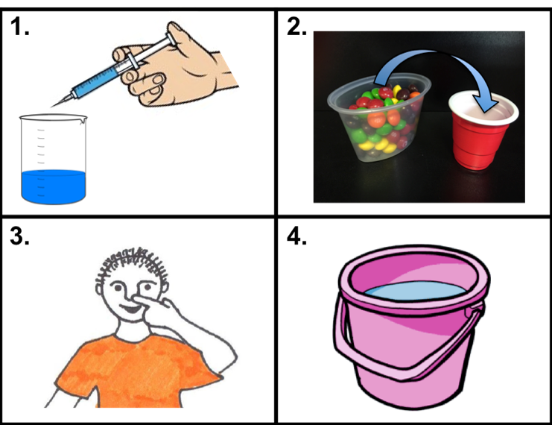
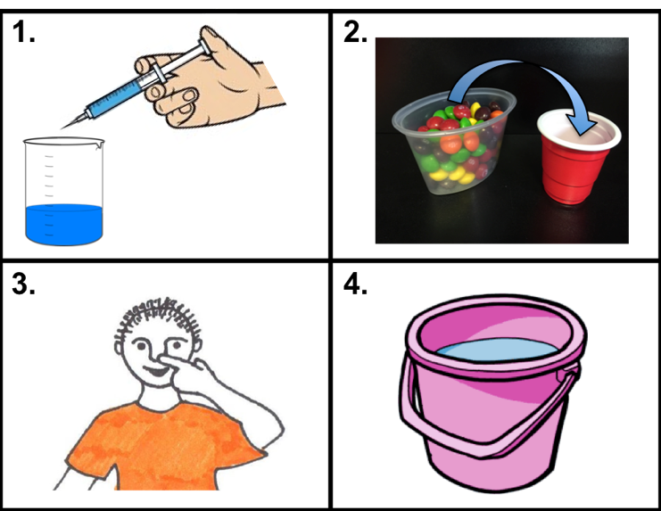

IMPROVE: What worked well with your suit? What needs improvement?
Make alterations to your suit and try to complete the challenge course again.
Example answer: The glove was not waterproof. We need to check that any holes or seams in the glove are sealed well. It was difficult to pick up the candies because it was hard to use the thumb. To improve that, we will make the glove more fitted to the hand.

