Visual Aids

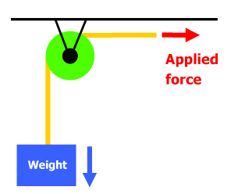

A fixed pulley with no mechanical advantage.

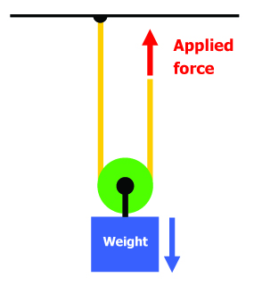

A movable pulley with a mechanical advantage of two.

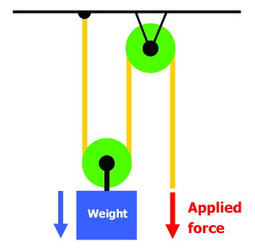
A two-pulley system with one movable pulley and one fixed pulley, and a mechanical advantage of two.

