

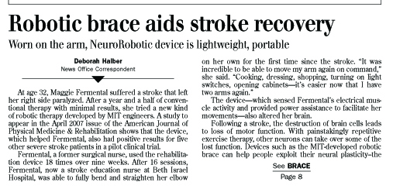

TeachEngineering.org – Free STEM Curriculum for K-12

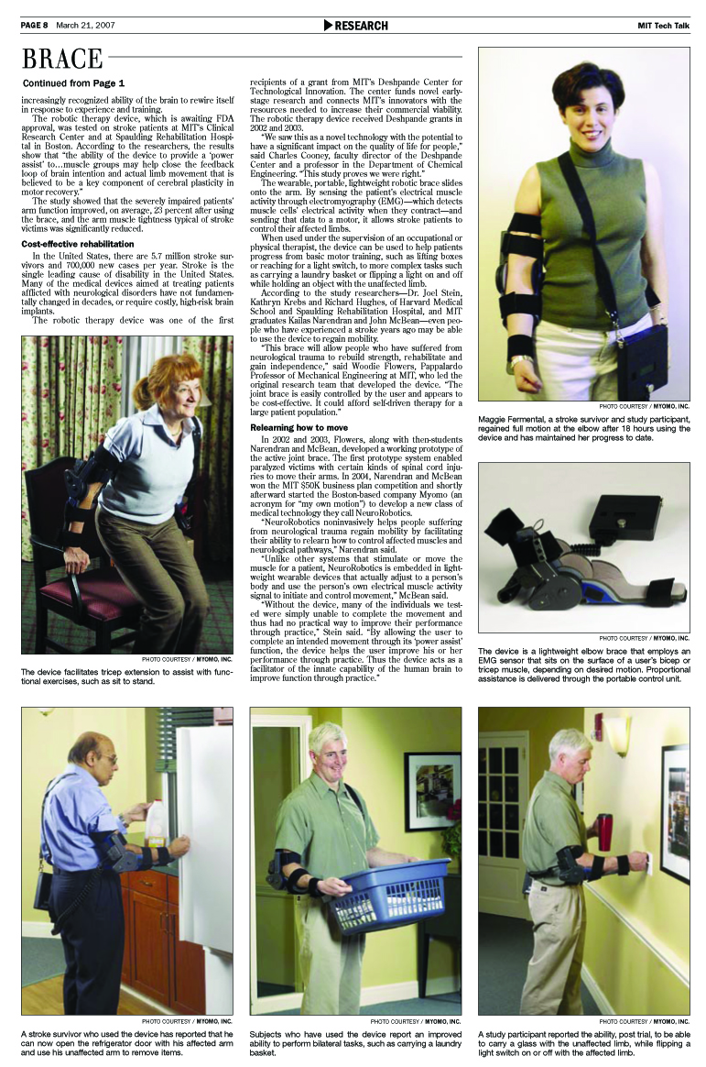

Article source: Halber, Deborah. Robotic Brace Aids Stroke Recovery: Worn on the Arm, NeuroRobotic Device is Lightweight, Portable. Published March 21, 2007. TechTalk: Serving the MIT Community, Vol. 51, No. 22, MIT News Office, Massachusetts Institute of Technology. Accessed November 18, 2008. Used with permission. http://web.mit.edu/newsoffice/2007/techtalk51-21.pdf and http://web.mit.edu/newsoffice/2007/brace.html
Images source: Myomo,Inc., http://www.myomo.com/. Used with permission.

