Part 1: Visualizing Magnetic Fields

1A: Single Magnet Purpose: Compare ferrofluid shapes with magnetic field line images.

In the image below, notice that the field lines at the magnet’s poles are spread out like a spiked circle.
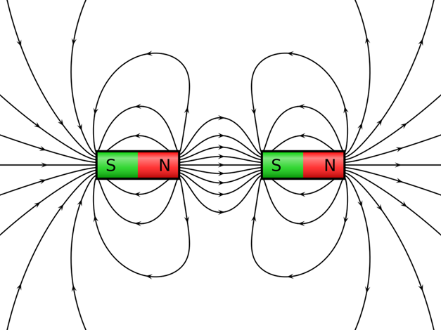

Instructions:
- Place one magnet on the side of the ferrofluid in a bottle until the ferrofluid forms a spiky ball, like a 3D version of the field lines on paper.
- Place a magnet diagonally along the side of the ferrofluid in a bottle to see a transition, where one side forms small spikes, while the other stays smooth and continuous.
- Draw your results in your Magnets and Magnetic Fields Worksheet in Station 1, Part 1.

1B: Multiple Magnets Purpose: Use two magnets to show how the same and opposite magnetic poles behave.

Instructions:
- First, move the two magnets closer and farther away from the fluid. Then, place one magnet on each side of the bottle with opposite poles facing each other. What do you observe?
- Next, place one magnet on each side of the ferrofluid bottle with the same poles facing each other. What do you observe?
- Draw your results in your Magnets and Magnetic Fields Worksheet in Station 1, Part 2.

Part 2: Magnetic Interactions Experiment

Purpose: Different materials interact with magnets differently You will explore how different materials affect magnetic fields by placing materials between a magnet and a magnetic field–viewing device.

Instructions:
- Position a magnet close to, but not touching, the ferrofluid bottle so the magnetic field is clearly visible as a spiky, “hedgehog-like” shape.
- For each of the following materials, predict what will happen when you place each type of material between the magnet and the ferrofluid.
  - Paper
  - Cardboard
  - Plastic
  - Aluminum
  - Steel
- Categorize the materials into one of the three groups below:
  - Non-magnetic material: No visible change occurs; the magnetic field passes through unaffected.
  - Thin magnetic material: The ferrofluid spikes sag, indicating the magnetic field is weakened but still present.
  - Thick magnetic material: The ferrofluid collapses and falls to the bottom of the bottle, showing the magnetic field is strongly redirected or blocked.
- Draw and label images showing how the different materials provided interact with magnets in your Magnets and Magnetic Fields Worksheet in Station 1, Part 2.



Magnetic Field Treasure Hunt

Purpose: Separate magnetic washers from non-magnetic washers.

You will use magnets to “fish” through a bowl of washers, identifying those that are attracted to the magnet.

Then, sort the magnetic washers into the bowls below.

Magnetic Non-Magnetic

Compare and contrast the magnetic and non-magnetic washers.

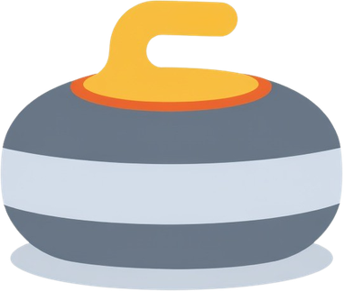
Magnetic Field Strength Curling

Purpose: Use magnets to propel a magnetic disk toward a target.

In this game, you will use a large “launcher” magnet to propel small magnetic disks toward a target, with the goal of landing as close to the center as possible to score the most points.

Rules:
  - Launcher magnets must remain behind the marked line on the playing field at all times.
  - Disks are launched by bringing a small disk close to the launcher magnet and then suddenly releasing it.
  - Use magnetic repulsion to cause the disk to slide across the playing field toward the target.
  - The disks must stay on the surface of the field; they should not be lifted into the air.

NOTE: The gameplay is like shuffleboard, curling, or horseshoes. You can use strategy to knock opponents’ disks away from the target or push your own disks closer to the center to earn more points.

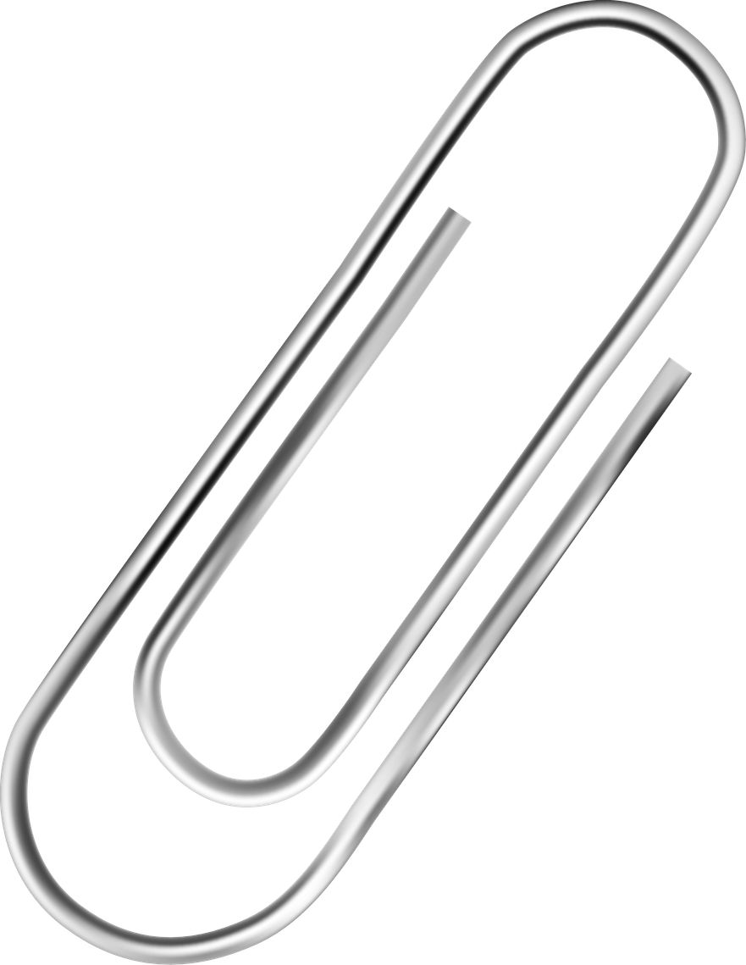
Magnet and Paperclip Play

Purpose: Freely experiment with magnets and paperclips.

Instructions:
- Test how many paperclips you can pick up using:
  - A couple of small magnets.
  - A stack of larger or stronger magnets.
- Compare results and discuss why stacking magnets changes the outcome.

- Explore magnetic repulsion:
  - Can you push two repelling magnets together without letting them snap apart?
  - Can this be done with a single pair of magnets?
  - What happens when multiple magnets are stacked to make a stronger magnet?

- Explore magnetic attraction and control:
  - Can you keep two attracting magnets close together without letting them touch?
  - How much effort does it take as the magnets get closer?

- Explore temporary magnetization:
  - Rub a paperclip along a magnet several times.
  - Observe how the paperclip becomes magnetized and can then pick up other paperclips.

- Draw and label images explaining your observations in the Activity Station 4 section of the worksheet.

