GIS Student Walk-Through Worksheet
Procedure
- Import historical tornado and hurricane data into Google Earth Pro by following these steps:
  - In the Google Earth Pro drop-down menu > click File > Import

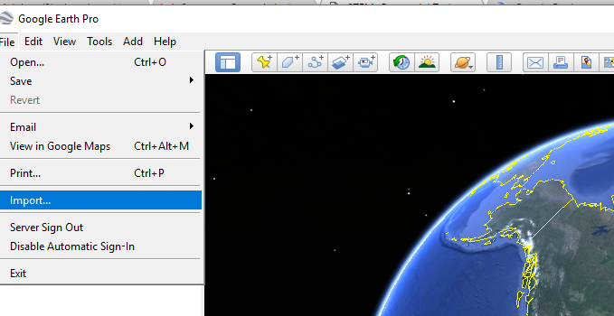

Figure 1. The Google Earth Pro drop-down menu.
  - In your downloads folder, find and open (unzip/extract) the zip file named:
Hurricane and Tornado Files. (Tip: You may want to first move this zip file to another location on your computer before unzipping it, since it contains many individual files.)
  - In the folder window, from a drop-down menu at the bottom > select “ESRI shape (*.shp)” to view all files of that type.
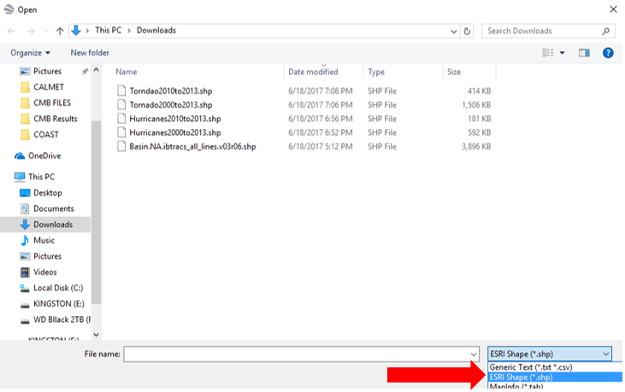

Figure 2. Select just the “ESRI Shape (*.shp)” files.

  - Select the data files you want. Start by selecting these two files, either:
Tornado2000to2013.shp OR Tornado2010to2013.shp
Hurricane2000to2013.shp OR Hurricane2010to2013.shp
If the 2000 to 2013 dataset is too large for your computer, use the 2010 to 2013 dataset files.
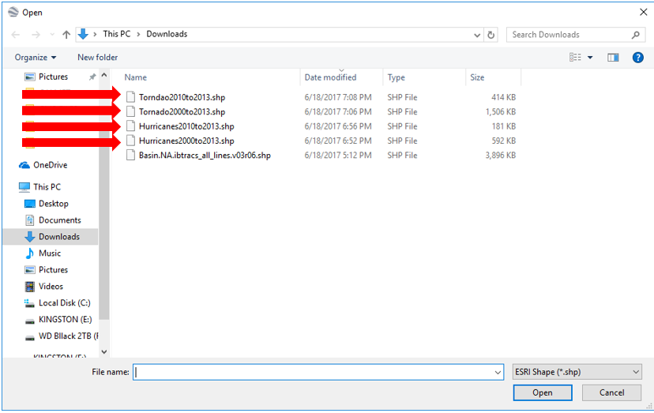
For either sets of years, choose the matching hurricane and tornado data so that you can analyze matching years.

Figure 3. Select the hurricane and tornado .shp files.
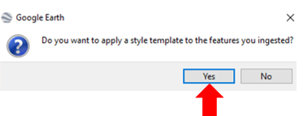
  - A prompt asks if you want to add a style
template > click Yes.
Doing this enables the data to be
depicted in different colors.

Figure 4. Choose “Yes” to add the style template.
  - At the Google Earth Pro prompt for the style template settings > select the Color tab > click “Use single color” > pick a color for this dataset. Note: For your next dataset, choose a different color.
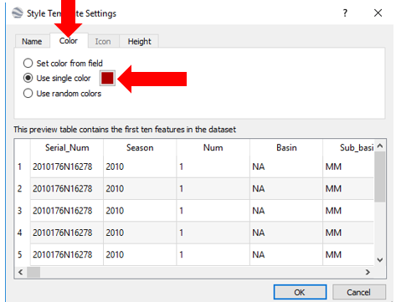

Figure 5. Style template color selection.

  - Select OK > select Save.
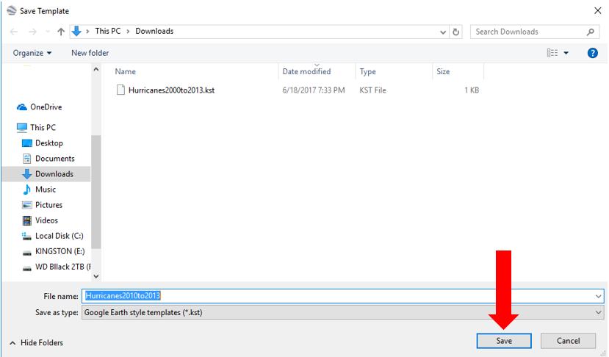

Figure 6. Save your style template color selection.

  - Nothing appears until the Tornado2000to2013.shp (or other appropriate file) box, on the left side of the screen under Places, is checked/selected.
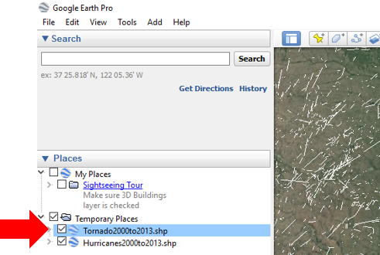

Figure 7. Under the Google Earth Pro “Places” section, choose your data files.

- Repeat step 1 so that both Tornado2000to2013.shp and Hurricanes2000to2013.shp are displayed in Google Earth Pro. (Alternatively, choose the two 2010to2013 files.)
- Once the data is visible, pick a state that you think has tornado events.
- Create a radius of 40 miles around its capitol city.
  - Click the measure tool (ruler button) at the top, middle of the Google Earth Pro window.
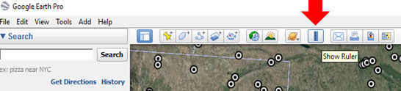

Figure 8. Select the measure tool.
  - When a window pops up > select the Circle tab > change the radius units to miles.
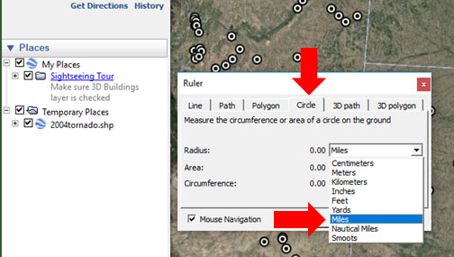

Figure 9. Select “miles” as the circle radius unit.
  - Use the curser to create a circle around your selected location.
  - After you create a circle > click Save.
Tornado Data Investigation Questions
- Within that radius, what is the number of tornados? (If more than 10, write 10+.) ____________
- Click on a data point and record the date that tornado occurred. ________________________
Based on the tornados you counted, what was the worst month for tornados? ____________
- Using the tornado date > search the Internet to find any information on that specific tornado.
- How strong was the tornado?
- Duration:
- Injuries and/or deaths:
- Other comments:

- Select a state that you think has hurricane events.
- Create a radius of 40 miles around its capitol city.
Hurricane Data Investigation Questions
- Within that radius, what is the number of hurricanes? (If more than 10, write 10+.) ____________
- Click on a data point and record the date that hurricane occurred. ________________________
Based on the hurricanes you counted, what is the worst month for hurricanes? ____________
- Using the hurricane date > search the Internet to find any information on that specific hurricane (the hurricane may have a name).
  - How strong was the hurricane?
  - Duration:
  - Injuries and/or deaths:
  - Other comments:
Combination of Tornados and Hurricanes Analysis Questions
- Did the location you choose have both tornados and hurricanes? ____________
- Could you move some place, in the same state, and be in a safer location? Explain.

- As an environmental engineer looking at the data, do you think the state government should reduce its disaster relief fund? Would you locate a hurricane/tornado relief center in your selected area? Would it be better to place the relief center in a different part of the state? Explain.

- Research the type of geography in the area. How does the local geography affect the formation and movement of hurricanes/tornados in this region?

- Discuss with another group how the number of hurricanes/tornados varied between your locations, and pulling in Question 4 research results, how geography might be a factor in the difference.

- Now that we have used GIS to represent the hurricane/tornado data, create a bar graph of the number of hurricanes/tornados. Graph the events based on month. What do you notice?
Do hurricanes/tornados occur during a specific times of year?

- Discuss with a neighboring group the value of presenting the data via GIS and in another graphical manner. Write down three highlights from your discussion.

