Create a Safe Pathway for Turtles - Design Sheet

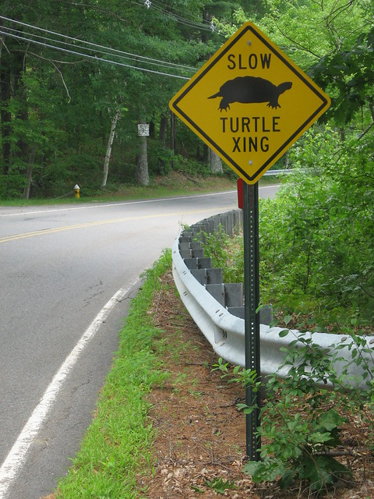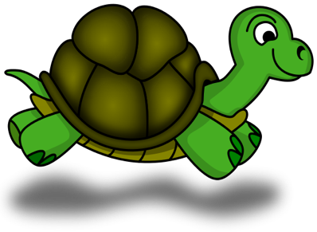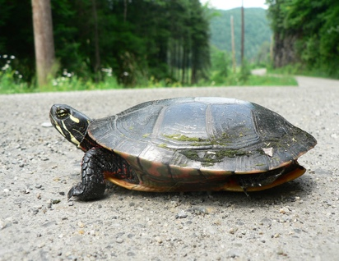
This Photo by Unknown Author is licensed under CC BY-SA
This Photo by Unknown Author is licensed under CC BY-SA
Ask: How can a turtle safely get around the road? Brainstorm ideas. Write them down. Now is the time to be creative. What are all possibilities?

 Imagine: What are the materials you will need to build your crossover? How will you use them?

Materials Use

Plan: Sketch and label your turtle crossing.

Create: Describe how the structure was built. What was your role in the process?

Improve: Describe some ways you improved your design while you were building. Describe how you would redesign the crossover if you started all over.

Reflect: Was your team correct in choosing the right materials? What worked? What did not work?

What was the hardest part about building your crossover?

Reflect on if your design is practical and how well it would work in the real world.

