Engineering Design Process Packet

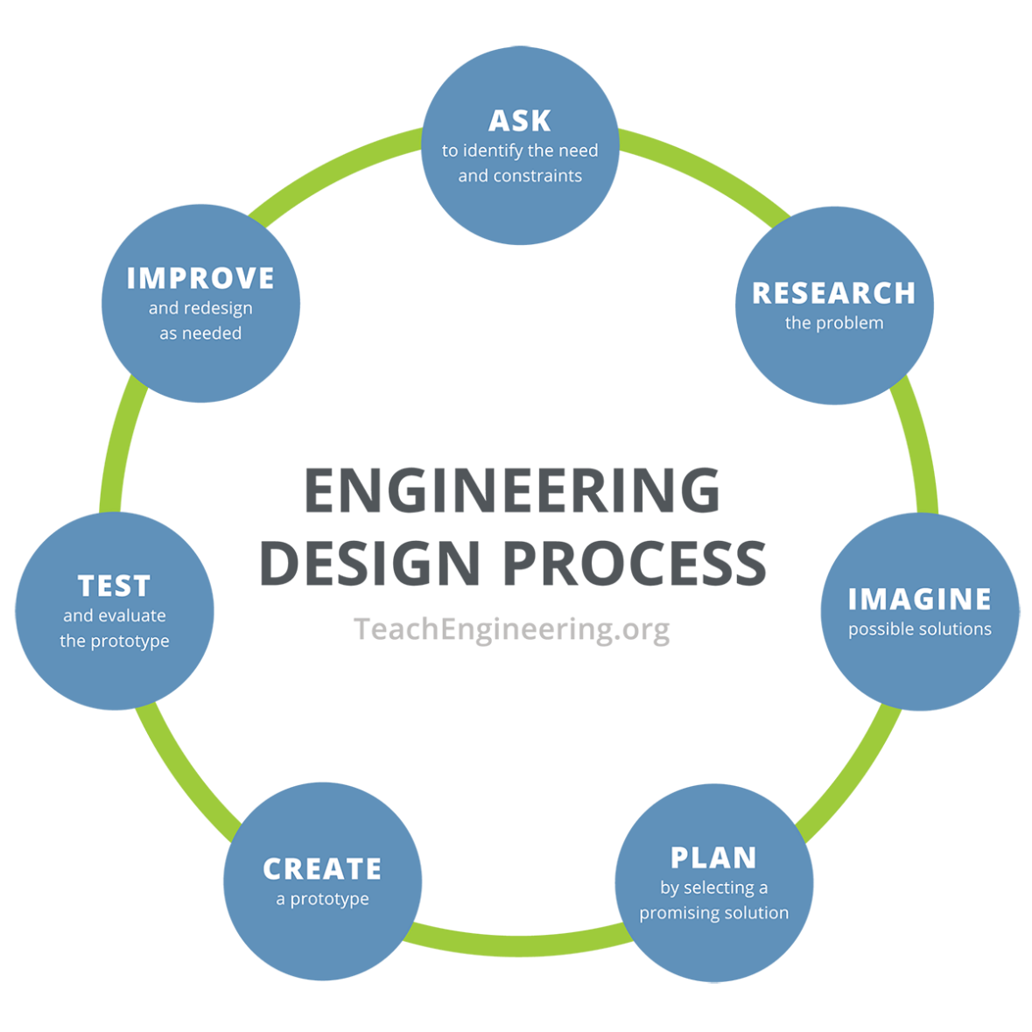
Instructions: Using the engineering design process, you and your team will act as robotic engineers tasked with programming a robotic arm to pick up objects and sort them into designated bins based on their color or size.

- Ask – Identify the need and constraints of the problem.
____________________________________________________________________________
____________________________________________________________________________
____________________________________________________________________________
____________________________________________________________________________
- Research
____________________________________________________________________________

____________________________________________________________________________
____________________________________________________________________________

____________________________________________________________________________
____________________________________________________________________________

____________________________________________________________________________

____________________________________________________________________________
- Imagine – Sketch three to four possible layouts or flow diagrams and consider potential challenges for each approach.

a | b
c | d

- Plan – As a team, select ONE solution. This can be one specific solution or a mixture of ideas. Draw your team’s solution in the box below.

- Create – Code and teleoperate the SO-101 leader arm.

- Test – Test your design (algorithm) and then answer the following questions.

What worked in your design, and why?

____________________________________________________________________________
____________________________________________________________________________
____________________________________________________________________________
____________________________________________________________________________
____________________________________________________________________________

What did not work in your design, and why?

____________________________________________________________________________
____________________________________________________________________________
____________________________________________________________________________
____________________________________________________________________________
____________________________________________________________________________

- Improve – Based on your testing and results, how would you improve your design? Why?

____________________________________________________________________________
____________________________________________________________________________
____________________________________________________________________________
____________________________________________________________________________
____________________________________________________________________________
____________________________________________________________________________
____________________________________________________________________________
- Iterate – Make changes and retest your updated prototype.
Did your changes improve your prototype? How?
____________________________________________________________________________
____________________________________________________________________________
____________________________________________________________________________

What worked in your updated design, and why?

____________________________________________________________________________
____________________________________________________________________________
____________________________________________________________________________
What did not work in your updated design, and why?

____________________________________________________________________________
____________________________________________________________________________
____________________________________________________________________________

