Sole Survivors Student Worksheet Answer Key

Part 1: Research & Design
Your Foot Condition: _____Plantar Fasciitis___________________________

Brief Description: Read the article provided and write 2-3 sentences explaining the foot condition and how an orthotic could help.
Plantar fasciitis is a common foot condition that causes pain in the heel and bottom of the foot. An orthotic can help by providing arch support and cushioning, which alleviates pressure on the plantar fascia and reduces pain during walking and standing.

Orthotic Design Goals: List what your orthotic needs to do to help with this condition
- Provide arch support
- Cushion the heel area
- Distribute pressure evenly across the foot

Sketch Your Orthotic Insole Design: Use the space below to draw the shape and label where you will use soft, medium, or firm foam.

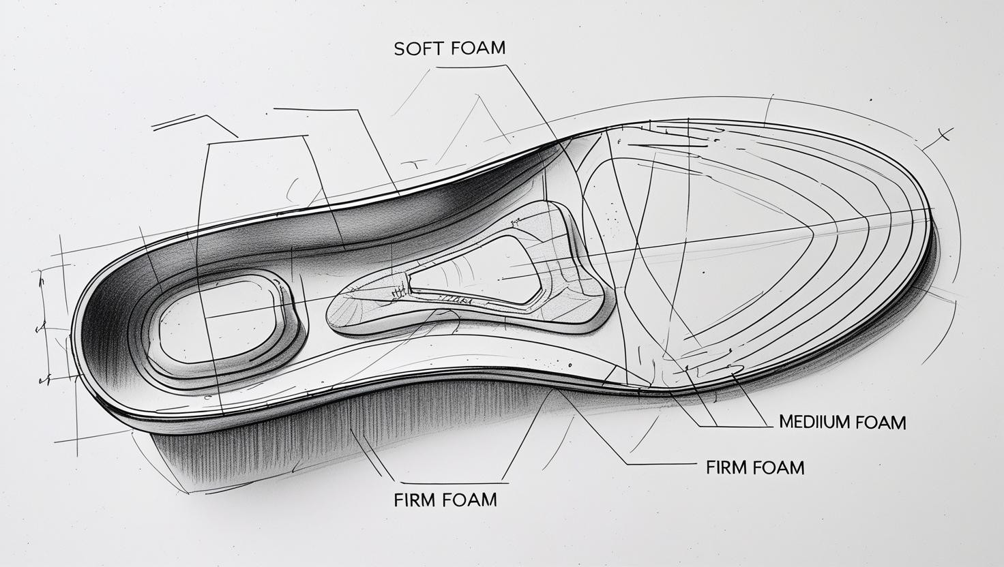

Part 2: Data Collection — Ball Drop Impact Test
Drop Height (cm) | Indent Depth (mm) Without Orthotic | Indent Depth (mm) With Orthotic
30 - simulates standing | 5 | 3
60 - simulates running | 10 | 6
90 - simulates jumping | 15 | 10
120 - carrying backpack | 20 | 12

Part 3: Graphing Your Results
Instructions: Use the grid to plot your indent depths (in mm) against drop height (in cm).
Create two separate graphs, one for “Without Orthotic” and one for “With Orthotic.” Label your axes clearly.

X-axis: Drop Height (cm) — Mark 0 to 160 cm in increments of 30 cm.
Y-axis: Indent Depth (mm) — Mark from 0 to max indent depth based on your data.

Graph 1: Without Orthotic Graph 2: With Orthotic
Graph 2 different lines for different thickness es of orthotics


Y-axis: Indent Depth (mm)
X-axis: Indent Drop height (cm)
10 20 30 40 50 60 70 80 90 100 110 120 130 140 150
5 10 15 20 25 30 35 40 45 50 55 60 65 70

Y-axis: Indent Depth (mm)
X-axis: Indent Drop height (cm)
10 20 30 40 50 60 70 80 90 100 110 120 130 140 150
5 10 15 20 25 30 35 40 45 50 55 60 65 70

Part 4: Analysis and Advertisement
- When you dropped the weight from a higher height, what happened to the force on the orthotic?
Answers will vary.

For example: When using the orthotic, I noticed that the indent depth was significantly less compared to when there was no orthotic. For example, at a drop height of 150 cm, the indent depth decreased from 30 mm without the orthotic to only 15 mm with the orthotic.

- Explain how the speed and kinetic energy of the weight affected the amount of energy transferred through the material.
Answers will vary.

For example: This indicates that the orthotic effectively cushions the impact and distributes pressure more evenly across the foot.

- How does your orthotic help reduce pressure on the foot?
Answers will vary.

For example: My orthotic helps reduce pressure on the foot by providing targeted support in key areas such as the arch and heel. The use of soft foam in the heel area absorbs shock during impact, while the medium-density foam in the arch supports the foot's natural shape. This combination helps to minimize stress on the plantar fascia and other structures, leading to less pain and discomfort during activities.

- Write a short advertisement slogan or message for your orthotic targeted to doctors:
Answers will vary.

For example: "Revolutionize foot care with our custom orthotics—engineered for comfort, and designed to alleviate pain! Give your patients the support they need for happier, healthier feet.”

