Investigations of Nitinol – Student Guide
Demonstration: Observations and Inferences
What are some things you notice about the demonstration? What is changing in the situation? (Be careful not to confuse what you see and observe with what you think is causing the changes.)
Observation 1:

Observation 2:

What do you think is causing the changes you see in the situation? What inferences can you make about the situation? What might be some of the causes of the observations you are making about the situation?
Inference 1:

Inference 2:

Make a list of questions you have about the situation you have observed. What do you wonder about the situation? What do you wonder about the possible applications of the situation?
Wonder question 1:

Wonder question 2:

Wonder question 3:

Engineering Design Process

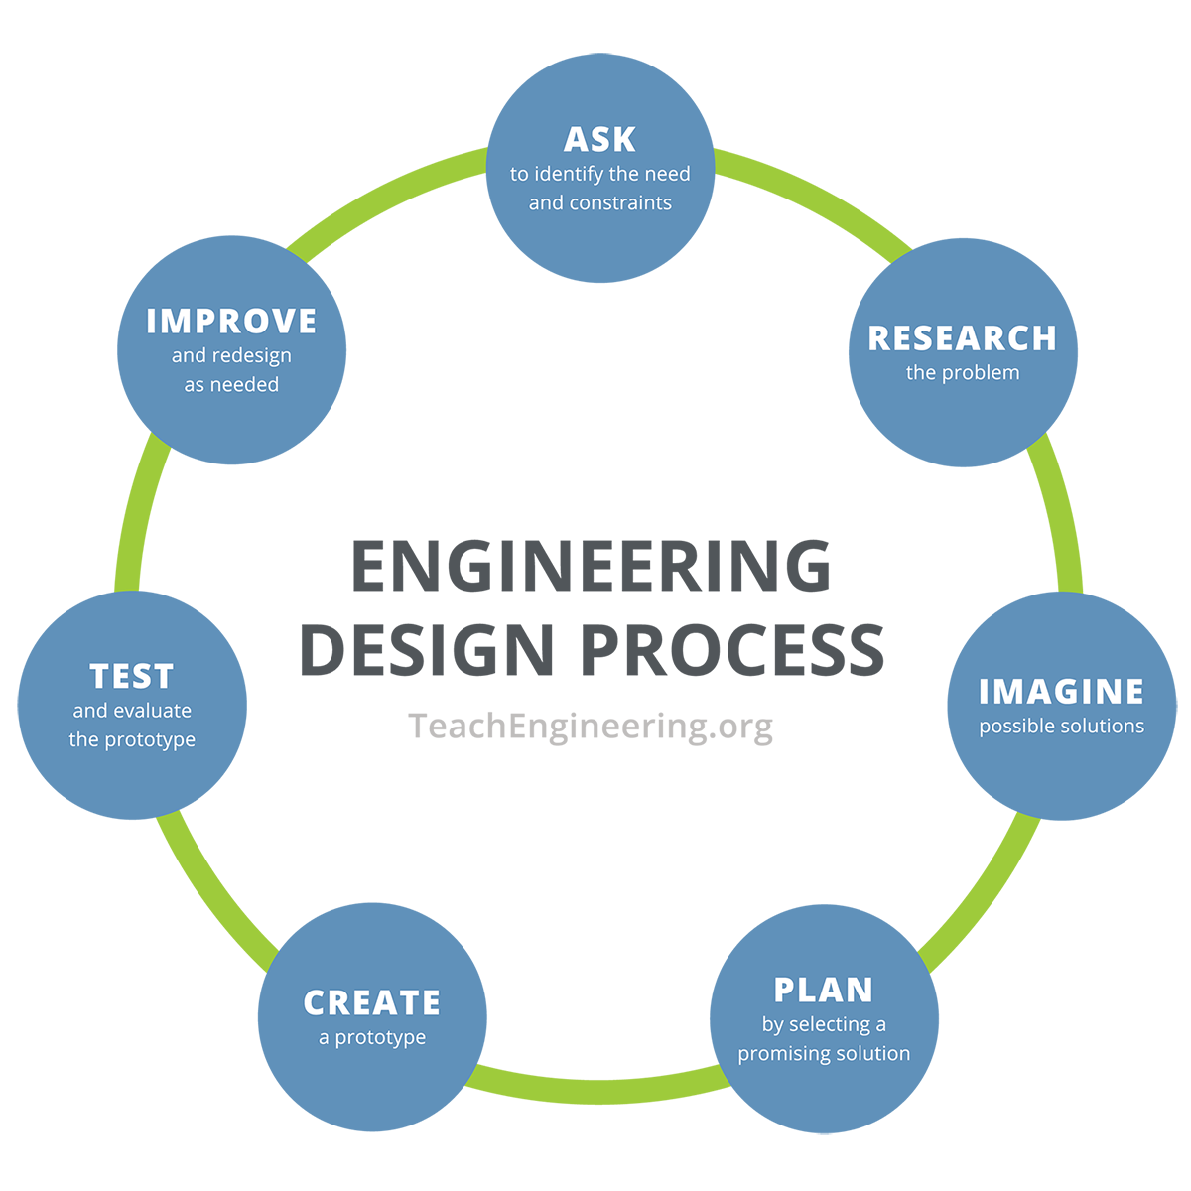
Research
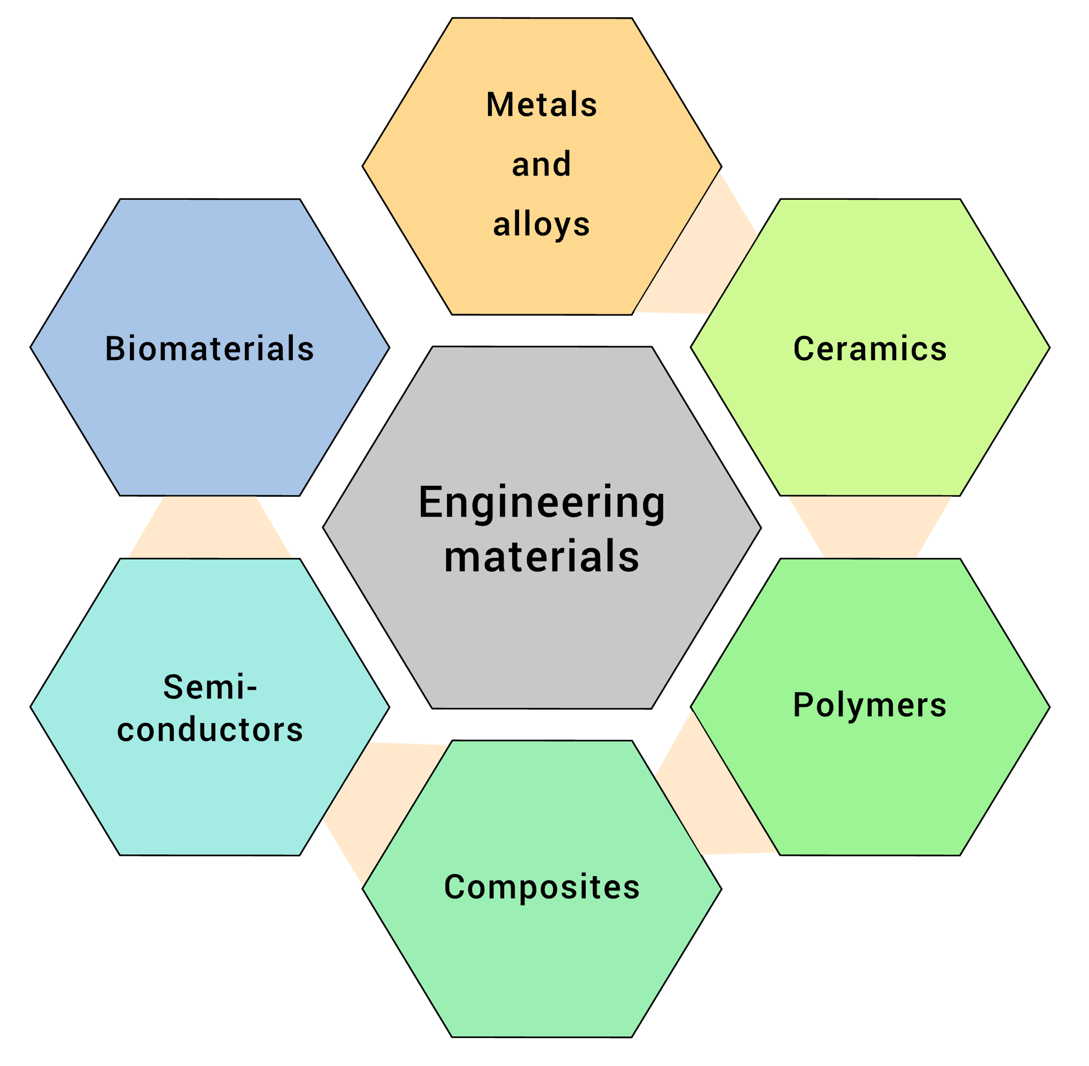
Instructions: Complete the following notes, diagrams, and discussion prompts as your teacher goes through the background slides for the activity.

Materials Science and Engineering
____________ ______________ work in an interdisciplinary field discovering new materials and understanding their ____________________.
____________ ______________ work to find _________ for materials in other fields and industries.

Thinking Like an Engineer
Engineers use a general process to __________ ___________ and ___________ _________________.
This process is called the engineering design process, and it includes the following steps:
- _____________ the problem
- _____________ the problem
- _________ solutions
- _________ a solution
- Create a ______________ design
- Test and ______________ the prototype
- ______________ design as needed
This process can repeat over and over because the goal is the _________ possible solution!

Background Information
Instructions: Complete the following chart to answer the questions about metals and nonmetals.

Type | Elements | Properties | Location on P. Table
Metals
Nonmetals
Structure of Metals and Nonmetals
Instructions: Complete the following as your teacher goes through the background slides.

Metals have a specific ___________________ micro-structure called a _______ _______.
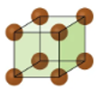
Unit cells have ____________ __________ that show the position of each of the atoms.
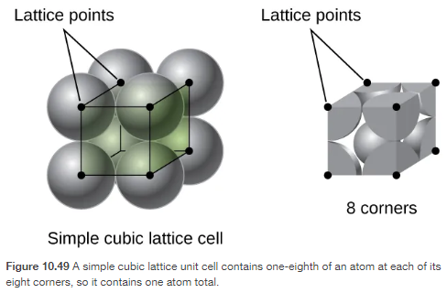

One type of unit cell pattern is called a __________ _______ _____________.

Structure of Nitinol (NiTi)
The ____________________ changes in the shape of NiTi are due to ___________________ changes in its ________________.
The NiTi structure starts as a _________ _______________ called __________________ and changes to a ______________ _________ structure called __________________.

____________________ _____________________
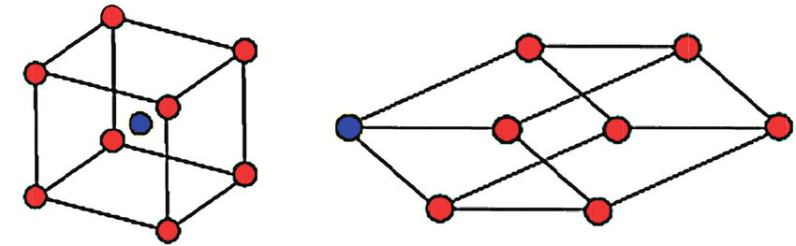

Imagine
Brainstorm as many ideas as you can for a device you want to create. Remember: There are no bad or crazy ideas!

Plan
Have each team member share their ideas. As a team, select ONE solution. This can be one specific solution or a mixture of ideas. Draw your team’s solution in the box below. Make sure to label parts and materials to be used.

Create – Build your prototype as shown in your group’s drawings.

Test – Test your design and then answer the following questions.

What worked in your design, and why?

____________________________________________________________________________
____________________________________________________________________________
____________________________________________________________________________
____________________________________________________________________________
____________________________________________________________________________

What did not work in your design, and why?

____________________________________________________________________________
____________________________________________________________________________
____________________________________________________________________________
____________________________________________________________________________
____________________________________________________________________________

Improve – Based on your testing and results, how would you improve your design? Why?

____________________________________________________________________________
____________________________________________________________________________
____________________________________________________________________________
____________________________________________________________________________
____________________________________________________________________________
____________________________________________________________________________
____________________________________________________________________________

Whiteboard Meeting Notes
Record the following from the board meeting:
- A difficulty a group encountered, and how they worked through it.

- A sketch of another group’s design or experiment.

- Four words, phrases, or images other groups used that explained their design or experiment well.

- Other miscellaneous notes:

