Part 4: Arduino Touch Sensor

Introduction:
In this activity you will construct a circuit and program the Arduino to connect the touch sensor and a single LED. The goal is to have the LED flash when you place your finger on the touch sensor.

Required materials:
- laptop with USB port
- Arduino Uno
- USB 2.0 cable, type A/B
- LED
- 2 220 ohm resistors
- mini breadboard
- touch sensor
- 4 jumper wires

Setup of circuit:

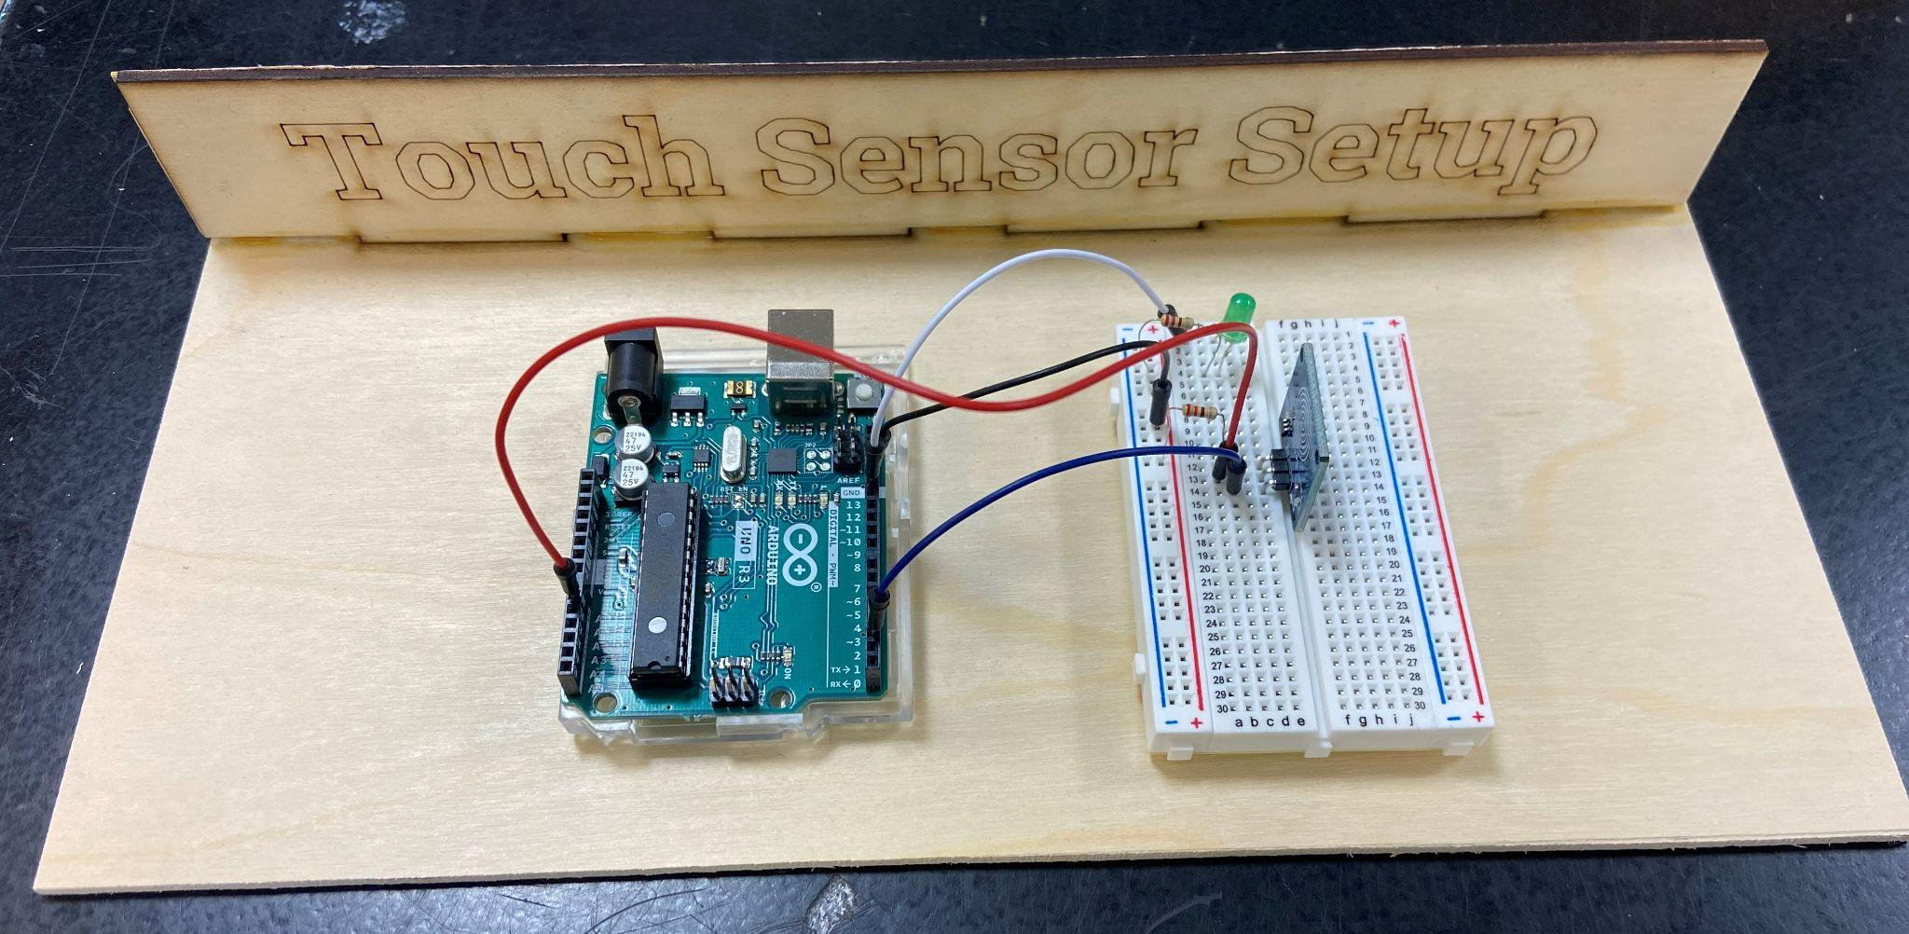

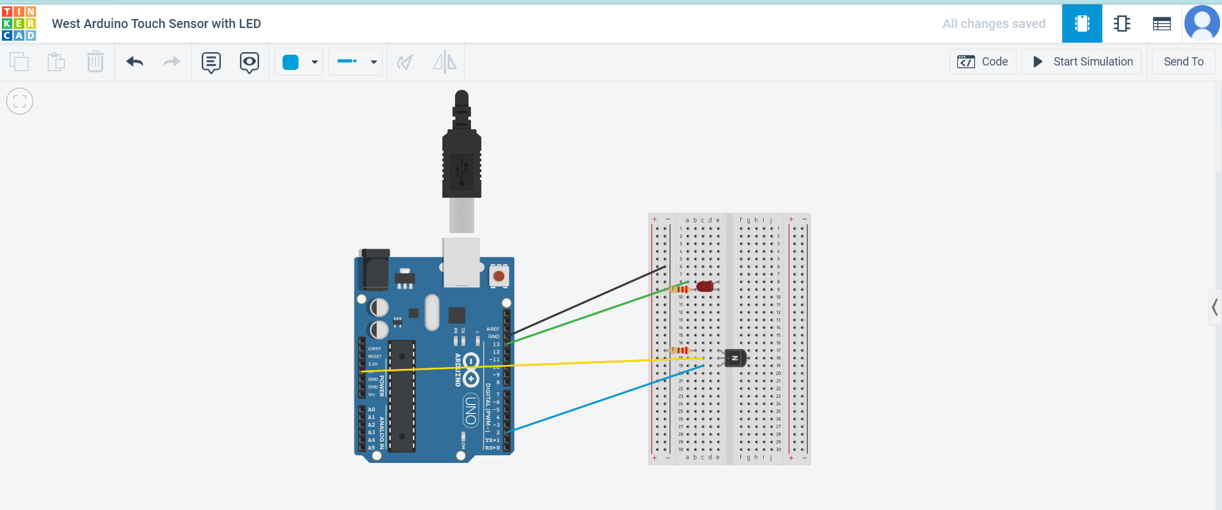

Connecting the touch sensor and LED through the Arduino:

- Once you have the circuit built, copy the following code into a new sketch.

// Capacitive Touch Sensor
// When Sig Output is high, touch sensor is being pressed

#define ctsPin 2 // Pin for capacitive touch sensor

int ledPin = 13; // pin for the LED

void setup()

{

Serial.begin(9600);

pinMode(ledPin, OUTPUT);

pinMode(ctsPin, INPUT);

}

void loop()

{

int ctsValue = digitalRead(ctsPin);

if (ctsValue == HIGH)

{

digitalWrite(ledPin, HIGH);

Serial.println("TOUCHED");

}

else{

digitalWrite(ledPin,LOW);

Serial.println("not touched");

}

delay(500);

}

- Compile and download to the Arduino.
- Click on the magnifying glass in the upper-right corner to open the Serial Monitor. 
- Press the touch sensor again, and the message in the Serial Monitor on the bottom of the screen should change from “Not Touched” to “Touched.”
- Show your teacher and get checked off for successfully completing this task.
- Name your sketch TouchSensor and save it to your desktop folder.

