Thinking Small – Worksheet Answer Key

Part 1
How small is small?
Instructions: Answer the questions below independently unless otherwise directed.

- Define small. What is small to you? What is the smallest thing you own?

Student answers will vary

- Look around the room and write down the smallest item that you can see.

Student answers will vary

- So then, what is smaller than small? What is the smallest thing you know about but can’t see? Brainstorm with your group and write your ideas below.

Student answers will vary

- If you can’t see the things you wrote about above, then how do you know they exist? Brainstorm with your group and write your ideas below.

Student answers will vary. Some ideas might be…
- They know that people can get sick from bacteria and viruses even though we can’t see them
- Mold grows on rotting food
- Tiny objects have to eat even tinier objects (which cannot be seen)
- Everything is made of something else, even small things

Can you put the items on the cards in order by size?
Instructions: With your group , complete the card sort by arranging the objects on the cards in order or largest to smallest, then answer the questions below. When you are done, fill in the chart to check your work.

- Which item did you identify as the smallest? Why? Which item did you identify as the largest? Why?

Student answers will vary

- Were there any items that were tough to place? Why?

Student answers will vary

Check your work! Look through the Scale of the Universe (https://htwins.net/scale2/) to check the order of your card sort. Find the objects on the computer program and record their size below in the chart.

CHART FOR SCALE OF THE UNIVERSE
Rank Largest to Smallest | Object | Size in Scientific Notation (Click on the Object)
1 (Largest) | The Sun | 1.4 x 10⁹ km
2 | The Earth | 1.27 x 10⁷ km
3 | The Moon | 3.5 x 10⁶ km
4 | Football Field | 1.097 x 10² m
5 | Human | 1.7 x 10⁰ km
6 | Marble | 1.5 x 10⁻² m
7 | Coffee Bean | 1 x 10⁻² m
8 | Ant | 4 x 10⁻³ m
9 | Dust Mite | 3 x 10⁻⁴ m
10 | Width of Hair | 1 x 10⁻⁴ m
11 | X Chromosome | 4 x 10⁻⁶ m
12 | Bacteriophage | 2 x 10⁻⁷ m
13 | Carbon Nanotube | 1 x 10⁻⁹ m
14 | Hydrogen Atom | 3.1 x 10⁻¹¹ m
15 (Smallest) | Single Electron | 5.64 x 10⁻¹⁵ m

Part 2
How do we measure small things?
Instructions: Read the segment below and independently complete the conversions that follow. Check answers with your group before moving on to Part 3.

Reading Segment
How do scientists measure objects? Scientists use the International System of Units (SI). In the chart below are the base units for measurements we will make frequently. To measure quantities, scientists use specialized equipment. You will be measuring primarily the physical quantities below.

Physical Quantity Measured | Base SI Unit | Symbol
Temperature | Kelvin | K
Mass | Kilogram | kg
Volume | Liter | L
Length | Meter | m
Time | Second | s

Scientists also need to convert between units of measurement. For example, a scientist may ask for 400 ml (milliliters) instead of 0.4 L of a liquid, or they may ask for 20 mg (milligrams) instead of 0.020 g (grams). Knowing how to convert between units is very important. Using the table below let’s practice a couple of unit conversions.
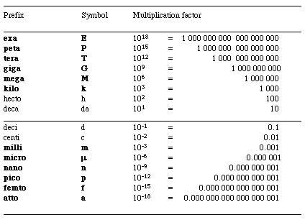
- Convert 25 microliters into liters. _0.000025_ L

- Convert 0.357 liters into milliliters. ____375_ mL

- Convert 37 centimeters into meters. _0.37__m
- Convert 78 milligrams into grams. __0.078___g

- Convert 48 nanometers into meters. 0.000000048m

- Convert 5 grams into milligrams. _5000__mg

Part 3
Practicing Taking Measurements
Instructions: Complete the three challenges below with your group. Make sure all measurements go on this worksheet.

Measuring Mass (grams) and Volume (Liters) in science uses a special set of equipment. In this activity, we will use scales, beakers, graduated cylinders, plastic pipettes, and micropipettes. When measuring volume in science it is extremely important to measure accurately. Therefore, we must think about what equipment we must use to get the best measurement.

Challenge 1 (Measuring Mass)
How do we measure mass? Examine your scale and think about the following questions: What do you see on your scale? What are the different units your scale can measure in? What unit will we use to measure? How do you know your scale is set to that unit?

Taring your scale: When we weigh materials, we often need to put them in a container in order to weight them. However, we don’t want to count the weight of the container when we are measuring the mass of the material. To negate the weight of the container, place an empty container on the scale and press the “tare” button. Let’s practice!

- Weigh 3 grams of salt. Which object is closest in size to your pile of salt? A loaf of bread, a cell phone, a ping pong ball, a pencil eraser, or the tip of a pencil?
Tip of a pencil
- Weigh 15 grams of salt. Which object is closest in size to your pile of salt? A loaf of bread, a cell phone, a ping pong ball, a pencil eraser, or the tip of a pencil?
Ping pong ball
- Now that you are a professional, explain in writing what you do when using a scale to measure the mass of your substance below.
Student answers will very but should include the following:
Tare the weigh paper or weigh tray, slowly add what you are weighing to the scale
Remove material carefully with scoopula if you go over

Challenge 2 (Measuring Volume)
In science we need to be accurate in our measurements. That means choosing the right size tools that will give us the most accurate measurement. Using graduated cylinders of various sizes to measure the different volumes, select the best one, and measure the volume. Record what size graduated cylinder you used and explain why you selected that size.

- 7 mL: Answers will vary depending on what size graduated cylinders you make available to students

- 15 mL: Answers will vary depending on what size graduated cylinders you make available to students

- 28 mL: Answers will vary depending on what size graduated cylinders you make available to students

57 mL: Answers will vary depending on what size graduated cylinders you make available to students

93 mL: Answers will vary depending on what size graduated cylinders you make available to students

Challenge 3 (Measuring Volume Using Micropipettes)
Sometimes you need to measure volumes that are too small to use a graduated cylinder. What would we do then? For example, how would we measure 2μL? 15μL? 25μL? To measure these volumes, we will need to use special tools called micropipettes. Follow the three steps below to learn about and use your micropipette

Step 1: To introduce micro-pipetting, watch the video, Lab Skills: Micropipetting Basics (https://www.youtube.com/watch?v=22Y34316nZs) and answer the following questions:

- What is the role of the “plunger”?
To release and uptake material into the micropipette tip

- Can you measure 500μL on a P200? Why or why not?
You cannot because the p200 only measures up to 200 μL

- How often should you reuse a pipette tip?
Whenever you change the material you are measuring or if the tip gets contaminated

- When measuring liquids, do you push the plunger to the first or second stop before inserting it into the liquid
First

- True or False: your micropipette tip should touch the bottom of the liquid container to get the best measurement.
False

- True or False: you should remove the tip once you are done by grabbing it with a gloved hand.
False

Step 2: Practice using your pipette to measure the liquid amounts below. Remember to set the micropipette for the amount you want to measure and get a clean tip before you measure! All measurements should go into the labelled “liquid waste” beaker

- 25 μLs red water
- 70 μLs blue water
- 103 μLs red water
- 141 μLs blue water

Step 3: Reflection Questions

- When do you think researchers use micropipettes? When in this class do you think we will use micropipettes?
Student answers will vary

- What is the hardest part of using the micropipette?
Student answers will vary

- If you were teaching your friend how to use a micropipette for the first time, what do you think is really important for them to know?
Student answers will vary but should include calibrating the micropipette, putting the tip on by pressing it into the tip tray, pressing down to the first stop, inserting tip into the liquid at the top, releasing plunger, holding the micropipette vertically as you hold it over the microcentrifuge tube or liquid waste, press slowly to second stop, then release the tip into the sharps waste.

Part 4
What about the things we can’t see? How do we measure things that are too small to be seen?

Scientists can’t always use scales, graduated cylinders, and micropipettes to see and measure materials. Sometimes those objects and particles are just too small to see or measure without specialized equipment like microscopes. You learned about the electromagnetic spectrum in your physics class last year! Analyze the figure below with your partner. What can you tell me about light waves, wavelengths, frequencies, and some technological applications at different wavelengths?

So how do scientists use microscopy to see and manipulate very tiny objects? Let’s watch a segment of Mysteries of the Unseen World (from 21:38 - 35:00 https://www.youtube.com/watch?v=OzFvGx6DZOs). As you watch this segment, record the answers to the questions below.

I. Compound Microscope:

- How does a compound microscope work to visualize small creatures?
By stacking lenses and using light to magnify the images under the lenses

- What are the limitations of a compound microscope? Why?
Cannot see down to scales of butterfly’s wings because visible light waves are too big to be seen on the compound microscope and everything smaller is out of focus

II. Scanning Electron Microscopy:

3. How does Scanning Electron Microscopy (SEM) work to allow us to see items smaller than visible light?
By firing electrons at the object to form an image that can be magnified over a million times

4. What are some examples of things you can see with a Scanning Electron Microscope?
The scales in a butterfly’s wings that only reflect blue light, a butterfly egg, shark skin, caterpillar mouth,
fruit fly eye, snail tongue

III. Nanoworld:

- What is special about the…
  - Lotus Flower: repels almost any liquid

  - Gecko’s Feet: feet covered by bristles with split ends that have sticking power

  - Spider Silk: stronger than steel and elastic 100x thinner than human hair

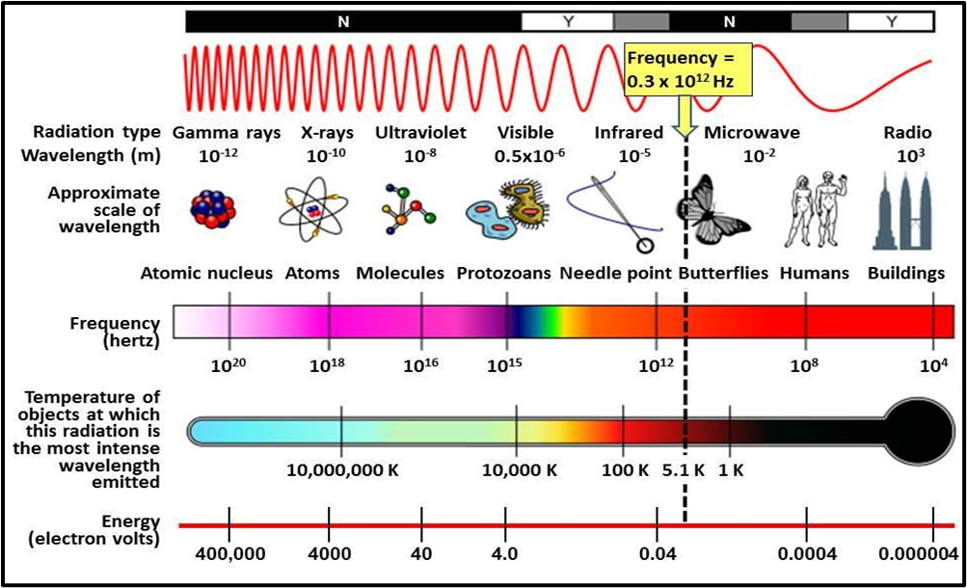

6. How would you describe the nanoworld?
Student answers will vary

7. Why do you think the nanoworld is the new frontier?
Student answers will vary

8. What can our most advanced microscopes do?
They can show individual atoms

Part 5
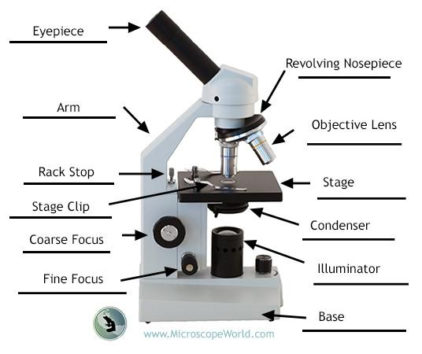
Focusing on the Small Things!

In this activity, you will use the Compound Light Microscope. Light microscopes use both objective lenses and eyepiece lenses to help magnify objects so that you can see them. Microscopes have been used in Biology since Antonie van Leeuwenhoek (1632–1724) first used them, although his microscope was much simpler. The image to the right will help us review the parts of the microscope. Before we use it in class though, let’s review some basic information.

- How do we carry the microscope?

Carry the microscope with both hands. One hand should be on the arm of the microscope and the other hand should be underneath the base. (Answers here may vary slightly from what students have learned in previous classes, this is an opportunity for them to access prior knowledge).

2. What steps do you take to use the objective lenses to find your object of interest?

Starting with the smallest lens (least magnifying), use the coarse focus to move the stage closer to or farther away from the lens. Move very slowly and check the stage distance from the lens to avoid cracking the slide. Once you have a good coarse focus of the specimen you can use the fine focus to make the image even more clear. To change objective lenses, drop the stage slowly to the lowest position and then turn the objective lens to the next highest magnification and refocus using the same previous process. (Answers here may vary slightly from what students have learned in previous classes, this is an opportunity for them to access prior knowledge).

Now try it yourself! Select one of the organisms on the slides before you and practice visualizing them at different powers. Draw what you see below:

Student drawings will vary
Student drawings will vary
Student drawings will vary

10X
40X
4X
Now that you are good at finding an organism in a fixed slide, let’s see if you can find any organisms in a drop of pond water on a wet slide! To do so place one drop of pond water on your clean slide. Carefully place the coverslip on top of it, and then move your slide onto the stage! Draw what you saw in the pond water below!

Student drawings will vary

