UNIT Template

Part 1: Unit Overview
Title | Enter your Unit title here.
Focus Grade Target Check the grade band that applies to this Unit. | ​​☐​ Lower Elementary School (K-2)  ☐​ Upper Elementary School (3-5)  ☐​ Middle School (6-8)  ​☐​ High School (9-12)​
Subject Area(s)  Check all subject areas that apply to this Unit.  Subject area definitions | ☐​ Algebra  ​☐​ Biology  ​☐​ Chemistry  ☐​ Computer Science  ​​☐​ Data Analysis and Probability  ☐​ Earth/Space  ☐​ Geometry  ​☐​ Life Science ​ | ☐​ Measurement  ​​☐​ Numbers and Operations  ☐​ Physical Science ​  ☐​ Physics ​  ☐​ Problem Solving  ​☐​ Reasoning and Proof ​​  ☐​ Science & Technology
Time Required | Enter the total time required (in minutes) to complete the Unit. (Note: This should be the sum of all associated lessons and activities.)
Keywords | Add 4-10 words here in alphabetical order that a layperson or teacher may use to search for your Unit.

Unit Content Summary – 50-100 words
Briefly summarize what topic/content the Unit covers using the present tense. Do not summarize the associated lessons and activities. This should be a summary of the unit as a whole.

For example:
Water is essential to life. Understanding how the water cycle works, the importance of water as a natural resource, and how our household water cycle functions is essential knowledge for everyone. Through a range of water-based explorations and the engineering design process, students learn about the water cycle and how engineers manage it.

Engineering Connection – 60-100 words
Describe how the scientific and mathematical concepts being studied in this Unit pertain to real-world engineering. Explain for the teacher how everyday engineering ties to what is being done in this Unit. (Do not just summarize the Unit content.) See an example.

Unit Overview – 200 words
In paragraph form, summarize what students learn in the associated lessons and activities of the Unit.

For example:
Through a series of three lessons and one activity, students are introduced to inertia, forces and Newton's three laws of motion. For each lesson, a combination of class demonstrations and PowerPoint® presentations are used to explain, show and relate the concepts to engineering. Lesson 1 starts with inertia, forces and Newton's first law of motion. Lesson 2 builds on lesson 1 with a review and then introduces Newton's second law of motion. Lesson 3 builds on the previous two lessons with a review and then introduces Newton's third law of motion. In a culminating activity, students apply their knowledge of forces, friction, acceleration and gravity in an experiment to measure the average acceleration of a textbook pulled along a table by varying weights, and then test the effects of friction on different surfaces.

Unit Schedule
List the suggested order of the associated lessons and activities along with their durations and brief descriptions in this Unit.

For example:
The following schedule provides a suggested order of the lessons and activities. However, you may choose to only teach some of the lessons and/or activities – as time and priorities permit.
Duration | Activity/Lesson Name | Brief description/Learning highlights
60 min | Paper Tower Design Challenge (Activity) | Students work as civil engineering teams in small groups to design and construct model towers out of paper with minimal teacher guidance on completing the challenge.
120 min | Efficient Car Design Challenge (Activity) | Students learn how a car's aerodynamics and rolling resistance affect its energy efficiency by designing and constructing model cars out of simple materials
60 min | Straw Bridges Design Challenge (Activity) | Working as engineering teams, students use the engineering design process to plan, create, and test model bridges.
60 min | Tinkercad Circuits & EV Motor Workshop (Lesson) | Students follow a guided engineering skills workshop presentation using the free online Tinkercad web app learning the basics about circuits, using a simulator to create circuits, and applying these skills to build a model EV electric motor.
600 min | Electric Vehicle Design Challenge (Activity) | Students creatively collaborate in teams to design, build, test, and iterate a model electric vehicle (EV) car that runs on a battery-powered electric motor circuit. In a final design expo, teams have the opportunity to present their final EV model, their design process journey, and their perspectives on the intersection of engineering and environmental resiliency regarding EVs.

Other Related Information (optional)
List any other relevant information to this Unit here. See an example.

Part 2: Contributor, Supporting Program, Acknowledgements
Contributors
List the names of any person (including yourself) who participated in the development of this Unit (e.g., other teachers, mentors, lab directors, education staff, etc.). List the primary author first.

Supporting Program and Acknowledgements

If this instruction was developed as part of a special program, list the name of the supporting program and/or organization AND provide the grant number, if applicable.

For example:
Research Experience for Teachers (RET), University of Houston
This curriculum was developed under National Science Foundation RET grant number ABC-XXXXXXXX. Any opinions, findings, and conclusions or recommendations expressed in this material are those of the authors and do not necessarily reflect the views of the National Science Foundation

Part 3: Photos, Images, and Figures
Unit Photos, Images and Figures
Teach Engineering requires a minimum of TWO photos or images per Unit to help teachers visualize the nature of the Unit. (There are placeholders below for photos and images, but we encourage you to add as many as you like.)

Please DO NOT use photos or figures from the Unit’s associated Lesson(s) and Activities here. These should be NEW photos or images, directly related to the Unit overall. You may supplement images sourced from the internet as long as they are licensed for public use (e.g., Wikimedia Commons, Flikr and Pixabay). Note: if authors plan on submitting photos that include their students, the author is responsible for securing the appropriate permissions from parents, guardians, or administrators.

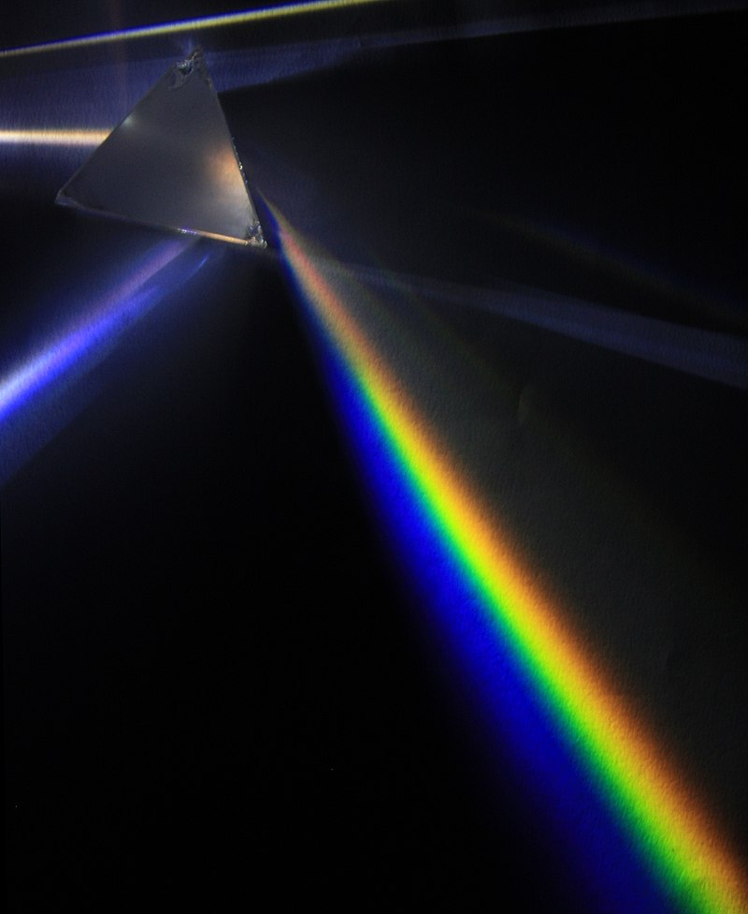
For example:
Image 1: Insert into Procedure under “Day 1”
Image file: unit-image1-prism.jpg
ADA Description: A glass prism sits on a black background; a light source shining through the prism is demonstrating refraction of white light into the visible light spectrum.
Source/Rights: 2009 D-Kuru, CC BY-SA 3.0, Wikipedia, source link.
Caption: Why does white light diffract into the colors of a rainbow when it shines through a prism?

Insert your image on the left. Include all required information (e.g., File name, ADA description, Source/Rights, Caption) for that image in the Image Box to the right. Also, make sure to include each image in jpg or png format with your submission.
Image 1 / Figure 1

File name: The photo must be included as an attachment and must have the exact same name as you type here. Example: unit-image1.jpg

ADA Description: Write this text as if describing key elements of the image to a blind person.

Source/Rights: Include copyright or identifying information for any images used. Images from the Internet should be either in the public domain or licensed for use through Creative Commons (CC-BY or CC-SA); you must still attribute them to the person or website from which they were pulled as well as provide a direct link to the image.

Caption: This text will appear directly below the Image. This should not be the same text as used for the ADA Description.



Image 2 / Figure 2: Enter the location of where you want the image or figure in the text by saying (Insert Figure 2 here).

File name: Example: unit-image2.jpg

ADA Description:

Source/Rights:

Caption:

