HANDS-ON ACTIVITY Template

Part 1: Activity Overview
Title | Enter your Activity title here.  Make sure the title clearly describes WHAT students will be doing (e.g., Engineering a Gatorade Gravity Machine for Soccer Practice.)
Focus Grade Target Check the grade band that applies to this Activity. | ​​☐​ Lower Elementary School (K-2)  ☐​ Upper Elementary School (3-5)  ☐​ Middle School (6-8)  ​☐​ High School (9-12)​
Subject Area(s)  Check all subject areas that apply to this Activity.  Subject area definitions | ☐​ Algebra  ​☐​ Biology  ​☐​ Chemistry  ☐​ Computer Science  ​​☐​ Data Analysis and Probability  ☐​ Earth/Space  ☐​ Geometry  ​☐​ Life Science ​ | ☐​ Measurement  ​​☐​ Numbers and Operations  ☐​ Physical Science ​  ☐​ Physics ​  ☐​ Problem Solving  ​☐​ Reasoning and Proof ​​  ☐​ Science & Technology
Time Required | Enter the total Time Required (in minutes) to complete the Activity. For longer activities, please add a brief explanation for how to break up the time, such as “three 50-minute class periods”.
Expendable Cost Per Group | ​​​​In US dollars; list the total material costs that are associated with this Activity per group that cannot be re-used in another Activity. For example, do not include the cost of common classroom or laboratory items such as scissors, paper, a microscope, or beakers.​  Important Note: we strive to meet the “engineering on a shoestring” approach. If the Activity requires substantial non-expendable items that are not typically found in classrooms, such as Arduino, LEGO robots, etc., please contact the editors at Teach Engineering.
Group Size  Check the box that applies to this Activity. | Independent (1 student) ☐  Pairs (two students) ☐  Small groups (three to five students) ☐  Whole class ☐
Setting | Check all that apply:  Formal Classroom/ In-School ☐  Informal Learning/ Out-of-School (i.e., museum, community center, camp, other non-school settings) ☐
Keywords | Add 4-10 words here in alphabetical order that a layperson or educator may use to search for your Activity.
Testing Information
Briefly describe the K-12 formal or informal testing conducted with this curriculum. Please include the date, school/group, location, grade level, and number of students.

Summary – 200 words
Summarize what your Activity is about in one paragraph using the present tense. See an example.

Engineering Connection – 60-100 words
Describe how the scientific and/or mathematical concepts being studied in this Activity pertain to real-world, everyday engineering. (Do not recap the Activity summary.) ​See an example.​

Educational Standards (optional)
In priority order, list up to four educational STEM standards that students would learn because of completing this Activity. For each standard, include the source, year, grade band, standard nomenclature (e.g., number(s)/letter(s)), and standard summary. Note: If your activity is strictly designed for informal learning, standards are optional.

Provide at least TWO from the following:
- List Next Generation Science Standards (NGSS)
- List Common Core Math Standards (CCSS)
- List Standards for Technological and Engineering Literacy (STEL)
- List The Computer Science Teachers Association (CSTA) Standards
- List State Science and/or Math Standards

For example:
North Carolina, science, 2004, 1.01 (grades 8-8): Identify and create questions and hypotheses that can be answered through scientific investigations. ID# S1028531.

Learning Objectives
Using bullet points and statement form, identify up to three main goals or student outcomes of the Activity.

For example:
After this activity, students should be able to:
- Describe the flow of electrical energy through a simple circuit.
- Solve problems involving pressure, density and Pascal's law.
- Think and outline design iteration suggestions.

Prerequisite Student Knowledge (optional)
List any skills or knowledge a student must already have to be successful in this Activity, such as knowledge of a certain concept or topic, specific math skills, etc.

For example:
Students should have:
- a familiarity with compass directions.
- a basic understanding of gravity and friction.

Part 2: Activity Instructional Plan
Equipment and Materials
Create a detailed, bulleted list of all equipment, materials, and multimedia resources needed for the entire Activity.
- Specify the quantity of each item per group, per student and/or per class, as appropriate.
- Provide all measurements in metric units - include US or English units if helpful [e.g., “a length of string, 2 m (~6 ft.)”]
- Provide links to specific materials that may be harder to find.
- If your activity requires expensive materials, list lower-cost alternatives that educators can use so they can still complete all or parts of the Activity.

For example:
Each group needs:
- 1 laptop computer with access to the internet (for research purposes)
- 10 g iron filings
- 1 Arduino Uno microcontroller (available online)
- Engineering Design Worksheet, one per student

For the entire class to share:
- various filter media, such as cotton balls, cheesecloth, cotton cloth or whatever is available
- poster paper
- magic markers
- Access to this Minga work video #1 (2:01): The Essence of the Minga
- 1 wooden plank

Introduction and Motivation (for students) – at least 250 words (or about 1/2 page)
Write a 5-minute educator script to introduce the Activity, written in the educator’s voice and directed to students. This could:
- Connect to a real-world phenomenon or problem that reflects authentic science or engineering practice.
- Incorporate phenomena-based learning or problem-based learning to spark curiosity and sensemaking — for example, by showing a short video, image, or demonstration.
- Use motivating questions such as:
  - “What do you notice?”
  - “What do you wonder?”
  - “What problem are we trying to solve?”
  - “Why might engineers care about this?”
- As you introduce the activity, briefly consider how it reflects learner-centered design for a wide range of learners:
  - Center People and Purpose
    - Who is this problem for?
    - How might different people experience it differently?
    - Tip: Invite empathy and real-world relevance.
  - Engage All Learners
    - How can this activity better connect to students’ lives or communities?
    - How are students invited to share ideas and questions early-on?
    - Tip: Use open prompts and learner-relevant examples.
  - Represent Ideas Clearly and Accessibly
    - Are key ideas explained in more than one way (e.g., talk, visuals, demo)?
    - Is language clear and supportive for a diverse range of learners?
    - Tip: Keep instructions simple and scaffold where needed.
  - Support Multiple Ways to Participate
    - How are students positioned as active problem-solvers?
    - What are the multiple ways learners can contribute or approach the problem?
    - Tip: Emphasize that there are many valid solution pathways.
  - Design for Belonging and Flexibility
    - How may students see themselves reflected in the context?
    - How can this activity adapt to different learners or settings?
    - Tip: Frame the work as iterative, collaborative, and open-ended.

- Include educator instructions and answers in parentheses, such as: (Write the equation on the classroom board.) or (Possible answers: xxx, yyy, zzz.)

See an example.

Procedure
Develop a comprehensive instructional guide for the educator to employ for this Activity using the following three-section format. Note: All THREE sections (i.e., Background, Before the Activity, and During the Activity) MUST be completed thoroughly.

To clarify the Activity setup and procedure, reference images, figures and photos throughout this section. Reference where you want the image to go simply saying (Insert Image/Figure/Photo 1) in the text. Ensure that any images referenced here are added appropriately in Part 5: Photos, Images, and Figures.

- Background (Educator's Guide)
Clearly explain (for educators' reference only) any essential background information (such as the explanation of science, engineering and/or math concepts related to the Activity) the educator may need to know to successfully complete this Activity. This should be written in paragraph format.

- Before the Activity (Preparation)
Provide a bulleted list describing all necessary educator preparation steps. This must include materials gathering, document copying, workspace setup, and any pre-assembly required.

For example:
- Gather materials and make copies of the worksheet…
- Describe any other pre-activity preparation here…

- During the Activity
Outline the exact steps an educator follows to guide students through the entire Activity. Be as detailed as possible. This should be a numbered list with each step beginning with a strong verb. Be detailed enough for an educator unfamiliar with the activity to execute it successfully. Integrate the seven steps (i.e., Ask, Research, Imagine, Plan, Create, Test, and Improve) of the Engineering Design Process, where appropriate.

For example:
Day 1
- Divide the class into groups of three or four students each.
- Ask students to consider the problem….
- Give students 15 minutes to imagine solutions…
Insert Image 1 here
- (Continue to describe step-by-step procedures …)
- (Numbered list format)

Day 2
- Prompt the class with the following question….
- Have students turn to their shoulder partner and discuss for 5 minutes.
Insert Image 2 here
- (Continue to describe step-by-step procedures …)

Assessment and Reflection
Provide a plan for how learners’ understanding will be gauged throughout and/or after the activity. This may include pre-activity, activity-embedded (formative), and post-activity (summative) assessments, or reflection-based approaches depending on the setting.

Include at least one or more strategies that fit your activity and learning environment.

Pre-Activity Assessment
List the type and name of the Pre Assessment(s) (e.g., motivating questions, pre-quiz, discussion) and briefly describe how the educator should use it before the activity. Include sample answers if posing questions.

For example:
- Pre Activity Quiz: Students complete the Pre Quiz worksheet which allows the educator to establish a baseline understanding of students' prior knowledge and misconceptions before instruction.
- Quick Poll: Before the Activity begins, ask the class a question and tally their responses on the board. Ask: Can we get electrical energy from a fruit or vegetable?

Activity Embedded (Formative) Assessment
List the type and name of the Activity Embedded assessment(s) (e.g., worksheets, lab notebooks, prototype development, etc.) followed by a description of the assessment procedure to be used during the activity so the educator knows what to do; if posing discussion questions, provide example answers.

For example:
- Worksheet /Pairs Check: Have students work individually or in pairs on the Make a Battery Worksheet. Upon completion, have them compare answers with a peer or another pair.
- Hypothesize: Ask each group: what would happen if we added more potatoes in a row to our circuits? (Possible answers: Adding more potatoes in a row is the same as adding batteries in a row. The voltage of each piece of potato is added up. Thus, the voltage of our circuit would increase.)

Post-Activity (Summative) Assessment
List the type and name of the Post Activity assessment(s) (e.g., reflection questions, exit tickets, final presentations, etc.) followed by a description of the assessment procedure after the activity so the educator knows what to do.

For example:
- Wrap Up Engineering Discussion Questions: Solicit, integrate and summarize student responses.
  - What are ways an engineer might modify an electromagnet to change the strength of its magnetic field? (Possible answers: increase the number of coils in the solenoid, increase the electric current flowing through the wire or use a metal core that magnetizes more easily.)
  - How are electromagnets used in everyday applications? (Possible answers: Refrigerators, washing machines, dishwashers, can openers, garbage disposals, sewing machines, computer printers, vacuum cleaners, electric toothbrushes, electric razors.)

- List 4-5 thought questions (with answers) to assess understanding.

Academic Vocabulary (optional) | Definitions (you may source definitions from Wikipedia or Wiktionary)
orbit | The gravitationally curved trajectory of an object.
particle | A small, localized object to which can be ascribed several physical or chemical properties such as volume, density, or mass.
See an example.

Worksheets and Attachments (optional)
List the names of any documents you will use as part of this Activity such as presentations, handouts, assessments, coding language, etc. Please also provide answer keys for all handouts/assessments. These documents MUST be in editable formats (e.g., docx, xlsx, pptx). Upload these documents separately along with this template. Do not provide these documents as links or as pdfs.

Clearly label each worksheet or attachment and include the Activity name in the file. Teach Engineering accepts most files in an editable format including Microsoft Word (.docx) Microsoft Excel (.xlsx) Microsoft PowerPoint (.pptx), JPEG files (.jpg) and Portable Network Graphics (.png) and others. If you have any questions, please contact your editors at Teach Engineering. See an example.

Part 3: Supporting Activity Information
Troubleshooting Tips and Potential Safety Issues (optional)
Troubleshooting Tips and Suggestions
Think through likely common snags that might be encountered while conducting the Activity. Provide a bullet list of suggested solutions and approaches to avoid pitfalls for the educator to successfully complete the Activity. See an example.

Safety Issues
Provide in a bullet list of the safety measures that must be considered (e.g., use eye protection, caution near flames, etc.) See an example.

Scaling, Extensions, and Enrichment
Scaling:
Explain modifications or suggestions to the Activity that would make it more or less challenging for use at various grade levels. (For example: Reducing or increasing the number of redesign steps, graphing the data, etc.)

For example:
- For lower grades, reduce the number of redesign steps.
- For older/ advanced students, increase the number of redesign steps and have them graph their results with Excel.

Extensions and Enrichment:
Provide additional activities that explore the Activity topic further. See an example.

References (optional)
List all references used to create the Activity, especially the background knowledge section. Consider using a modified MLA format. Provide in A-to-Z order according to authors’ last names or website banner page name, whichever appears first in citation. See an example.

Part 4: Contributor, Supporting Program, Acknowledgements
Contributors
List the names of any person (including yourself) who participated in the development of this Activity (e.g., other educators, mentors, lab directors, education staff, etc.). List the primary author first.

Supporting Program and Acknowledgements

If this instruction was developed as part of a special program, list the name of the supporting program and/or organization.

For example:
Research Experience for Teachers (RET), University of Houston
This curriculum was developed under National Science Foundation RET grant number ABC-XXXXXXXX. Any opinions, findings, and conclusions or recommendations expressed in this material are those of the authors and do not necessarily reflect the views of the National Science Foundation.

Part 5: Photos, Images, and Figures
Activity Photos, Images and Figures
Teach Engineering requires a minimum of FOUR original photos per Activity to help educators visualize what the Activity looks like in practice. These photos do not need to be professional—smartphone photos work fine! These photos should show students engaging in the Activity. Images of students planning, building, testing, and showcasing their prototypes are especially valuable. While placeholders are provided below, authors are encouraged to include as many photos as they wish.

You may also include illustrations or diagrams (known as figures) that specifically reference a topic within the text. For example, in explaining the parts of a cell or how a suspension bridge works, a figure may reference that explanation. Figures may also be used to help explain how to build a tool or a machine.

Supplemental images from the internet may also be used, as long as they are licensed for public use (for example, from Wikimedia Commons, Flickr, or Pixabay). Please note that if photos include students, it is the author’s responsibility to obtain the necessary permissions from parents, guardians, or administrators before submission. If the author is providing images they took, make sure to list the author’s own name under the Source/Copyright.

Reference where you want the image to go in the Activity by simply saying (Insert Image 1 here) or (Insert Figure 1 here) in the text above and attach the photo in a box below.

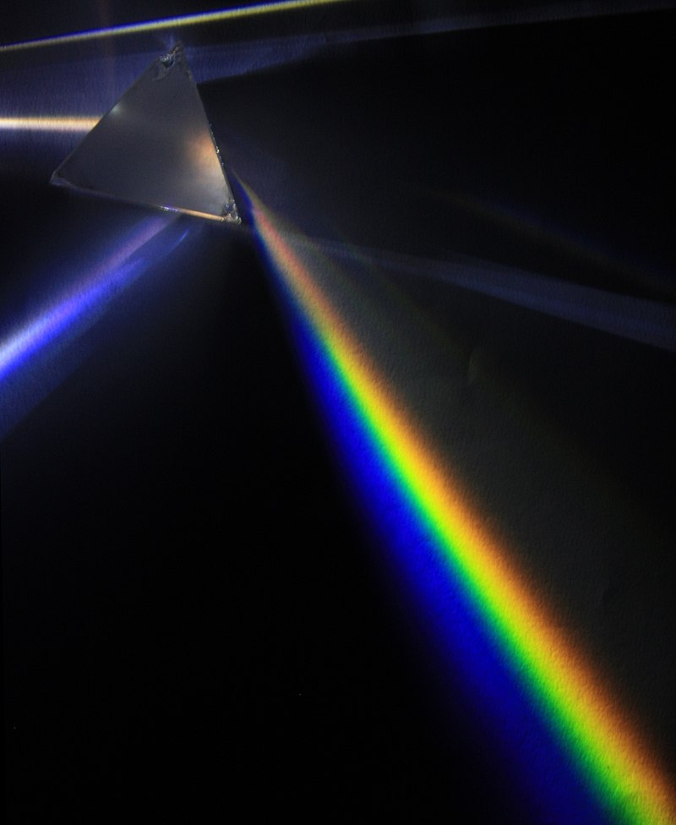
For example:
Image 1: Insert into Procedure under “Day 1”
Image file: activity-image1-prism.jpg
ADA Description: A glass prism sits on a black background; a light source shining through the prism is demonstrating refraction of white light into the visible light spectrum.
Source/Rights: 2009 D-Kuru, CC BY-SA 3.0, Wikipedia, source link. If you took the photo, list your full name.
Caption: Why does white light diffract into the colors of a rainbow when it shines through a prism?

Insert your image on the left. Include all required information (e.g., File name, ADA description, Source/Rights, Caption) for that image in the Image Box to the right. Also, make sure to include each image in jpg or png format with your submission.

Image 1 / Figure 1: Enter the location of where you want the image or figure in the text by saying (Insert Figure 1 here).

File name: The photo must be included as an attachment and must have the exact same name as you type here. Example: activity-image1.jpg

ADA Description: Write this text as if describing key elements of the image to a blind person.

Source/Rights: Include copyright or identifying information for any images used. Images pulled from the Internet should be either in the public domain or licensed for use through Creative Commons (CC-BY or CC-SA); you must still attribute them to the person or website from which they were pulled as well as provide a direct link to the image.

Caption: This text will appear directly below the Image. This should not be the same text as used for the ADA Description.



Image 2 / Figure 2: Enter the location of where you want the image or figure in the text by saying (Insert Figure 2) here.

File name: Example: activity-image2.jpg

ADA Description:

Source/Rights:

Caption:

Image3 / Figure 3: Enter the location of where you want the image or figure in the text by saying (Insert Figure 3) here.

File name: Example: activity-image3.jpg

ADA Description:

Source/Rights:

Caption:

Image4 / Figure 4: Enter the location of where you want the image or figure in the text by saying (Insert Figure 4) here.

File name: Example: activity-image4.jpg

ADA Description:

Source/Rights:

Caption:

